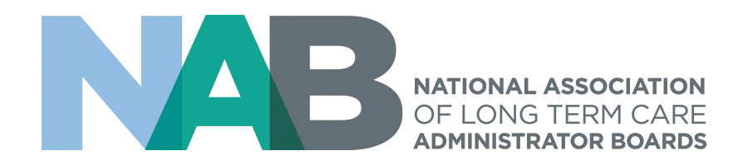

NCERS Forum Minutes
June 8, 2022 4:00 to 6:00 pm Chicago, IL

Attendees:
Callan Bassett (BMU)
Kathy Chapman (OH)
Lisa Hahn (VA)
Terry Holecek (FL)
Melissa Holland (OK)
Lila Horowitz (DC), NAB Staff
Annette Jorden (IA)
Bob Lane (DC)
Laurie Loughney (NJ)
Euijah Outerbridge (BMU)
Kathryn Wilhoit (TN)
Kathie Will (OH)
Donald Wilson (NM)

Kathy Chapman welcomed attendees and introductions were made.
Approval of Minutes: A motion was made and seconded to approve the meeting minutes from October 2021. Motion passed.
CE Registry Update
Lila reported the total number of users of the CE Registry (NAB Administrators vs. Paid Administrators)
States using CE Registry
RCAL registration for administrators was not included for those from OK. Melissa Holland stated that assisted living administrators call her organization for assistance, so Lila suggested that they direct the administrators to contact the NAB office for assistance and support with the CE Registry.
Bermuda asked if they can be added to the registry as an international partner/subscribing member of NAB?
Laurie Loughney said that she had submitted a NJ Core of Knowledge 100 hour program to NAB and had to pay a fee but no NAB credit is awarded. It was suggested that since the attendees are not yet licensed, the program would not be considered continuing education.

Compliance Issues
Annette Jorden of Life Care Services noted that there were 2 sponsors with non-compliance issues. What changes or additional issues need to be identified to resolve/prevent future non-compliance issues? Lila advised that the compliance issues occurred before she joined the NAB staff and she did not have enough knowledge on those particular situations to provide more information.
Callan Bassett of Bermuda asked for clarification on certified sponsor requirements and fees. Lila shared an brief explanation on the difference between standard sponsors and certified sponsors and directed Callan to review the NAB NCERS manual for CE Providers as a source of clarification.
Much discussion took place between those in attendance regarding the necessity of posttests to award CEs. Is it necessary and useful to require post-tests? How is course proficiency established? Is it necessary? Can test questions be in a Q & A format through the course? Forum members concluded that they will follow rules established for awarding CEs but were in agreement that post-tests were not a necessary component. Attendance monitoring systems that show actual time in the course would suffice.
Meeting was adjourned.

