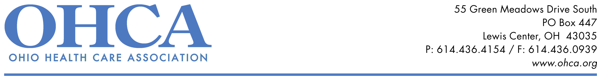

2020 Photo Contest Submission Form

CONTACT INFORMATION

Name:

Member Name: _________________

Address:

City: State: Zip:

Phone Number: E-mail:

ENTRY INFORMATION

Photo Taken By:

Photo Title:

Narrative/Description of Photo (Maximum 30 words):

CONVENTION AWARDS

Do you have a special employee, innovative program, event, community interaction or other notable occasion we should recognize during the 2021 OHCA Convention? If there is someone or something pictured, or something else you believe is worthy of recognition, please let us know here,, send an email to ohca@ohca.org, or send us a Facebook message at www.facebook.com/OHCA.Ohio and we will be in touch!

ENTRY REQUIREMENTS
- Entries must be submitted by an OHCA provider member; no more than 1 entry per member.
- Photos must be in high definition digital (JPEG, GIF, TIFF) format. Color and black and white images will be accepted.
- Entries should represent an aspect of daily life including personal interactions, activities, services, therapy and events. Portraits will also be accepted.
- An entry form is required for each photograph.
- Photo releases must be submitted for each individual pictured.
- The member provider is responsible for obtaining and keeping on record an appropriate HIPAA authorization for each individual.

SUBMISSIONS
- Submit entries to msmith@ohca.org via email
- Attach the photo, Photo Submission Form for each entry, and a Photo Release Form for each individual pictured
- Complete entries must be received no later than November 15, 2020.

Questions? Contact Mandy Smith at OHCA (msmith@ohca.org, 614-288-0613)

