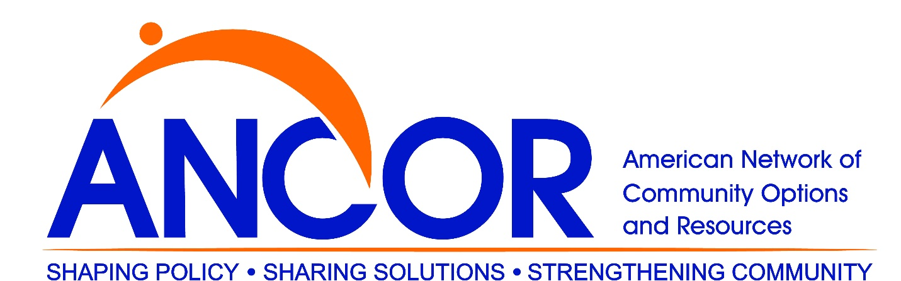

OHCA ID/DD members are also members of the American Network of Community Options and Resources ([**ANCOR**](http://www.ohca.org/www.ancor.com)) as part of their OHCA membership. There will be no extra charge beyond the normal OHCA dues for this benefit.

ANCOR is the pre-eminent national organization for ID/DD providers. OHCA has been an organizational member of ANCOR for many years. OHCA has an agreement with ANCOR to pay a single, statewide fee for our members also to be ANCOR members.

To access membership benefits on the [**ANCOR website**](http://www.ohca.org/www.ancor.org), please login and you will be able to access ancor.org, and member rates will be immediately populated for conferences, webinars and other events, and you will have access to the ANCOR Connected Community.

* [**ANCOR Member Benefits**](http://www.ancor.org/sites/default/files/pdf/ancor_benefitsbrochure2018_20180522_web.pdf)
* [**ANCOR Website**](http://www.ohca.org/www.ancor.org)
* [**ANCOR Logo**](http://www.ohca.org/docs/documents/5653/ANCOR%20Logo.jpg)
* [**ANCOR Proud Member Logo**](http://www.ohca.org/docs/documents/5653/ANCOR%20Proud%20Member%20Logo.jpg)
* [**ANCOR Proud Member Logo Web Code and Instructions**](http://ancor.org/about-ancor/membership/proud-member)