Dear Provider:

You are receiving this notice because the version of the Sandata Mobile Connect® (SMC) application (app) that you are using will no longer be supported. You must update your SMC app by August 1, 2021, or it will no longer work.

Sandata releases updates to the SMC app on a regular basis. You must install these updates  to ensure the SMC app continues to work.

How can I make sure my app is updated?

1. Turn on auto-updates for the SMC app.
2. Manually check the app store for your smart device and install the update.
   * Go to your smart device’s app store to check for and install the latest update for the SMC app. The app store should show the version number and date of the latest update that is available.

The app update screen in the Apple app store looks like this:

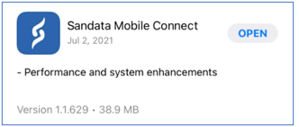

Once you have installed the latest update, you should see an app version of 1.1.629 or higher on the login screen of the SMC app, as shown below.

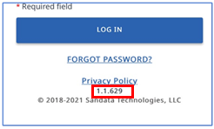

**Note:** To install the latest SMC app updates, Apple devices must be running the Apple operating system (iOS) 12 or higher and Android devices must be running the Android operating system of 4.4 or higher.

**What if I don’t update my app by August 1, 2021?**

If you are not using version 1.1.573 or higher of the SMC app by August 1, 2021, your app will no longer be supported and will not work.

To fix this, you must:

1. Delete the SMC app from your phone
2. Go to your smart device’s app store
3. Re-install the SMC app

This will ensure that you are using the latest version and that it will work as expected.

It is important to make sure that you install SMC app updates. Sandata emails a release notification to providers when there is a release, or updates, coming out for the app. The email includes the date that the update will be sent out, and what the new version of the app will be. The updates that are mentioned in the email will be available to install from the app stores on either Apple or Android devices about a week or two after the release notification email is sent.

If you have questions about installing app updates on your smart device, please reach out to the maker of your smart device. If you have questions about the SMC app itself, please reach out to EVV Provider Hotline at **855.805.3505**.

Best Regards,

**Sandata Customer Care**

Sandata

26 Harbor Park Drive, Port Washington, NY 11050

cid:image005.png@01D778D1.65A4B4F0