**Daily Life and Employment**

This guide is focused on your Daily Life and Employment. It is intended to help you, your family, or the people who support you think about what you like and want to do as you grow from childhood into young adulthood and beyond. This guide will help you think about questions to ask, things to do, and resources to access that lead to a job, career, volunteer position, or continuing education of your choice.

This guide provides the questions to ask or think about, and strategies to get the answers and move closer to the desired result. It is not intended to be all-inclusive but is a starting place for families to individualize it to meet their own unique needs. It is meant to be a conversation starter as families begin to think about and plan for a good life.

**Why do people work?**

The quick answer is to make money to support themselves financially and get the things they want. But work is also an opportunity to build friendships, learn new things, and achieve a sense of accomplishment, competence, and pride! Working gives people something to do with their time, adds structure to their day, builds social networks, and helps attain a sense of purpose. Work is an important part of adult identity, and this is as true for people with disabilities as it is for anyone. Having the right job can greatly increase satisfaction with and quality of life.

Sometimes people with disabilities encounter barriers to employment. Some common barriers include not knowing what kind of job they want to do, not having the skills needed for a particular job, not having work experience, and other issues such as transportation and needed accommodations. Another barrier can be the lack of expectation of the person, family or other supporters that the person can and should be employed.

People with disabilities have a higher rate of unemployment than the general population. But it does not have to be that way. People with disabilities often want to work and are able to work if given the support and preparation they need to be successful.

It begins early and continues throughout the life course. Beginning in childhood, families, schools, friends, community members, support coordinators, and other supporters can encourage the child to develop a vision for their future, including what kind of job they would like to have. All children dream about what they want to be when they grow up, and children who happen to have a disability or special healthcare need are no different! As children prepare to leave high school, they begin to focus even more on jobs, careers, college or continuing education. As adults, sometimes we make the decision to change jobs or careers and eventually begin to think about retirement.

**A Change in Our Thinking…**

In the past, many people with disabilities have not had many chances to find employment in their community alongside their non-disabled peers. They commonly worked in jobs that were created just for people with disabilities and segregated from the rest of the community. Some reasons why people with disabilities may not have had access to employment were:

* Low expectations about what people with disabilities can contribute as workers;
* Stereotypes about what type of work people with disabilities can do;
* Focus on the limitations of a person with a disability instead of their abilities and skills;
* Lack of exposure to work experiences in the community.

Today, the way we think about employment for a person with a disability has changed. People with disabilities are also valued employees in their communities. People with disabilities want to work and want their families and supporters to see beyond old stereotypes and focus on their skills, abilities, and interests when thinking about employment. People with disabilities can and do hold real community jobs as productive and valued employees.

**What does it Take to Get to the Good Life?**

On the next two pages, you will find a worksheet to begin to create your own employment trajectory.

First, on the left side of the large bubble on the upper right side of the page, list a few things that make a good life for you, in general (not specific to employment). These are often the things you want that employment will help make possible!

Next, list your long-term vision for employment in the large bubble on the right side. In the lower section of the bubble is space for you to list conditions, preferences and support needs.

Conditions are things you MUST have in order to apply for or accept a job. Preferences are those things you would LIKE to have in a job. Conditions and preferences could include things such as salary, schedule, benefits, environment, benefits, job tasks, or dress code. Support Needs are things that will help you be successful in getting and keeping a job. Examples could include your particular learning style, job accommodation needs or transportation.

In the box on the bottom right, list the things you don’t want in your life overall on the left. On the right, list the things you don’t want in your employment vision.

The boxes along the trajectory arrow are to help you think about and list life experiences you have had or need to have at the transition and adult life stages. List life experiences or events that help you move toward your desired employment vision ABOVE the line in the box, and the experiences and events that could move your trajectory toward the things you don’t want, BELOW the line.

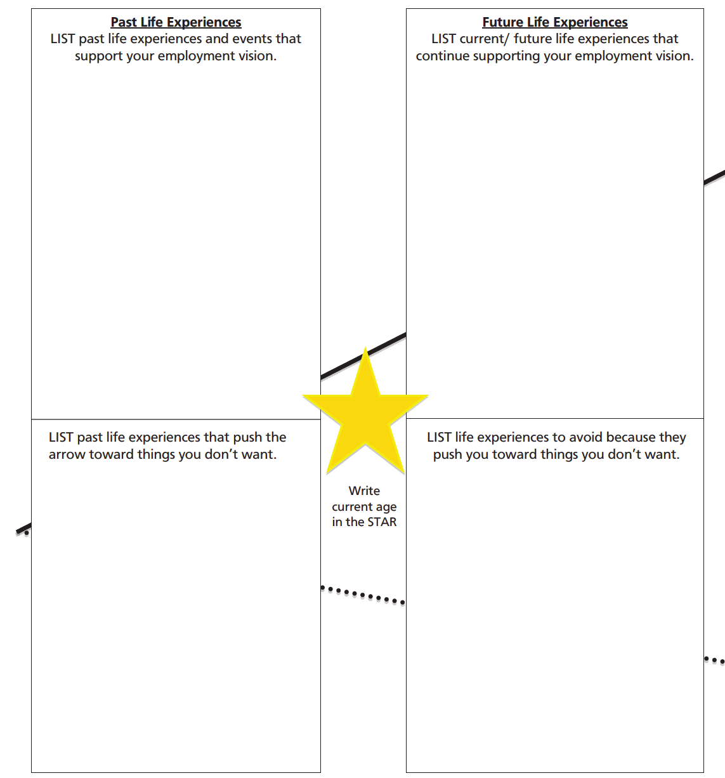

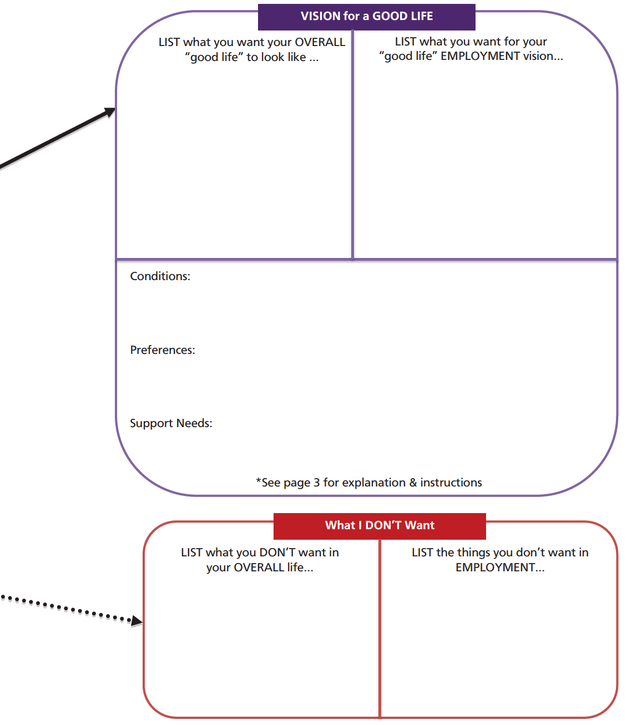

The Trajectory is a template of the UMKC IHD, UCEDD. More materials at lifecoursetools.com

**Discovering Who**

Before you can make decisions about what you want to do in your adult life, like the kind of job or career you want, you have to learn about yourself and your interests. What do you have a passion to spend your day doing? What is it about work that is appealing to you? What’s going to ignite a fire in you that will make you get out of bed and contribute each day?

No one knows you and your interests better than you and those closest to you. One way to begin this process is by creating a One Page Profile. A One Page Profile is a short introduction to a person, which captures key information on a single page. On the next page is a template for you to create your One Page Profile. You should include enough detail that someone who has never met you would have a good idea of who you are and understand what matters to you.

**What people like and admire about me**: This is a list of your positive strengths, talents, and qualities. Ask family or others who know you well for input, or do this exercise as a group activity.

**What’s important to me**: Things about your life that are important to you, including people, places, interests, passions, hobbies, possessions, rituals, routines, as well what’s important related to work. What are the things that you value the most and make you who you are?

**How to best support me**: Identify specific kinds of support that are helpful to you and what is not. Think about the support you need to create the best environment and outcomes in your life.

For more tools to help you navigate the transition to employment, visit **lifecoursetools.com**

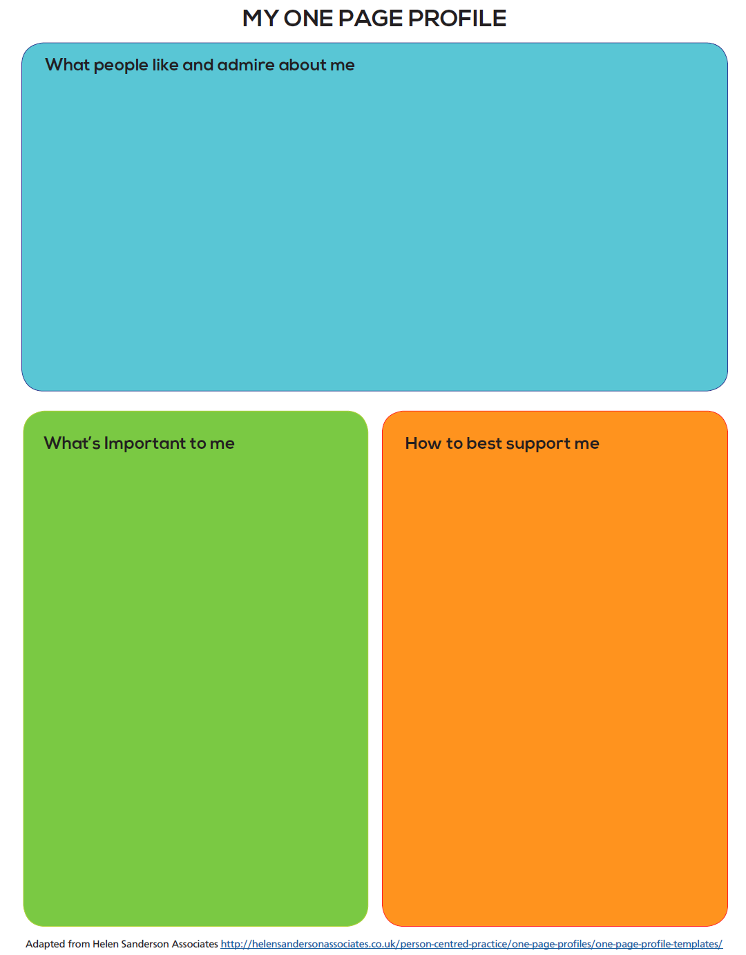

The One Page Profile is a template of the UMKC IHD, UCEDD. More materials at lifecoursetools.com

**Discovering How**

Everyone uses a variety of resources and supports to get through their day-to-day routines. People build upon their own assets, skills, and capabilities. Most of us have people in our lives that do things for us (and vice versa). We tap into available community groups, clubs, organizations, and resources. And who doesn’t use technology these days?

Ideally, when someone has different abilities or support needs they might need to access eligibility-based supports, but should also remember to look to the same types of supports that anyone else would use!

In order to support a trajectory to an inclusive, quality, community life, support for people with disabilities and families should ideally be a combination and partnership of the personal strengths and assets of the person and family, relationship-based supports, technology, community resources, and eligibility-based supports.

**Personal assets and strengths** are those things that a person or family brings to the table. It might be tangible resources, or it might be the knowledge, skills, strengths, personality or capabilities of the person.

**Relationship-based supports** are the things with which family, friends, neighbors, co-workers and other people can help. One person probably can’t provide all the support a person might need, but several people might each be able to do one thing!

**Technology-based supports** could be anything from specialized technology, computers, tablets, smartphones, to something as simple as an alarm clock.

**Community-based supports** are those things that any community member can access. This might include community centers, parks and recreation, public transportation or faith-based resources.

**Eligibility-based supports** include those services or things that someone is eligible to access based on disability, age, income or other specific criteria.

Sometimes, a person might rely so much on systems supports that it can get in the way or interfere with relationships, community and other things that are important to them. The trick is to provide just enough support, where and when the person needs it, for them to be able to live the life they would like.

People need supports to lead good lives. Using a combination of lots of different kinds of support helps to plot a trajectory toward an inclusive, quality, community life.

The next two pages will help you explore the people, places, technology, and resources that will help you figure out what kind of a job or career you want, as well as support your efforts to find a job, keep a job, and have the on-the-job supports to help you be successful.

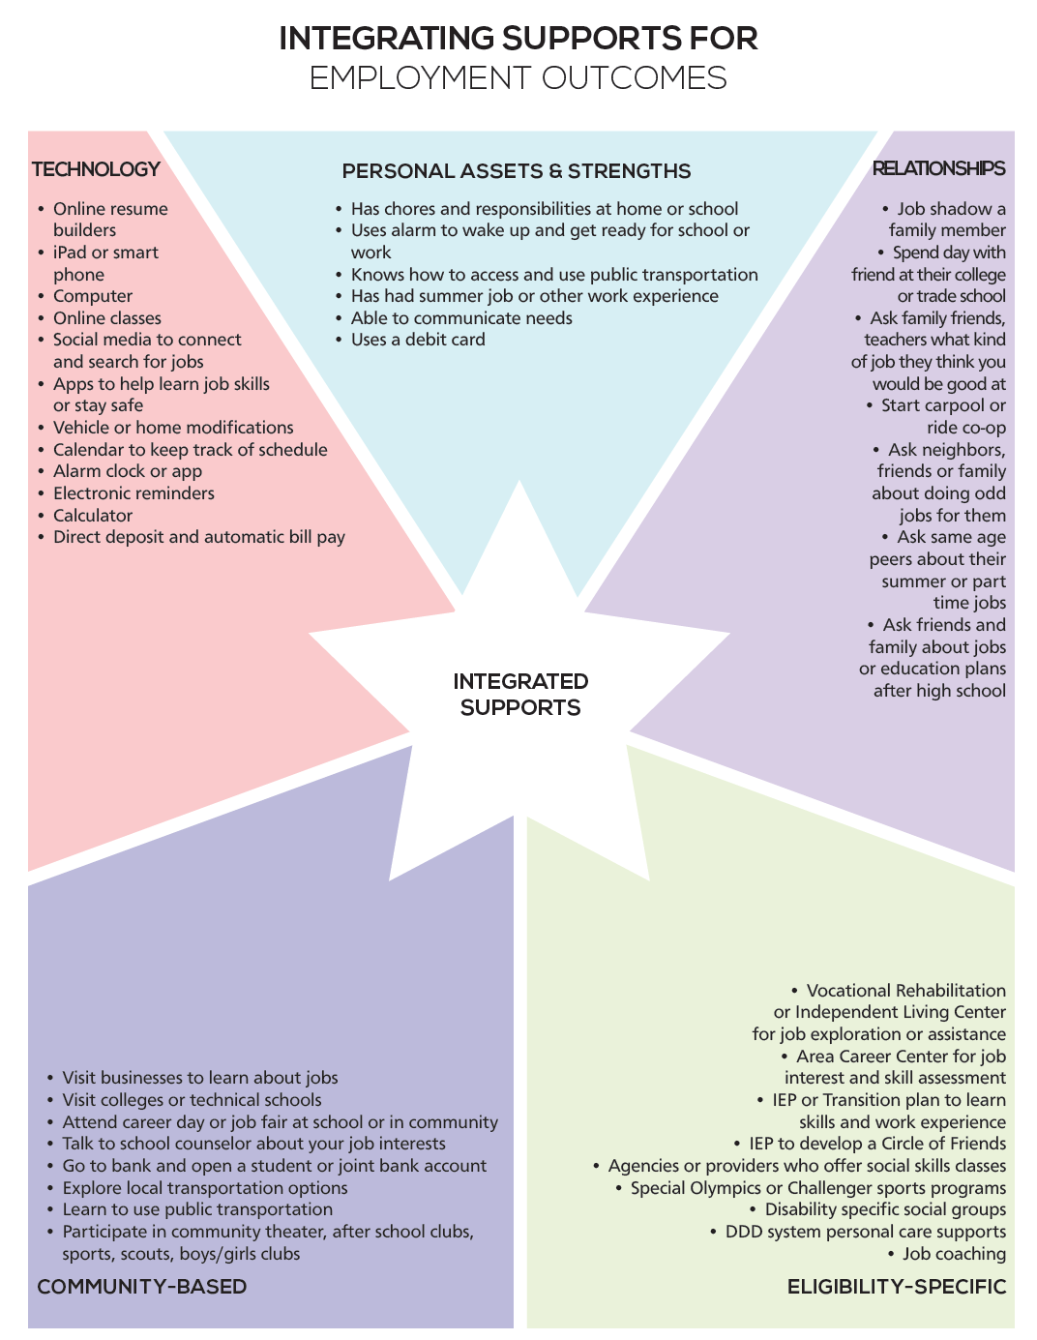

The Integrated Star is a template of the UMKC IHD, UCEDD. More materials at lifecoursetools.com

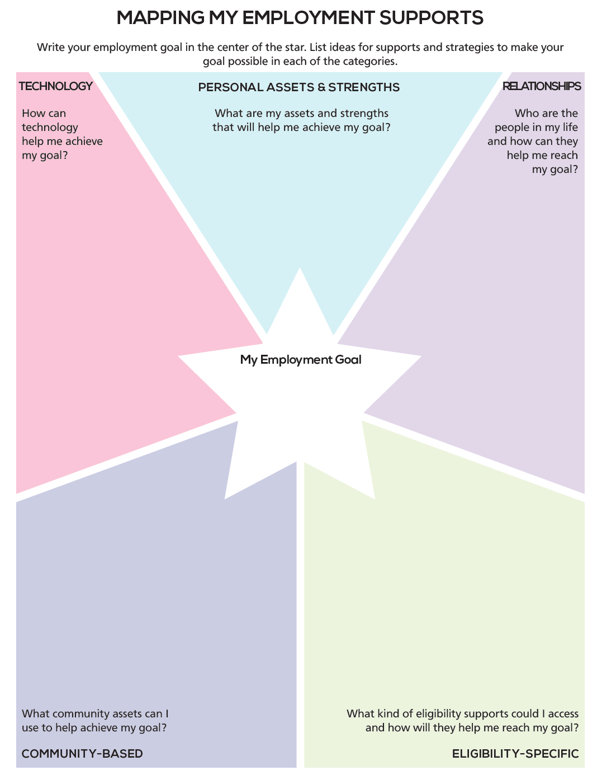

The Integrated Star is a template of the UMKC IHD, UCEDD. More materials at lifecoursetools.com

**Service Options**

The Ohio Department of Developmental Disabilities (DODD) has many service options to support people with their employment goals and adult day service needs:

* Adult Day Supports
* Vocational Habilitation
* Basic Employment Skills Training
* Career Planning
* Group Employment Supports
* Individual Employment Supports

This resource packet is designed to provide you with information about the day service options available through Ohio’s Medicaid waivers for someone to live, work or play in their community.

**The Path to Employment and Supports**

No

No

No

**Service Changes**

On (mm/dd/yyyy), a new waiver service, Basic Employment Skills Training, will be available and changes will be made to the Vocational Habilitation service. Here’s how the services will compare.

**Putting it All Together**

People can use a combination of supports, funded through different agencies, to help them get or keep a job and to be involved in their communities. For example, services from OOD can be used at the same time a person is using some services through the waiver, county board services or community options. All these supports should be explored through the person-centered planning process and outlined in the person’s plan.

Services should complement each other and work together in order to support someone in achieving their goals or desired outcome. Multiple services may be authorized to support a person on their path to community employment or for socialization and recreational services.

[Ohio Employment First Agency Navigation Tool](https://ohioemploymentfirst.org/up_doc/Agency-Navigation-Tool-2018.pdf) **- Full Agency Descriptions**

**Art Studios Scenarios**

Tamara has always wanted to pursue art as a possible way to make money and be a part of a group of artists who want to figure out what a career as an artist might look like. At home, she makes jewelry, as well as crochets, but her attempts often don’t end up the way she wants them to. She wants access to better materials and more information about how to make things, and to market her work once she makes it. She goes to a day program that gives her opportunities to make crafts, but she wants to investigate new materials and get serious. She decides to look into another program that specializes in art only. This art studio/program, ABCD, helps artists with disabilities figure out what they want to make, and how to pursue selling it and/or celebrating it in a variety of ways. The support people at ABCD are artists themselves, so they know what kinds of materials working artists need, and also have knowledge about what a career in art is all about. Tamara is able to connect with other artists, both with and without disabilities, to learn from their struggles and successes. ABCD supports artists to learn about careers in arts, access materials in order to create topnotch pieces, market what they make and also helps them build independence and learn what is “out there” for any artist who wants to make money. Included in the programming are visits to other artists’ studios, art supply stores, online learning about what it takes to have a career, and specific training, both in the ABCD studio and outside of it, on how to make really cool art. (HCBS billable services involved: Basic Employment Skills Training and Career Planning.)

Andy wants to use his interest in art to meet people and have fun. He wants to learn and explore different ways to make art, including painting, sculpture, drawing, and other media but doesn’t have an interest in the finished products outside of giving what he makes to friends and relatives and decorating his room and house. He makes greeting cards and loves to doodle in a notebook. He’s always up for trying new things too. He also attends ABCD, but unlike Tamara, he’s just in it for the fun and learning and opportunities to meet people. He goes to museums, meets artists, learns about and makes art as a hobby and a pastime, a way to make friends. He loves going to openings and supporting his artist friends. He shows his work at exhibits sometimes, but the work is always marked “not for sale.” He has just as much of a good time as Tamara but only comes twice a week. He has a job at a movie theatre four days a week and loves it. He uses ABCD as a way to learn and be a part of the world. (HCBS billable services involved: Adult Day Supports. For the movie theatre job: Individual Employment Supports.)