|  |
| --- |
| USER GUIDE |
| ***Provider Relief Fund (PRF) REporting Portal - Reporting***  Date: November 19, 2021 |

Table of Contents

1 General information 1

1.1 Background Information 1

1.2 Purpose 1

1.3 Post-Payment Reporting Requirements 1

1.4 Responsibility for Reporting 2

1.5 Before Starting 2

1.6 Getting Started 6

2 Home Page 8

3 Navigation Within the Portal 11

4 Steps to Complete Reporting 13

4.1 Terms and Conditions 13

4.2 Step 1 – Report Summary Landing Page 13

4.3 Step 2 – Entity Overview 14

4.4 Step 3 – Subsidiary Questionnaire 16

4.5 Step 4 – Subsidiary Data 18

4.6 Step 5 – Payments to Recipient 21

4.7 Step 6 – Interest Earned on PRF Payments, Tax Information, and Single Audit Information 25

4.8 Step 7 – Payments Summary 29

4.9 Step 8 – Other Assistance Received 30

4.10 Step 9 – Nursing Home Infection Control Expenses for Payments Received during Payment Period 33

4.11 Step 10 – Other Provider Relief Fund Expenses for Payments Received during Payment Period 36

4.12 Step 11 – Unreimbursed Expenses Attributable to Coronavirus 39

4.13 Step 12 – Actual Patient Care Revenue or Lost Revenues 40

4.12.1 Actual Patient Care Revenue 40

4.12.2 Lost Revenues Questionnaire 41

4.14 Step 13 – Lost Revenues 42

4.13.1 2019 Actual Revenue (Calculation of Lost Revenues Attributable to Coronavirus) 42

4.13.2 2020 Budgeted Revenue (Calculation of Lost Revenues Attributable to Coronavirus) 44

4.13.3 Alternate Method of Calculating Lost Revenues Attributable to Coronavirus 47

4.15 Step 14 – PRF Financial Summary 50

4.16 Step 15 – Personnel, Patient, and Facility Metrics 57

4.17 Step 16 – Survey 62

4.18 Step 17 – Review and Submit 65

4.19 Locked Page 69

**Table of Figures**

Figure 1 Home Page 8

Figure 2 Password Reset 9

Figure 3 Password Policy 9

Figure 4 Successful Password Reset Pop Up 10

Figure 5 Progress Bar 11

Figure 6 Page Navigation 11

Figure 7 Acceptance of Terms and Conditions 13

Figure 7.1 The Reporting Landing Page 14

Figure 8 Entity Overview 15

Figure 9 Entity Overview – Field Validations 16

Figure 10 Subsidiary Questionnaire – Required and Conditional Questions 17

Figure 11 Acquired/Divested Subsidiaries 18

Figure 12 Delete Confirmation 19

Figure 13 Acquired/Divested Table - Required Field Validations 19

Figure 14 Subsidiary Information Table 20

Figure 15 Subsidiary Information Table - Required Field Validation 21

Figure 16 Provider Relief Fund Payments (Spreadsheet) 22

Figure 17 Certify Accuracy of Information 23

Figure 18 Certify Accuracy of Information- Dispute Comments 24

Figure 19 Contact Provider Support Pop-Up 24

Figure 20 $10,000 or Less Pop-Up 25

Figure 21 Interest Earned on PRF Payments, Tax Information and Single Audit Information 26

Figure 22 Federal Tax Classification 27

Figure 23 Fiscal Year End Date 28

Figure 24 Payments Summary: April 10, 2020 - June 30, 2020 30

Figure 25 Other Assistance Received 31

Figure 26 Other Assistance Received – Error Message 32

Figure 27 Nursing Home Infection Control Expenses- Between $10,001 and $499,999 34

Figure 28 Nursing Home Infection Control Expenses- $500,000 or More Table 36

Figure 29 Other PRF Expenses- Between $10,001 and $499,999 37

Figure 30 Other PRF Expenses- $500,000 or More Table 39

Figure 31 Unreimbursed Expenses Table 40

Figure 32 Actual Patient Care Revenue 41

Figure 33 Lost Revenues Questionnaire 41

Figure 34 Total Revenue/Net Charges from Patient Care (2019 Actuals) 43

Figure 35 Total Revenue/Net Charges from Patient Care (2020 Budgeted) 45

Figure 36 Upload Budget and Attestation 47

Figure 37 Lost Revenues Alternate Reasonable Methodology 48

Figure 38 Upload Narrative and Calculation of Lost Revenues 49

Figure 39 Table Error Messages 49

Figure 40 PRF Financial Summary- 2019 or 2020 Lost Revenue Path 50

Figure 41 PRF Financial Summary- Alternate Methodology Lost Revenue Path 51

Figure 42 Personnel Metrics- Error Messages 58

Figure 43 Personnel Metrics 59

Figure 44 Patient Metrics 60

Figure 45 Facility Metrics 61

Figure 46 Survey Financial Effects of PRF Payment(s) 62

Figure 47 Conditional Question Financial Effects of PRF Payment(s) 63

Figure 48 Survey Clinical Care Effects of PRF Payment(s) 64

Figure 49 Conditional Question Survey Clinical Care Effects of PRF Payment(s) 64

Figure 50 Review and Submit Page 67

Figure 51 Submit Pop-Up 68

Figure 52 Reporting Successful Pop-Up 68

Figure 53 Reporting Successful Email 69

Figure 54 Locked Page 70

# General information

## Background Information

The Coronavirus Aid, Relief, and Economic Security (CARES) Act (P.L. 116-136), the Paycheck Protection Program (PPP) and Health Care Enhancement Act (P.L. 116-139), and the Coronavirus Response and Relief Supplemental Appropriations Act (CRRSA) (Division M of P.L. 116-260) appropriated funds to reimburse eligible healthcare providers for healthcare related expenses or lost revenues attributable to coronavirus. These funds were distributed by the Health Resources and Services Administration (HRSA) through the Provider Relief Fund (PRF) program. Recipients of these funds agreed to [Terms and Conditions](https://www.hhs.gov/coronavirus/cares-act-provider-relief-fund/for-providers/index.html#terms-and-conditions), which require compliance with reporting requirements as specified by the Secretary of the U.S. Department of Health and Human Services (HHS) in program instructions.

## Purpose

HRSA developed the PRF Reporting Portal to enable PRF recipients (also referred to as “Reporting Entities” throughout this document) to comply with mandatory reporting requirements. Reporting Entities must complete a two-step process in the PRF Reporting Portal (also referred to as “the portal” throughout this document) in order to submit their reports to HRSA. To complete the two-step process, Reporting Entities must 1) register as users and 2) complete reporting on the use of funds. HRSA previously published the ***PRF Reporting Portal User Guide- Registration*** to assist PRF recipients in the completion of the first step of the process. The purpose of the ***PRF Reporting Portal User Guide- Reporting*** is to assist PRF recipients in the completion of the second step of the process – reporting on the use of funds.

## Post-Payment Reporting Requirements

PRF recipients should review the most recently published *Post-Payment Notice of Reporting Requirements* available on the [PRF Reporting Requirements & Auditing](https://www.hhs.gov/coronavirus/cares-act-provider-relief-fund/reporting-auditing/index.html) website for information about reporting requirements. Recipients are required to report on required data elements as part of the post-payment reporting process in each Payment Received Period in which they received one or more payments exceeding $10,000 in the aggregate as shown in *Table 1 Reporting Periods*. Reporting must be completed and submitted to HRSA by 11:59 PM Eastern Time on the last date of the Reporting Time Period. Only electronic submissions through the PRF Reporting Portal are permitted.

PRF recipients that do not report within the respective Reporting Time Period are out of compliance with payment Terms and Conditions and may be subject to recoupment.

If a PRF recipient received payments meeting the established monetary threshold during multiple Payment Received Periods, the recipient is required to report during each of the corresponding Reporting Time Periods as shown below.

| **Reporting Period** | **Payment Received Period (Payments Exceeding $10,000 in Aggregate Received)** | **Deadline to Use Funds** | **Reporting Time Period** |
| --- | --- | --- | --- |
| 1 | Payments received April 10, 2020 to June 30, 2020 | June 30, 2021 | July 1, 2021 to September 30, 2021 |
| 2 | Payments received July 1, 2020 to December 21, 2020 | December 31, 2021 | January 1, 2022 to March 31, 2022 |
| 3 | Payments received January 1, 2021 to June 30, 2021 | June 30, 2022 | July 1, 2022 to September 30, 2022 |
| 4 | Payments received July 1, 2021 to December 31, 2021 | December 31, 2022 | January 1, 2023 to March 31, 2023 |

Table 1 Reporting Periods

## Responsibility for Reporting

For the purposes of registration and reporting in the PRF Reporting Portal, the Reporting Entity is the entity that registers its Tax Identification Number (TIN) and reports on payments received by that TIN and/or its subsidiary TINs. A TIN is either an Employer Identification Number (EIN) or Social Security Number (SSN) and must be entered in nine-digit formats with no special characters. A parent entity may report on its subsidiaries’ General Distribution payments, regardless of whether the subsidiary TINs received the General Distribution payments directly from HRSA or whether General Distribution payments were transferred to them by the parent entity. The parent entity may report on these General Distribution payments regardless of whether the parent or the subsidiary attested to the Terms and Conditions. **The original recipient of a Targeted Distribution payment is always the Reporting Entity** **in accordance with the CRRSA Act.** A parent entity may not report on its subsidiaries’ Targeted Distribution payments. This is required regardless of whether the parent or subsidiary received the payment or whether that original recipient subsequently transferred the payment.

## Before Starting

Reporting Entities must complete registration before beginning to report on the use of funds. The report must be completed and saved stepwise and Reporting Entities are not allowed to skip steps. Data may be saved throughout the reporting process, so it is not necessary to complete the report at once. **A work session in the PRF Reporting Portal will timeout after 15 minutes of inactivity.** During each login to the portal and at the end of the reporting process, users of the portal will receive an email notification from ‘[PRFReporting-NoReply@hrsa.gov](mailto:PRFReporting-NoReply@hrsa.gov).’ Users of the portal should add this email address to their safe sender list before beginning. For instructions on adding ‘[PRFReporting-NoReply@hrsa.gov](mailto:PRFReporting-NoReply@hrsa.gov)’ as a safe email sender, portal users should follow the instructions of the email provider associated with the email account. As an example, instructions for Outlook users may be found [here](https://support.microsoft.com/en-us/office/block-or-allow-junk-email-settings-48c9f6f7-2309-4f95-9a4d-de987e880e46#bkmk_safesenders). Please note that the ‘[PRFReporting-NoReply@hrsa.gov](mailto:PRFReporting-NoReply@hrsa.gov)’ account is not monitored and should not be used to communicate with HRSA staff.

Reporting Entities should ensure they have all of the information required to report available before they begin. Information required to report includes:

* Business name, address, and contact information
* Provider type and provider sub-type:
  + Provider Types (Home and Community, Ancillary Services, Facilities, Outpatient and Professional, DME/ Suppliers, Other)
  + Provider Sub-types –conditional to Provider Types (e.g., Home Health Agencies, Dental Service Providers, Assisted Living Facilities, Pediatrics Practice, etc.)
* List (by TIN) of subsidiaries that are eligible healthcare providers[1]
* List (by TIN) of acquired/divested subsidiaries that are eligible healthcare providers and that received PRF payments during the period of availability of funds
* If the Reporting Entity is a subsidiary:
  + Will a parent entity report on any of the Reporting Entity’s General Distribution payments?
  + TIN(s) of parent entity reporting on behalf of the parent for General Distribution
  + If any Targeted Distribution payments were transferred to/by a parent, the total dollar amount
* If PRF payments were received for acquired/divested entities:
  + TIN(s) of Acquired/Divested Subsidiary(ies)
  + Acquired or Divested
  + Effective Date of the Acquisition/Divestiture
  + TIN of Acquiring/Divesting Entity
  + Total PRF Dollar Amount Received for the TIN
  + Percentage of Ownership
  + Controlling interest
* Total payments received or rejected (attestation rejected) for the Payment Received Period that corresponds to the reporting period (*i.e.,* Nursing Home Infection Control Distribution payments, General Distribution payments, other Targeted Distribution payments)
  + TIN of Recipient
  + Distribution (General/Targeted/Infection Control)
  + Amount Deposited
  + Amount Returned
  + Amount Retained
  + Attestation Date
* Amount of interest earned on Nursing Home Infection Control Distribution payment(s) from payment date until expense date, if applicable
* Amount of interest earned on Other PRF payments from payment date until expense date, if applicable
* Federal Tax Classification from IRS form W-9, Exempt Payee Code (Optional) from IRS Form W-9, Exempt from Foreign Account Tax Compliance Act (FACTA) Reporting Code (Optional) from IRS Form W-9,
* Fiscal Year end date of Reporting Entity
* Reporting Entity Subjected to Audit ([45 CFR § 75 Subpart F)](https://www.ecfr.gov/cgi-bin/text-idx?node=pt45.1.75)
  + If so, were PRF funds included in the audit?
* Other Assistance Received by the Reporting Entity during the period of availability (and its subsidiaries if included in the reporting) reported by calendar year quarter including:
  + Treasury, Small Business Administration (SBA) and the CARES Act/Paycheck Protection Program (PPP)
  + FEMA Programs (CARES Act, Public Assistance, etc.)
  + HHS CARES Act Testing
  + Local, State, and Tribal Government Assistance
  + Business Insurance
  + Other Assistance
* If the Reporting Entity received Rural Health Clinic (RHC) COVID-19 Testing Program funds, did the entity report on the use of funds?
* Use of Nursing Home Infection Control Distribution payments for nursing home infection control expenses during the period of availability, by calendar year quarter:
  + General and Administrative (G&A) Expenses
    - If Total PRF payments for the Payment Received Period is $500,000 or greater in aggregate, then expenses will be reported as:
      * Mortgage/Rent
      * Insurance
      * Personnel
      * Fringe Benefits
      * Lease Payments
      * Utilities/Operations
      * Other General and Administrative Expenses
  + Healthcare Related Expenses
    - If Total PRF payments for the Payment Received Period is $500,000 or greater in aggregate, then expenses will be reported as:
      * Supplies
      * Equipment
      * Information Technology (IT)
      * Facilities
      * Other Healthcare Expenses
* Use of Other PRF payments (*i.e.,* General Distribution and Other Targeted Distribution payments) for coronavirus related expenses during the period of availability, by calendar year quarter:
  + General and Administrative (G&A) Expenses
    - If Total PRF payments for the Payment Received Period is $500,000 or greater in aggregate, then expenses will be reported as:
      * Mortgage/Rent
      * Insurance
      * Personnel
      * Fringe Benefits
      * Lease Payments
      * Utilities/Operations
      * Other General and Administrative (G&A) Expenses
  + Healthcare Related Expenses
    - If Total PRF payments for the Payment Received Period is $500,000 or greater in aggregate, then expenses will be reported as:
      * Supplies
      * Equipment
      * Information Technology (IT)
      * Facilities
      * Other Healthcare Expenses
* Unreimbursed Expenses Attributable to Coronavirus
  + General and Administrative (G&A) Expenses
  + Healthcare Related Expenses
* If all Other PRF payments were used, 2019 and 2020 actual patient care revenue
* If all Other PRF payments were not used, then Reporting Entities will select one of the following methods to report on PRF payments applied to lost revenues:
  + Actual Patient Care Revenue (2019 through the end of the period of availability) by calendar year quarter, split by payer type:
    - * Medicare Part A + B
      * Medicare Part C
      * Medicaid/Children’s Health Insurance Program (CHIP)
      * Commercial Insurance
      * Self-Pay (No-Insurance)
      * Other
  + Budgeted and Actual Patient Care Revenues for 2020 and 2021 (for the period of availability of funding) by calendar year quarter, split by payer type:
    - * Medicare Part A + B
      * Medicare Part C
      * Medicaid/Children’s Health Insurance Program (CHIP)
      * Commercial Insurance
      * Self-Pay (No-Insurance)
      * Other

Additional documentation as follows:

* + - * 2020 and 2021 budgets approved prior to March 27, 2020
      * Attestation by Chief Executive Officer (CEO), Chief Financial Officer (CFO), or similarly responsible individual representing the Reporting Entity on accuracy of budget
* Alternate Method of calculating lost revenues by calendar year quarter, for the period of availability
  + - Narrative document describing methodology, why the methodology is reasonable, and a description establishing how lost revenues were attributable to coronavirus, as opposed to a loss caused by any other source
    - Calculation of lost revenues using the methodology described in the narrative document
    - (Optional) Additional Supporting Documentation
* Other Non-Financial Data reported by calendar year quarter (2019 through the period of availability)
  + Personnel Metrics: Total number of clinical and non-clinical personnel by labor category (full-time, part-time, contract, furloughed, separated, hired)
* Patient Metrics: Total number of inpatient admissions, outpatient visits (in-person and virtual), emergency department visits, and facility stays (for long-term and short-term residential facilities)
* Facility Metrics: Total number of staffed beds for medical/surgical, critical care, and other
* Responses to survey questions on the impact PRF of payments during the Payment Received Period that corresponds to the reporting period

Each of these data elements is explained more thoroughly within each corresponding section of the user guide.

## Getting Started

The PRF Reporting Portal is only compatible with the latest versions of Microsoft Edge, Google Chrome, and Mozilla Firefox. For portal users that do not have a compatible web browser, one may be downloaded for free. The portal must be accessed at: <https://prfreporting.hrsa.gov/>.

In addition to this *PRF Reporting Portal User Guide – Reporting*, Reporting Entities should reference the following key PRF resources during the reporting process:

* [PRF Reporting Portal User Guide – Registration](https://hrsac19.my.salesforce.com/sfc/p/" \l "t00000004XgP/a/t0000001FIcy/yU0WSf98g33mM6OuwWS2OK0mNwKY8cYwBK9PhP.2GoA)
* [PRF Post-Payment Notice of Reporting Requirements](https://www.hhs.gov/sites/default/files/provider-post-payment-notice-of-reporting-requirements-june-2021.pdf)
* [PRF Frequently Asked Questions (FAQs)](https://www.hhs.gov/coronavirus/cares-act-provider-relief-fund/faqs/index.html)
* [PRF Reporting Portal FAQs](https://hrsac19.my.salesforce.com/sfc/p/#t00000004XgP/a/t0000001FId8/wN.4dTa.NRiNhwh_0CBblH6gvvedhqOt7_.5OS7rP6U)
* [PRF Reporting and Auditing Requirements](https://www.hhs.gov/coronavirus/cares-act-provider-relief-fund/reporting-auditing/index.html)
* [PRF Terms and Conditions](https://www.hhs.gov/coronavirus/cares-act-provider-relief-fund/for-providers/index.html" \l "terms-and-conditions)
* [PRF General Information](https://www.hhs.gov/coronavirus/cares-act-provider-relief-fund/general-information/index.html)

Links to key PRF resources are available to Reporting Entities on the portal Home Page and throughout the portal. Please reference *Section 2 Home Page* to locate these resources.

For more information on how to navigate the portal, please reference *Section 3 Navigation within the Portal**.*

For a step-by-step walkthrough of the reporting process, please reference *Section 4 Steps to Complete Reporting*.

*Note: If the Reporting Entity received Rural Health Clinic (RHC) COVID-19 Testing Program payments and/or RHC COVID-19 Testing and Mitigation Program payments, they are required to report separately on the use of those funds at* [*https://www.rhccovidreporting.com*](https://www.rhccovidreporting.com)*.*

# Home Page

The PRF Reporting Portal Home Page allows Reporting Entities to register and log in to report on PRF payments, and to access resources and frequently asked questions (FAQs). It can be accessed at <https://prfreporting.hrsa.gov/>. The key elements are shown on the *Figure 1 Home Page.*

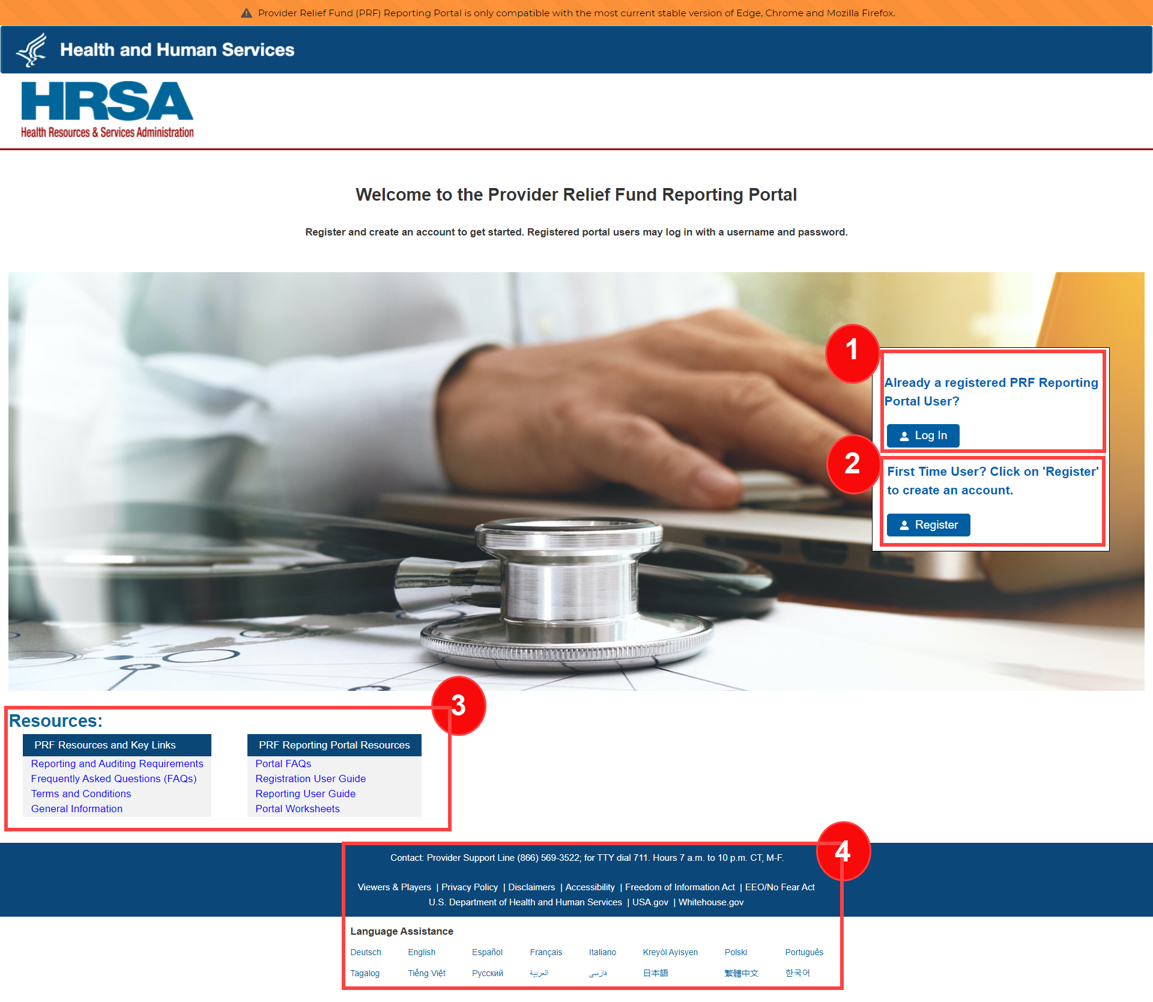

Figure 1 Home Page

1. **Log In:** Reporting Entities that are already registered as PRF Reporting Portal users can enter the portal by clicking on the ‘Log In’ button displayed under the ‘Already a registered PRF Reporting Portal User?’ heading. After clicking the ‘Log In’ button, Reporting Entities will be prompted to enter the username created during the registration process, check the ‘I’m not a robot’ box, and click the ‘Continue to Log In’ button. Reporting Entities that do not remember their password, can reset their password using ‘Forgot Password?’ link on the TIN and password page. Clicking this link will redirect the user to a screen called ‘Password Reset’ where the username associated with their portal account and TIN is required to reset the password as shown in *Figure 2 Password Reset*.

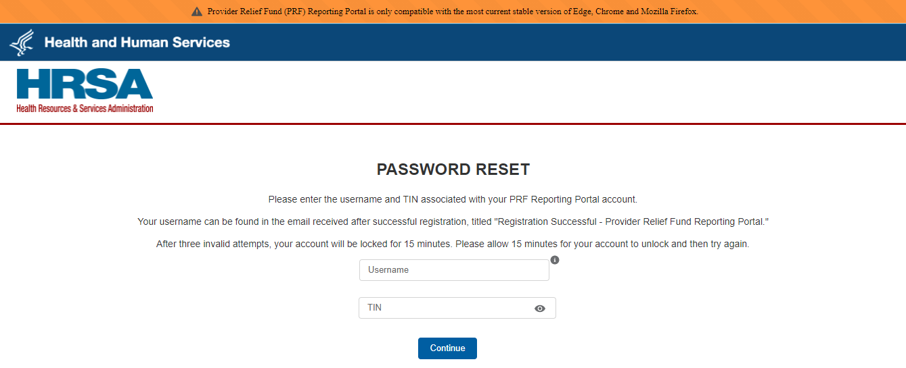

Figure 2 Password Reset

Entering a valid username and TIN will prompt the user to set a new password per the password policy as shown in *Figure 3 Password Policy*. If an invalid TIN is entered more than three times, the account will be locked for fifteen minutes before the provider can try again.

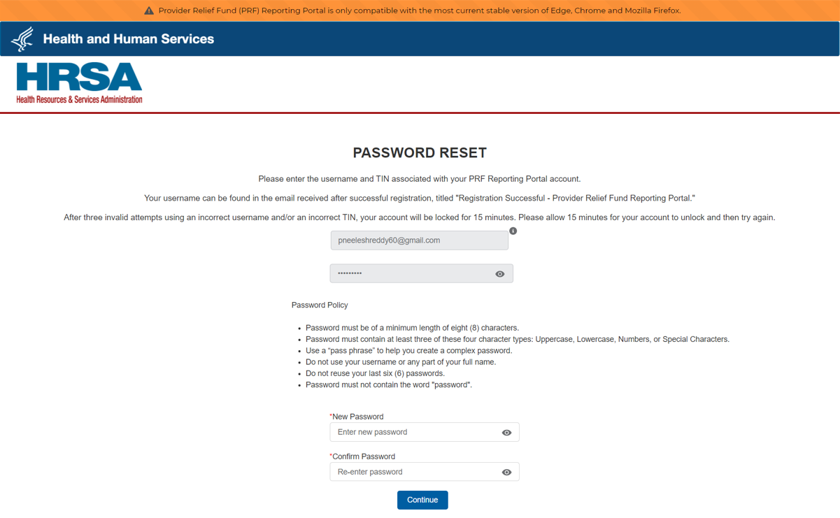

Figure 3 Password Policy

After the password is successfully reset, a pop-up window will appear with the message indicating a successful reset as shown in *Figure 4 Successful Password Reset Pop Up*. An email will also be sent to the user’s email for confirmation. Reporting Entities may contact the Provider Support Line at (866) 569-3522; for TTY dial 711 if they have forgotten their username or if they do not receive a link to reset their password. Hours of operation are 8 a.m. to 10 p.m. Central Time, Monday through Friday, when the portal is open for reporting. Hours are subject to change

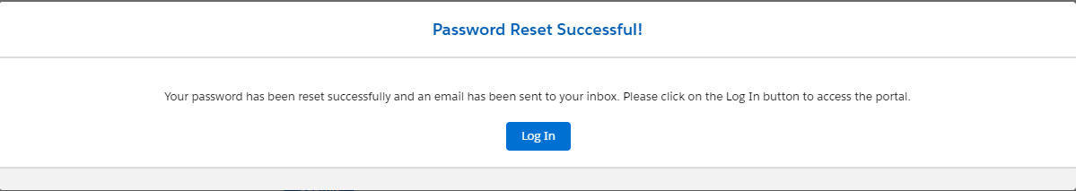

Figure 4 Successful Password Reset Pop Up

1. **Registration:** PRF Reporting Portal user registration is the first step in the reporting process. To begin registration, Reporting Entities should click the blue ‘Register’ button below the ‘First Time User?’ Click on 'Register' to create an account.’ heading. Reporting Entities must register for an account in the portal before reporting on the use of funds may begin. Reporting Entities should follow the steps in the [*PRF Reporting Portal User Guide – Registration*](https://hrsac19.my.salesforce.com/sfc/p/#t00000004XgP/a/t0000001FIcy/yU0WSf98g33mM6OuwWS2OK0mNwKY8cYwBK9PhP.2GoA) for detailed instructions on the registration process.
2. **Resources:** Reporting Entities are able to access important PRF resources on the Home Page. These resources may also be accessed using the blue ‘Resources & FAQs’ button in the upper right corner on all pages throughout the portal after successful login. Clicking the ‘Resources & FAQs’ button will open a new browser tab which will not affect previously entered data.
3. **Technical Questions and Language Assistance:** For technical questions regarding the use of the portal or questions regarding reporting that cannot be answered by this user guide or other available resources, Reporting Entities should contact the Provider Support Line. Provider Support Line contact information and hours of operation are found in the footer of the Reporting Portal Home Page and all subsequent pages. The footer also has other web links to standard government websites and language assistance.

# Navigation Within the Portal

After the successful login, users will be able navigate the portal through a series of pages in a sequential order – completing data entry for one step before proceeding to next. The progress can be observed by viewing the progress bar located at the top of each portal page as shown in *Figure 5 Progress Bar.* Blue circles represent steps that have been completed, a white circle with a blue outline represents the current step, and grey circles represent steps to be completed. It is not possible to skip steps to view subsequent pages.

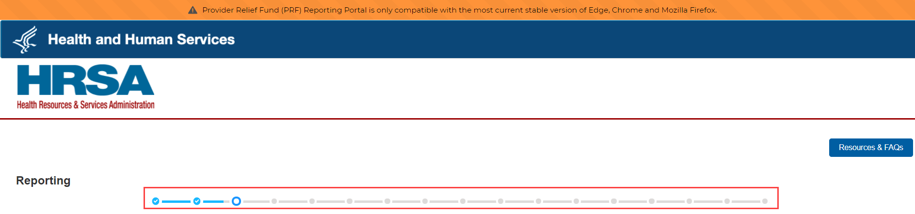

Figure 5 Progress Bar

Users can save partial information throughout the portal as long as they save the information on the current page by clicking on the blue ‘Save & Next’ or red ‘Save and Exit’ buttons as shown *Figure 6 Page Navigation*.Please note that the backward and forward navigation of the web browsers should not be used to navigate between steps. This will result in loss of data entered on the current page.



Figure 6 Page Navigation

Users can save information on the current page and advance to the next step by clicking the blue ‘Save & Next’ button, only if all required data fields are entered correctly without errors.

Users can return to a previous page by clicking the blue ‘Previous’ button. Please note that clicking on ‘Previous’ button without saving the information will result in data loss.

Users should exit the portal when they are not actively entering data by clicking the red ‘Save & Exit’ button. **Portal users should not exit the portal by closing the browser window or navigate away from the current page using the browser window as data entered on the current page will not be saved.**

To re-enter the portal, users will be required to log in using their username, TIN, and password. The portal will re-open on the first step (Entity Overview page) and all information previously saved will be evident. Click the blue ‘Save & Next’ button to navigate to the desired page to enter new data or correct any of the previously entered data fields.

Red asterisks (*) denote required data entry fields on each portal page. If a required data entry field has not been completed, a red error message will appear, and the user must correct the error before proceeding to the next page within the portal.

Tooltips (denoted asTooltip icon) provide additional information about the data fields such as definitions and specifications for formatting. Users should hover over the tooltip icon with their mouse ( Tooltip icon ) to learn additional details about the data entry fields. Reporting Entities should reference these tooltips before directing any questions to the Provider Support Line.

Each portal page will also have the blue ‘Resources & FAQs’ button in the upper right corner for Reporting Entities to easily reference helpful resources that are also available on the home page. This will open resources page in a new browser tab without losing data entered on the current page.

# Steps to Complete Reporting

After completing registration, a user will be able to log in to the [PRF Reporting Portal](https://prfreporting.hrsa.gov/) with their username, TIN and password. After successful login, users will land on a page showing their Active and Inactive Reports. Upon user selection of an active report, the user will be able navigate the portal through a series of steps in a sequential order – completing data entry for one step before proceeding to next.

## 4.1 Terms and Conditions

After entering the valid username, TIN, and password, users must certify that they have read and accept the PRF Reporting Portal Terms and Conditions by clicking on the radio button located to the left of the text ‘I have read and accept the terms and conditions.’ The ‘Next’ button will appear after the radio button is selected as shown in *Figure 7 Acceptance of Terms and Conditions*. Clicking ‘Next’ will enable the user to proceed to the next page.

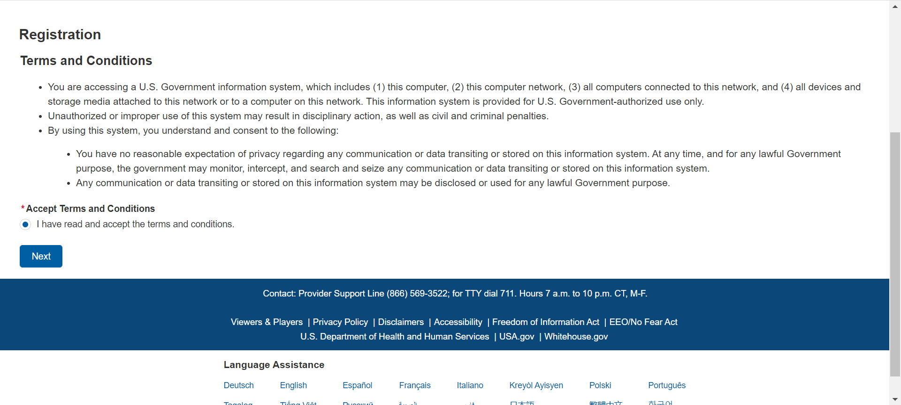

Figure 7 Acceptance of Terms and Conditions

## 4.2 Step 1 – Report Summary landing page

This page was added as a part of the **11/18/2021 release**. The Report Summary Landing Page is the first page displayed after the user has read and accepted the PRF Reporting Portal Terms and Conditions. It includes the user’s active and inactive reports along with the report status, reporting period dates, payments received dates, and funds available until dates. The purpose of this page is to provide a summary view of all reports which are organized into the Active and Inactive Reports tabs as shown in Figure 7.1 The Report Summary Landing Page.

The first tab labeled Active Reports displays reports within the current reporting period or if a report has been unlocked. Users will be able to access their active reports by clicking the report name within the Active Reports table.

The second tab labeled Inactive Reports displays reports for future and past reporting periods. If the reporting period has ended or if the reporting period has yet to begin, the associated report will be displayed in the Inactive Reports table.

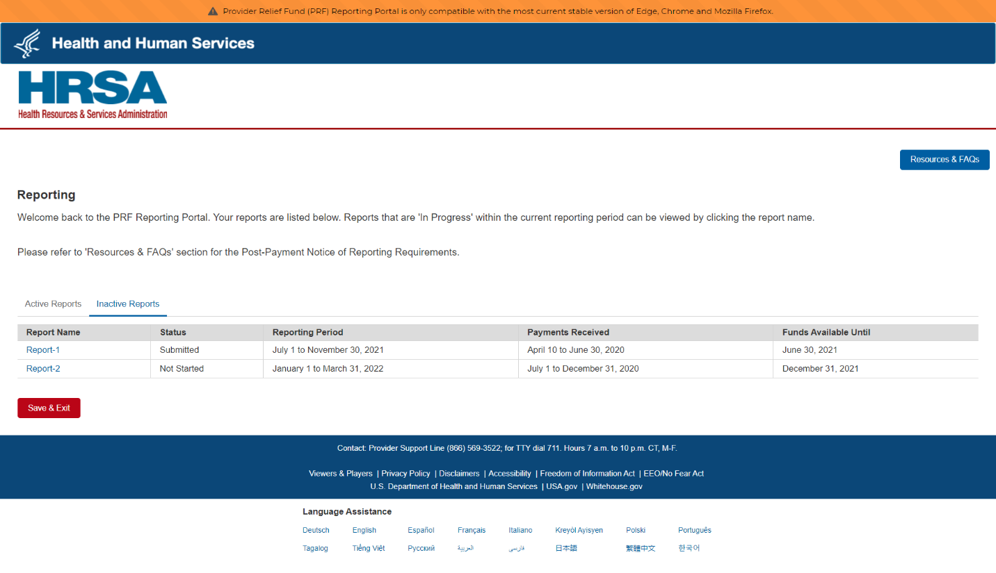

Figure 7.1 The Report Summary Landing Page

## 4.3 Step 2 – Entity Overview

The first step of reporting requires the Reporting Entity to confirm the pre-populated entity information provided during registration and add any new required information.

The first section of the page under the header ‘Entity Overview’ includes the following required fields: Tax Identification Number (TIN), Business Name, Provider Type (not pre-populated), and Provider Sub-Type (not pre-populated), as shown in *Figure 8 Entity Overview*. The TIN may not be changed and should be the TIN of the Reporting Entity. The Reporting Entity may also provide a Doing Business As Name (optional) which is not pre-populated.

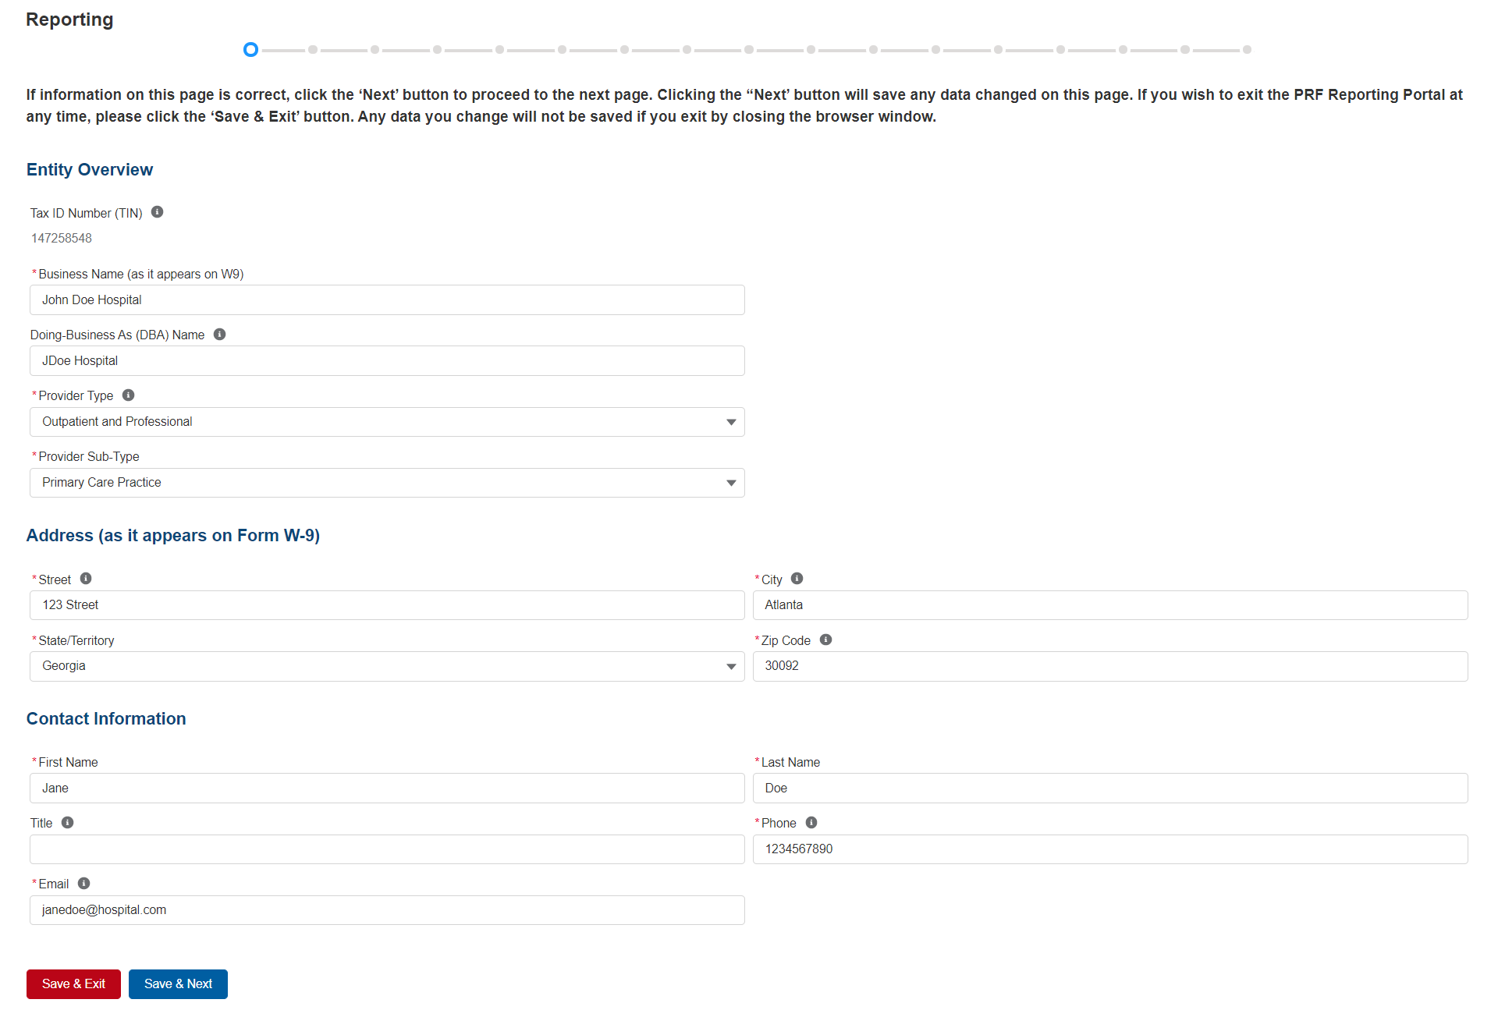

Figure 8 Entity Overview

Reporting Entities must select the Provider Type and Provider Sub-Type that best describes the type of practice by clicking the dropdown menus. The sub-types are conditional to the Provider Types. Select the combination that best describes the Reporting Entity’s type of business. If multiple Provider Types or Provider Sub-Types apply, choose the pair that reflects the majority of the business.

After the Entity Overview information, the Address (as it appears on IRS Form W-9) and Contact Information sections are shown. All of these data entry fields are pre-populated from registration. If any information has changed since registration, the Reporting Entity should update the fields. Address data entry fields are all required and include: Street, State/Territory (selected from a drop-down list), City, and ZIP code (entered as 5 numeric digits).

Contact information includes First Name, Last Name, Title (optional), Email, and Phone Number. The email address must be a valid, monitored email address as it will be used as part of the two-step authentication process every time users try to log in and will be used for communication that is necessary in the future, including but not limited to, questions about the reporting on the use of funds and return of unused funds.

**On this portal page, Reporting Entities should consider the following actions before saving:**

1. Confirm the information in the Entity Overview and Address by using the same information on the IRS Form W-9.
2. Ensure the contact email address is a valid, monitored email address.
3. Ensure portal users are able to log in to the portal in the future and receive future communications regarding reporting, by adding ‘[PRFReporting-NoReply@hrsa.gov](mailto:PRFReporting-NoReply@hrsa.gov) to the safelist of the contact email provided during the registration and reporting process.

If any of the information is missing, an error message(s), similar to one shown in Figure 9 Entity Overview – Field Validations, will be displayed.

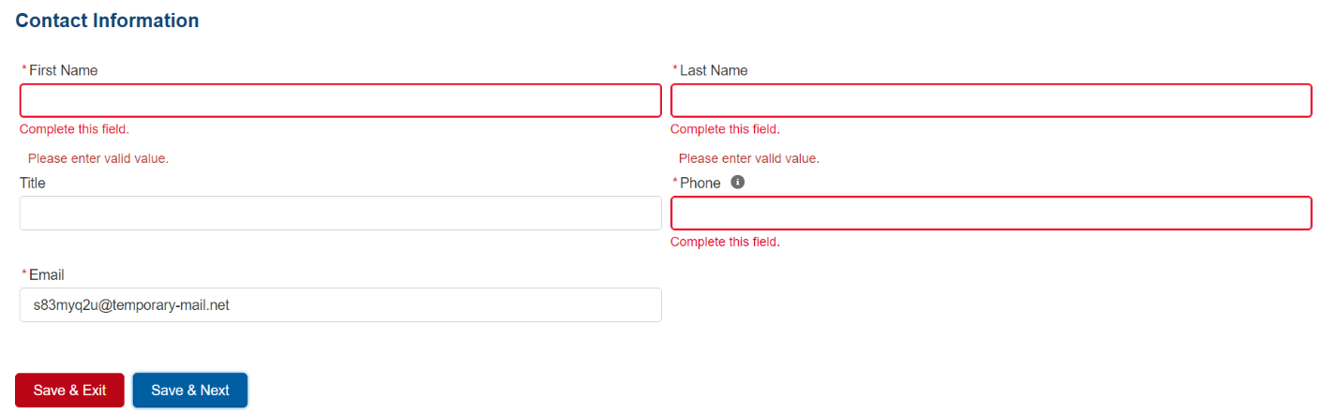

Figure 9 Entity Overview – Field Validations

Only after all of the required data entry fields in Step 1- Entity Overview are completed without any error messages, will users be able to advance to the next step in the reporting process. Portal users must click the blue ‘Save & Next’ button to proceed to the next page, Step 2 – Subsidiary Questionnaire.

## 4.4 Step 3 – Subsidiary Questionnaire

This page contains conditional questions that will affect how the Reporting Entity proceeds through the portal. The purpose of this page is to collect information about subsidiary entities for any Reporting Entities that are parent organizations and to collect information about parent entities for any Reporting Entities that are the subsidiary of a parent. Please refer to the [PRF website](https://www.hhs.gov/coronavirus/cares-act-provider-relief-fund/for-providers/index.html) for additional information regarding past payments, if needed.

To determine whether an entity is the parent organization, the entity must follow the methodology used to determine a subsidiary in their financial statements. If none, the entity with a majority ownership (greater than 50 percent) will be considered the parent organization.

The Subsidiary Questionnaire consists of four required questions with two conditional questions depending on the Reporting Entity’s answersas shown in *Figure 10 Subsidiary Questionnaire – Required and Conditional Questions*.

* Does the reporting entity have any subsidiaries that are eligible health care providers?[2] ***Note: It is very important that Reporting Entities answer this question correctly since this affects the data entry on the following page.***
* Did the reporting entity acquire or divest subsidiaries that are eligible health care providers and that received PRF payments during the period of availability of funds?[3] ***Note: It is very important that Reporting Entities answer this question correctly since this affects the data entry on the following page.***
* If the reporting entity is a subsidiary, will a parent entity report on any of the reporting entity’s General Distribution payment(s)?
  + (Conditional) If yes, the Reporting Entity will list nine-digit TIN(s) of the parent reporting on behalf of the reporting entity’s General Distribution payment(s).
* Were any Targeted Distribution payment(s) transferred to/by a parent entity?[4]
  + (Conditional) If yes, the Reporting Entity must enter the total dollar amount of Targeted Distribution payment(s) transferred to/by the parent entity. This is an aggregate amount if more than one TIN.

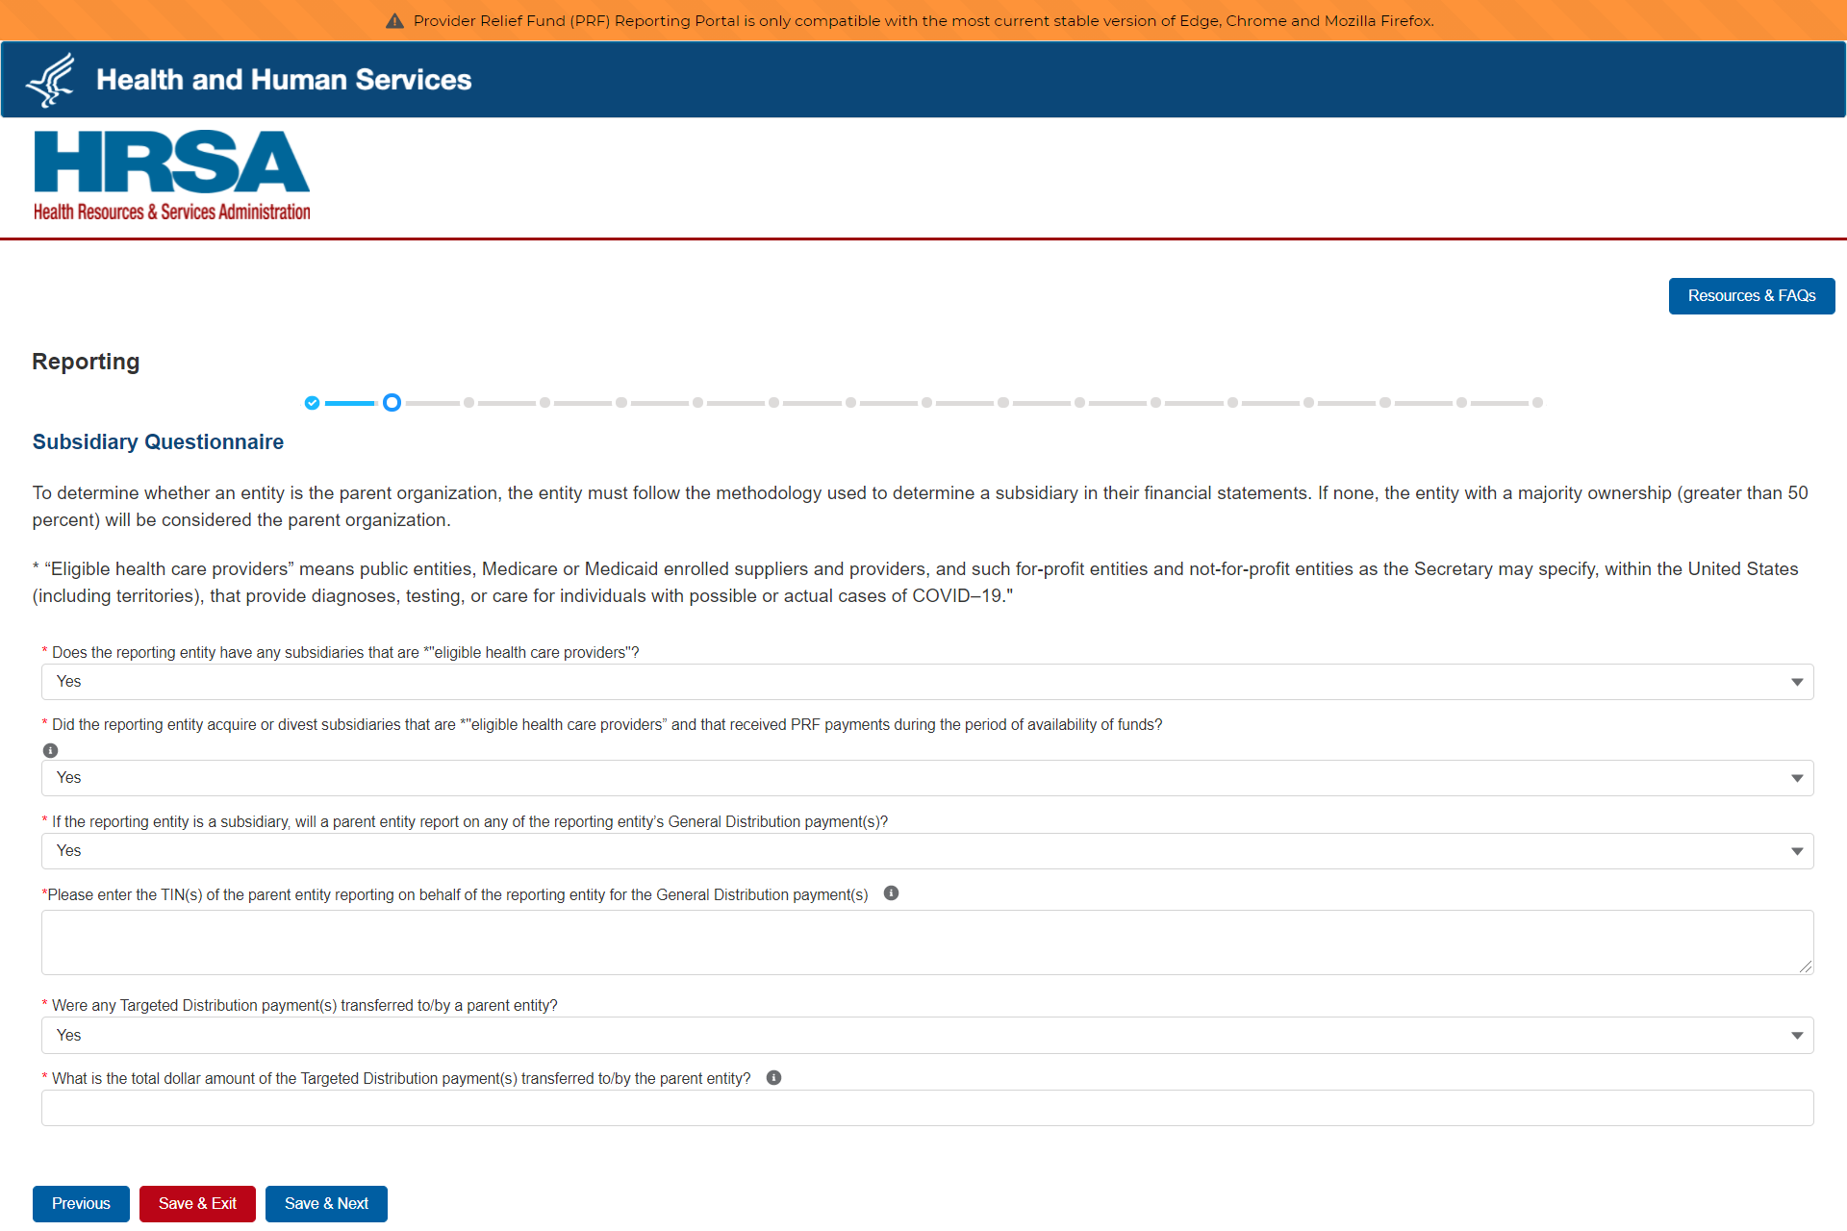

Figure 10 Subsidiary Questionnaire – Required and Conditional Questions

The Reporting Entity should answer all questions and click ‘Save & Next.’ If any of the questions are not completed, an error message ‘Complete this field.’ will appear in red under the missing field.

The Reporting Entity’s answers to the first and second questions determine the data fields on the next page. The Reporting Entity will be taken to Step 3 – Subsidiary Data, if answer to either of the following questions is ‘Yes’:

* “Does the reporting entity have any subsidiaries that are “eligible health care providers”?”
* “Did the reporting entity acquire or divest subsidiaries that are *“eligible health care providers” and that received PRF payments during the period of availability of funds?”

If the user answers ‘No’ to both questions, the user will be taken directly to Step 4 – Payments to Recipient.

Only after users have completed all of the required data entry fields without any error messages appearing in red, will they be able to advance to the next step in the reporting process. Users must click the blue ‘Save & Next’ button to proceed to the next page, Step 3- Subsidiary Data.

## 4.5 Step 4 – Subsidiary Data

Depending on the answers selected in Step 2 – Subsidiary Questionnaire, the Subsidiary Data page will render different data fields.

**Acquired/Divested Subsidiaries**

*Figure 11 Acquired/Divested Subsidiaries* will be shown only if the Reporting Entity selected ‘Yes’ to the second question “Did the reporting entity acquire or divest subsidiaries that are eligible health care providers and that received PRF payments during the period of availability of funds?” on Step 2 – Subsidiary Questionnaire.

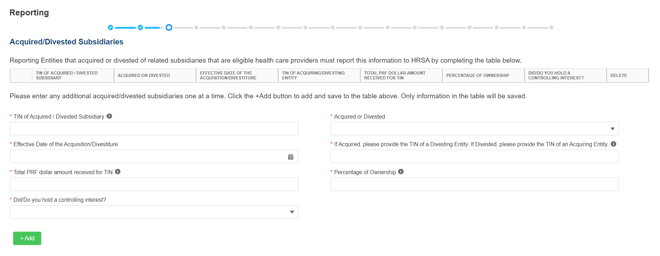

Figure 11 Acquired/Divested Subsidiaries

The Acquired/Divested Subsidiaries table will be blank and requires the Reporting Entity to complete it using the required input fields below the table. Reporting Entities should enter information about all acquisitions and divestitures during the period of performance.[5]

Reporting Entities that acquired or divested related subsidiaries (change of ownership) during the period of availability must indicate the change in ownership. Users will complete the subsidiary table by entering the following fields and then click the green ‘+Add’ button:

* TIN of Acquired/Divested Subsidiary: Users must enter the nine-digit TIN of the subsidiary. Special characters may not be used. The Reporting Entity will need to add the subsidiary TIN to the table even if the subsidiary did not receive and/or transfer a PRF payment.
* Acquired or Divested? Users must choose Acquired or Divested from the dropdown list.
* Effective Date of the Acquisition/Divestiture: The effective date should fall within the period of availability.
* If acquired, provide the TIN of a Divesting Entity. If divested, provide the TIN of an Acquiring Entity. The TIN should be nine-digits with no special characters.
* Total Dollar Amount Received for TIN: The dollar amount entered may be up to 14 digits including two decimal places with no special characters. A dollar sign will auto-populate within the table.
* Percentage of Ownership: The percentage amount must be a whole number. Special characters may not be used.
* Did/Do you hold a controlling interest?: Select ‘Yes’ or ‘No’ from the dropdown list.

Once all input fields are complete, the user should press the green ‘+Add’ button to populate the table. Upon clicking ‘+Add’, a number of data entry validations are run on the input fields. If any errors occur, red messages will appear under the applicable input field. The same TIN cannot be added to the table more than once and if a TIN needs to be removed, the user must click on the trash bin (Delete icon) icon at the end of each row of the table. When clicked on trash bin (Delete icon) icon, a confirmation pop-up as shown in *Figure 12 Delete Confirmation* be displayed.

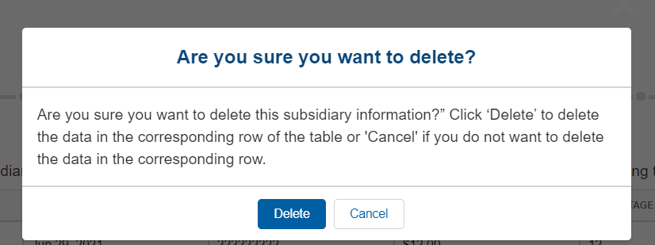

Figure 12 Delete Confirmation

If the user has not completed a required field, a red error message will appear below the required data entry fields. The user will not be able to proceed to the next page until all required fields have been completed without errors as shown in *Figure 13 Acquired/Divested Table - Required Field Validations*.

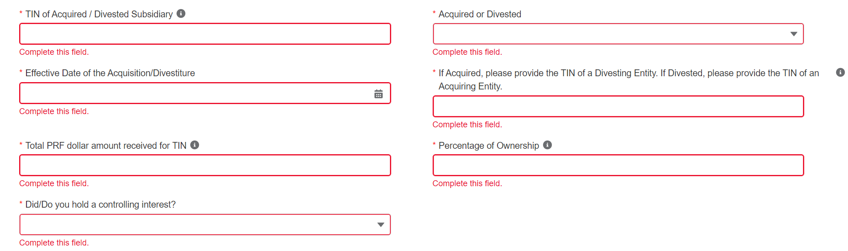

Figure 13 Acquired/Divested Table - Required Field Validations

**Subsidiary Information**

*Figure 14 Subsidiary Information Table* will be shown only if the Reporting Entity selected ‘Yes’ to the first question “Does the reporting entity have any subsidiaries that are *"eligible health care providers"?” on Step 2 – Subsidiary Questionnaire*.*

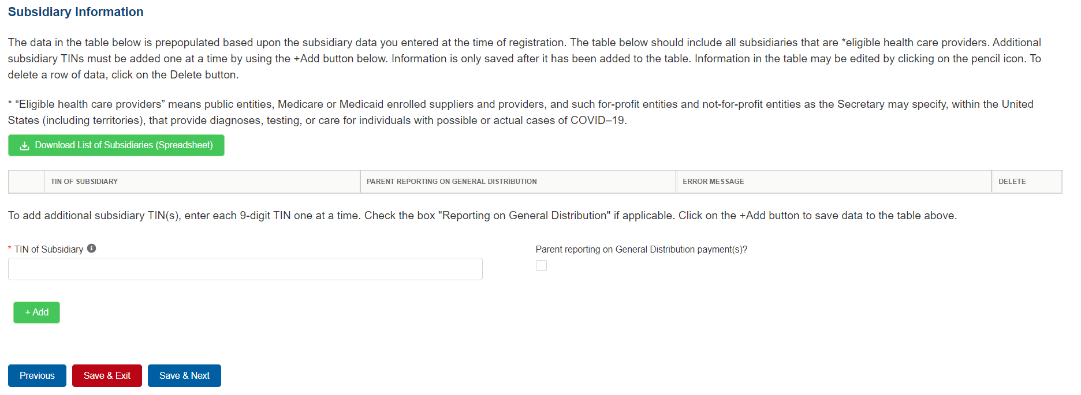

Figure 14 Subsidiary Information Table

The Subsidiary Information table will be prepopulated if one or more subsidiary TINs were provided during registration. If no subsidiary TINs were provided during registration, the table have a title row but will otherwise have no data. Reporting Entities must complete the table by using the required input fields below the table. **Reporting Entities must add all subsidiaries that meet the definition of “eligible health care providers,” even if there is no General Distribution payment to report on and even if subsidiaries did not receive a PRF payment.**

**For the purposes of PRF reporting, “eligible health care providers” are defined as public entities, Medicare or Medicaid enrolled suppliers and providers, and such for-profit entities and not-for-profit entities as the Secretary may specify, within the United States (including territories), that provide diagnoses, testing, or care for individuals with possible or actual cases of COVID–19.**

To add a subsidiary to the table, the Reporting Entity must enter a 9-digit TIN; and, if applicable, check the box “Parent reporting on General Distribution payment(s)?”. **Information is only saved after it has been added to the table.** Once the tables are complete, they will not be saved until the red ‘Save & Exit’ or blue ‘Save & Next’ button is clicked.

**To assist with the reporting process, Reporting Entities have the option to download a list of subsidiaries as a spreadsheet after completing the table by clicking the ‘Download List of Subsidiaries (Spreadsheet).’ This summary can be used to confirm the correct TIN(s) of subsidiaries have been entered. It is very important that the table of subsidiaries is correct because the Reporting Entity will only be able to report on a subsidiary’s PRF payment if the subsidiary TIN is correct in this table.**

If the portal user has not completed the ‘TIN of Subsidiary’ field, a red error message will appear as shown in *Figure 15 Subsidiary Information Table - Required Field Validation.* The user will not be able to proceed to the next page until the field has been completed without errors.

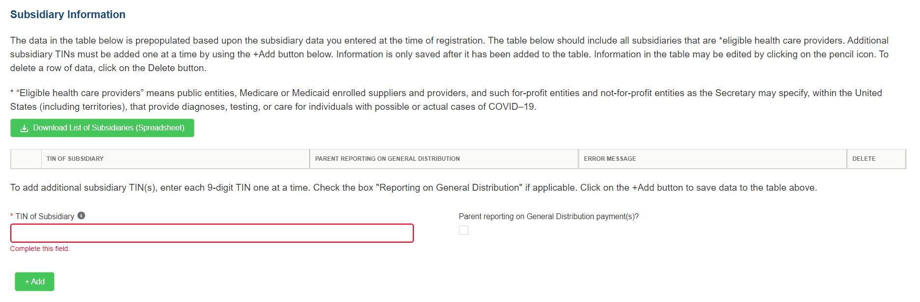

Figure 15 Subsidiary Information Table - Required Field Validation

After the table has been populated, the ‘TIN’ and ‘Reporting on General Distribution’ may be edited by clicking on the pencil icon (Edit icon ). If there is a mistake in the table, the subsidiary may be completely deleted from the table by clicking on the trash bin icon (Delete icon ). A pop-up confirmation will appear asking if the deletion is needed.

Users should add a ‘TIN of Subsidiary’ into the table using the input fields, by selecting if the TIN is a “Parent reporting on General Distribution payment(s)?” and pressing the green ‘+Add’ button. The TIN will be inserted into the table and automatically validated against HRSA’s PRF payment file. If the subsidiary TIN did not receive a PRF payment in the corresponding Payment Received Period, the message "TIN not found in the PRF payment file” is shown in the ‘Error Message’ column. TINs with error messages are automatically moved to the top of the table for easy identification. Reporting Entities should keep in mind that they are required to enter subsidiary TINs of eligible health care providers, but they do not need to check the box ‘reporting on General Distribution payment’ for TINs without payments in the current reporting period. After users have completed all of the required data entry fields, they will be able to advance to the next step in the reporting process, Step 4 - Payments to Recipients. Users must click the blue ‘Save & Next’ button to proceed to the next page.

## 4.6 Step 5 – Payments to Recipient

The user is directed to the Payments to Recipient page after successfully completing Step 3 – Subsidiary Data or if they answered ‘No’ to the following questions in Step 2 – Subsidiary Questionnaire:

* Does the reporting entity have any subsidiaries that are "eligible health care providers"?
* Did the reporting entity acquire or divest subsidiaries that are eligible health care providers and that received PRF payments during the period of availability of funds?

The tables of information presented in Step 4- Payments to Recipients highlight the payments made to the Reporting Entity (and its subsidiaries, if applicable) within the Payment Received Period that corresponds to the current Reporting Period as shown in Table 1 Reporting Periods*.* Information is pre-populated, including the type of distribution. ***As a reminder, payments made to subsidiaries will be included in the summary tables based on the subsidiary information entered on the previous Subsidiary Data page.***

The user may download a spreadsheet with all payment information shown on this page by clicking the green ‘Provider Relief Fund Payments (Spreadsheet)’ button as shown in *Figure 16 Provider Relief Fund Payments (Spreadsheet).* This functionality is intended to assist portal users in reconciling the payment amounts for the reporting period and the download is recommended but not required.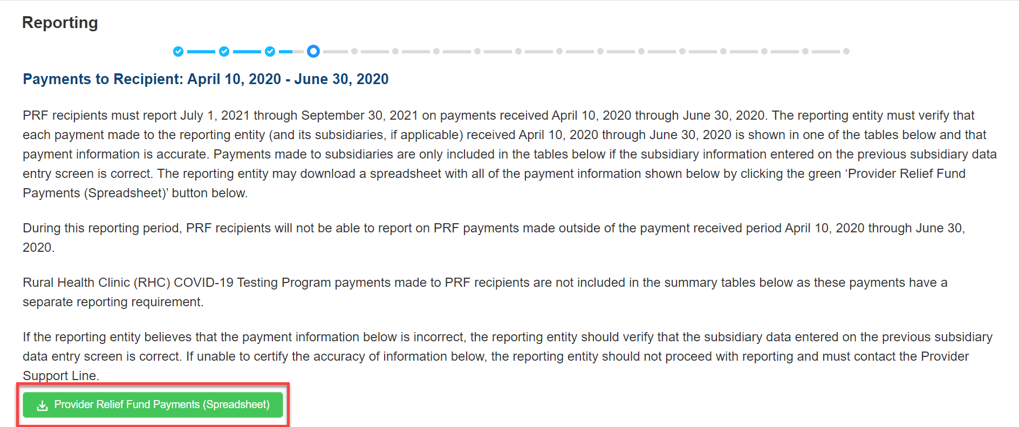

Figure 16 Provider Relief Fund Payments (Spreadsheet)

The tables displayed on this portal page summarize all payments made during the Payment Received Period corresponding to the Reporting Period:

* 1. Total Nursing Home Infection Control Payments (includes Quality Incentive Program (QIP) payments)[6]
  2. **Total Other PRF Payments (*i.e.,* all General Distribution payments and Other Targeted Distribution Payments)**
  3. Total Rejected Payments (Attestation Rejected).[7] Rejected payments are not included in the total payments on which Reporting Entities are required to report. *Please note, if the attestation was rejected, the recipient should have returned the payment within 15 days of the rejection in accordance with the payment Terms and Conditions. PRF recipients that do not return payments in a timely manner will be sent to debt collection.*

Each table on the Payments to Recipient page will have column headers and payment information if a payment was received during the corresponding Payment Received Period. The payment period summary table can be used to confirm for each payment: (1) TIN of recipient, (2) distribution type[8], (3) (dollar) amount deposited (*i.e.,* amount of original payment), (4) (dollar) amount returned (by recipient), (5) dollar amount retained (calculated as amount deposited – amount returned), and (6) attestation date. The Attestation Date field will be blank if the attestation was accepted by default. If a recipient retains a PRF payment for at least 90 days without attesting to or rejecting the payment Terms and Conditions, the recipient is deemed to have accepted the Terms and Conditions by default.

Nursing Home Infection Control payments are separated from all General Distribution and other Targeted Distribution payments because the funds may only be used for specific purposes as indicated in the payment Terms and Conditions. Reporting Entities will report on the expenses for the Nursing Home Infection Control payments separately from expenses for other payments.

The Reporting Entity must certify the accuracy of the information at the bottom of this page before preceding to the next step of reporting. If the information is accurate, users must select ‘Yes’ and click the ‘Save & Next’ button as shown in *Figure 17 Certify Accuracy of Information.*



Figure 17 Certify Accuracy of Information

If the information is not accurate, portal users should select ‘No’ and provide a description of the reason the information is inaccurate in the ‘Dispute Comments’ data entry field as shown in *Figure 18 Certify Accuracy of Information- Dispute Comments.* This field will appear only if ‘No’ is selected. The Reporting Entity must enter a text narrative in the Dispute Comments field and click ‘Save & Next’. The portal user is then asked to call the Provider Support Line to resolve the incorrect payment data. **The Reporting Entity must resolve the dispute as soon as possible as they will be unable to proceed to the next step in the reporting process until the dispute is resolved.** To resolve the dispute, the Reporting Entity must: 1) **complete the Dispute Comments data entry field, and 2)** call the Provider Support Line at (866) 569-3522; for TTY dial 711. Hours of operation are 8 a.m. to 10 p.m. Central Time, Monday through Friday, when the portal is open for reporting. **Users should note that the dispute comment is not sent to HRSA but is a way for the user to take notes on information they believe is inaccurate.***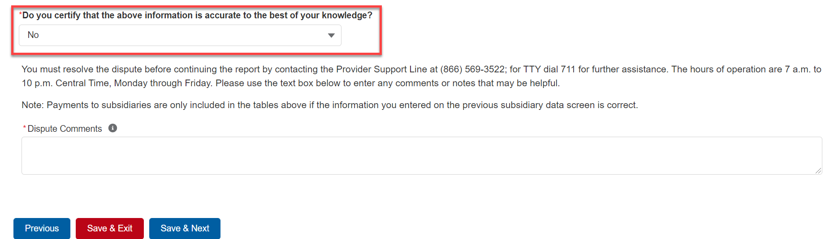*

Figure 18 Certify Accuracy of Information- Dispute Comments

Once providing dispute comments and clicking ‘Save& Next’, the user will see the pop-up as displayed in *Figure 19 Contact Provider Support Pop-Up*.

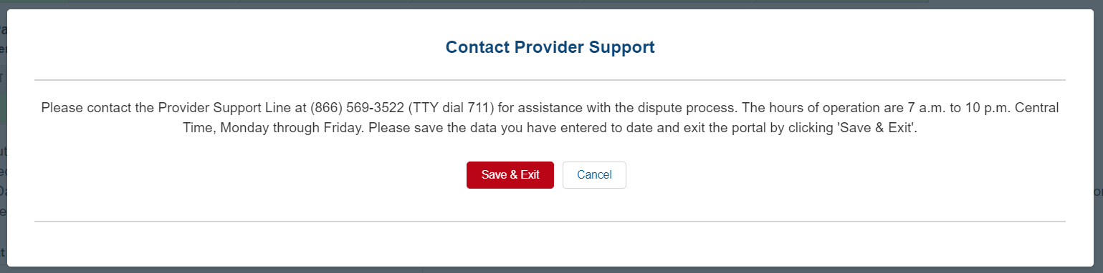

Figure 19 Contact Provider Support Pop-Up

**The Reporting Entity will be able to proceed with the reporting process only after the user is able to certify the accuracy of the information on this portal page.**

If a Reporting Entity certifies that the information on this portal page is accurate but has not received PRF payments exceeding **$10,000 in the aggregate during the Payment Received Period** corresponding to the Reporting Period as shown in Table 1 Reporting Periods, the reporting process will not proceed and the user will receive a pop-up message as shown in Figure 20 $10,000 or Less Pop-Up. Reporting Entities will not be able to report on the use of funds if their payments during the Payment Received Period do not exceed $10,000 in the aggregate. Users should click ‘Save & Exit’ to return back to the Reporting Portal Home Page if they are not required to report.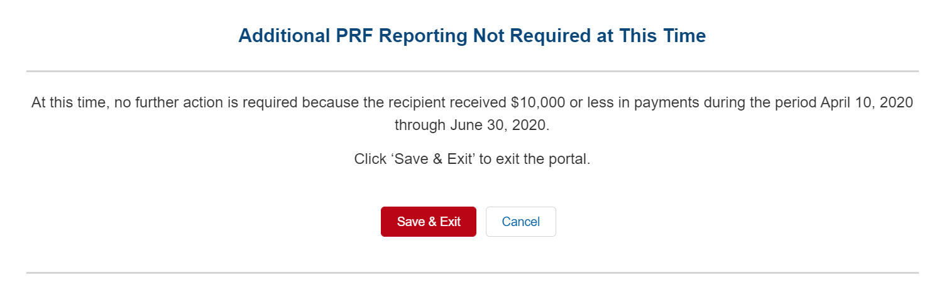

Figure 20 $10,000 or Less Pop-Up

Only after Reporting Entities have certified the accuracy of the information on this portal page will they be able to advance to the next step in the reporting process, Step 5- Interest Earned on PRF Payments, Tax Information, and Single Audit Information. Portal users must click the blue ‘Save & Next’ button to proceed to the next page.

## 4.7 Step 6 – Interest Earned on PRF Payments, Tax Information, and Single Audit Information

**Interest Earned**

If a Reporting Entity received more than $10,000 in aggregate in PRF payments for the Payment Received Period corresponding to the current reporting period, the Reporting Entity is directed to Step 5 – Interest Earned on PRF Payments, Tax Information, and Single Audit Information. On this page, the Reporting Entity is required to answer questions regarding interest earned on PRF payments received, tax information, and single audit information as shown in *Figure 21 Interest Earned on PRF Payments, Tax Information and Single Audit Information*.

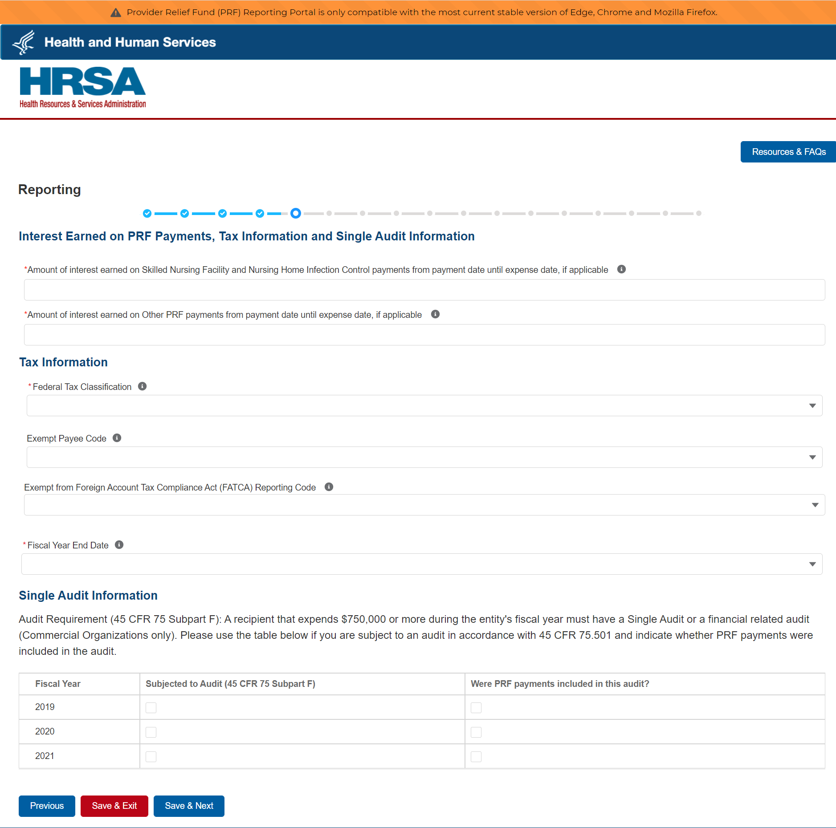

Figure 21 Interest Earned on PRF Payments, Tax Information and Single Audit Information

If PRF payments were held in an interest-bearing account, these interest amounts must be reported to HRSA and must be used only for allowable expenses or lost revenues. If interest is earned on PRF payments received in the Payment Received Period corresponding to the current reporting period, interest must be applied toward a reportable use of funds.[9] Interest should be calculated from the date the payment was received until the date of expenditure (or the date of return in the case of unused PRF payments). Interest must be broken down into two categories: (1) total amount of interest earned on Nursing Home Infection Control payments (if applicable), and (2) total amount of interest earned on all other PRF payments. The total amount of interest reported must be a number with up to two decimal points. A zero (0) value must be entered if the PRF payments were not held in an interest-bearing account or if no interest was earned on the payments.

**Federal Tax Classification**

The Reporting Entity must select from a dropdown list to choose the federal tax classification, the designated business type associated with the Reporting Entity’s primary TIN used for filing taxes. The Reporting Entity may refer to IRS Form W-9 for information regarding the federal tax classification, Exempt Payee Code (optional), and Exempt from Foreign Account Tax Compliance Act status (optional). Federal tax classification may be reported as Individual/Sole proprietor or Single-Member LLC, C Corporation, S Corporation, Partnership, Trust/Estate, or Other. If the Reporting Entity selects ‘Other,’ a new data entry field will appear and the Reporting Entity will have to specify the designated business type as shown in *Figure 22 Federal Tax Classification*. The Reporting Entity may opt to enter the same Exempt Payee Code and Exempt from Foreign Account Tax Compliance Act (FATCA) Reporting Code as designated on their IRS Form W-9. The dropdown lists for these fields are the same as the available selections on IRS Form W-9.

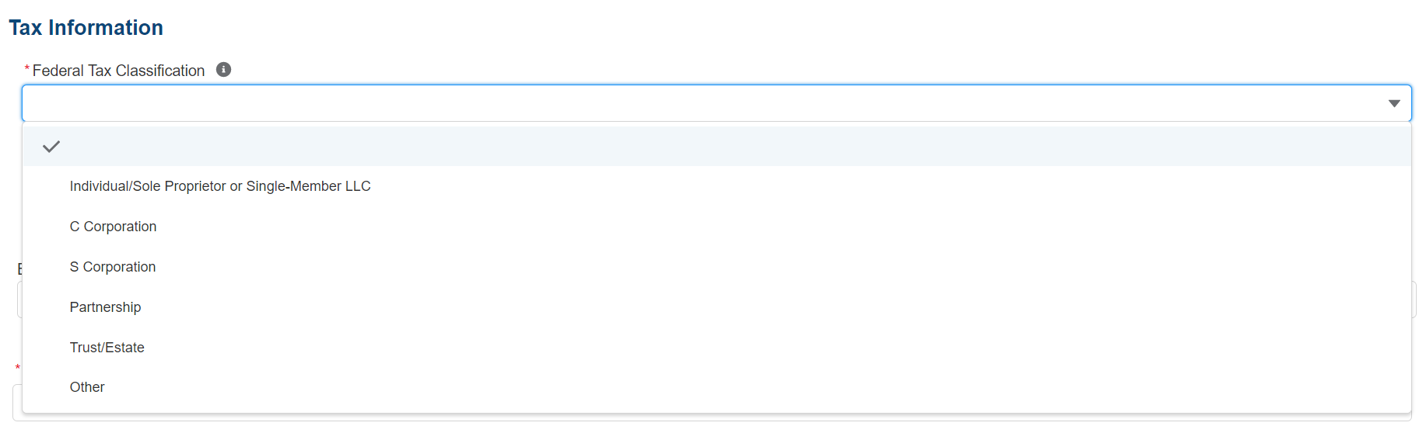

Figure 22 Federal Tax Classification

The Reporting Entity must select from the dropdown list the Fiscal Year End Date that accurately matches the month in which the Reporting Entity reports its fiscal year financial results as shown in *Figure 23 Fiscal Year End Date*. If the fiscal year end date has changed, the Reporting Entity should enter the fiscal year end date applicable at the time of reporting.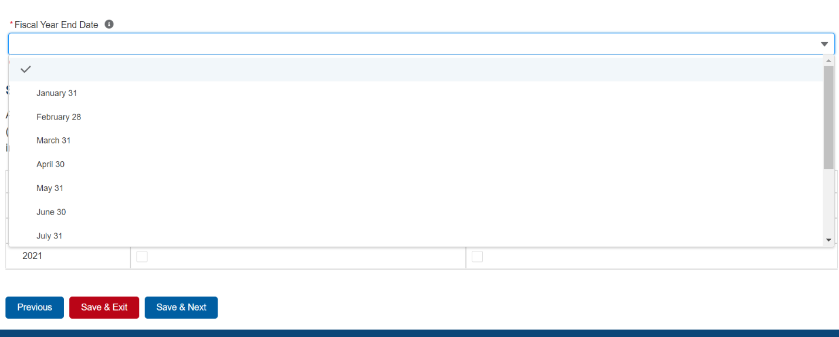

Figure 23 Fiscal Year End Date

**Single Audit Information**

Recipients that expend a total of $750,000 or more in federal funds (including PRF payments and other federal financial assistance) during their fiscal year are subject to Single Audit requirements, as set forth in the regulations at 45 CFR § 75 Subpart F.

Non-federal entities must have a Single Audit conducted in accordance with 45 CFR § 75.514 that must be submitted electronically to the [Federal Audit Clearinghouse](https://facweb.census.gov/uploadpdf.aspx).

Commercial organizations have two options under 45 CFR § 75.216(d) and § 75.501(i): 1) a financial related audit of the award or awards conducted in accordance with Generally Accepted Government Auditing Standards; or 2) an audit in conformance with the requirements of 45 CFR § 75.514 - Single Audit). Audit reports of commercial organizations must be submitted via email to HRSA’s Division of Financial Integrity at [PRFaudits@hrsa.gov](mailto:PRFaudits@hrsa.gov).

The Reporting Entity must complete the Audit Requirement table on this portal page by indicating for Fiscal Years 2019, 2020, and 2021, whether the recipient was subject to audit (45 CFR § 75 Subpart F) and whether PRF payments were included in the audit by checking the appropriate boxes. While these data entry fields must be completed accurately, the fields should only be checked as appropriate.

Only after users have completed all of the required data entry fields without any error messages appearing in red, will they be able to advance to the next step, Step 6 – Payments Summary, in the reporting process. Users must click the blue ‘Save & Next’ button to proceed to the next page, Step 6 – Payments Summary. To return to a previous page, users should click the blue ‘Previous’ button. Portal users should exit the PRF Reporting Portal when they are not actively entering data and should do this by clicking the red ‘Save & Exit’ button. **Portal users should not exit the portal by closing the browser window or navigate away from the current page using the browser window as data entered on the current page will not be saved.**

## 4.8 Step 7 – Payments Summary

The Payments Summary page is pre-populated based on the Reporting Entity’s answers to previous questions and payments received during the Payment Received Period which corresponds to the current Reporting Period as shown in Table 1 Reporting Periods. There is no validation or data entry required on this page. The Reporting Entity should review the dollar amounts shown and click ‘Save & Next’ if all amounts are correct. If the payment information does not appear correct, the Reporting Entity should navigate to the previous pages and ensure that data was entered correctly.

The Step 6 – Payments Summary page will display total reportable payment amounts as shown in *Figure 24 Payments Summary: April 10, 2020 - June 30, 2020*.The reportable payment amounts do not include payments received by the Reporting Entity and/or its subsidiaries outside of the current reporting period or where the attestation for the payment was rejected.

PRF payments received and retained are reportable as is any interest earned on those payments. The summary on this page includes the following:

* Total Nursing Home Infection Control Distribution (includes Quality Incentive Program) Payments[10]
* Total Other PRF Payments (includes all General Distributions and all Other Targeted Distribution Payments)
* Total Interest Earned on Nursing Home Infection Control Payments (as reported during Step 5 – Interest Earned on PRF Payments, Tax Information, and Single Audit Information)
* Total Interest Earned on Other PRF Payments (as reported during Step 5 – Interest Earned on PRF Payments, Tax Information, and Single Audit Information)
* Gross PRF Payments (including interest earned) – Calculated as Total Nursing Home Infection Control Payments + Total Other PRF Payments + Total Interest Earned on Nursing Home Infection Control Payments + Total Interest Earned on Other PRF Payments
* Total PRF Returned Payments
* Total Reportable Nursing Home Infection Control Payments – Calculated as Total Nursing Home Infection Control Payments + Total Interest Earned on Nursing Home Infection Control Payments
* Total Reportable Other PRF Payments – Calculated as Total Other PRF Payments + Total Interest Earned on Other PRF Payments
* Total Reportable PRF Payments – Calculated as Total Reportable Nursing Home Infection Control Payments + Total Reportable Other PRF Payments

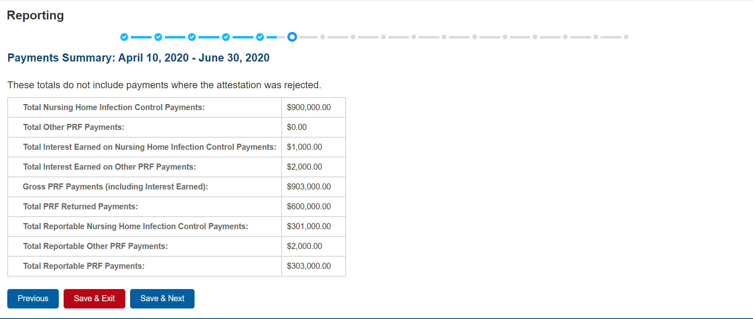

Figure 24 Payments Summary: April 10, 2020 - June 30, 2020

Users must click the blue ‘Save & Next’ button to proceed to the next page, Step 7- Other Assistance Received. To return to a previous page, users should click the blue ‘Previous’ button. Portal users should exit the PRF Reporting Portal when they are not actively entering data and should do this by clicking the red ‘Save & Exit’ button. **Portal users should not exit the portal by closing the browser window or navigate away from the current page using the browser window as data entered on the current page will not be saved.**

## 4.9 Step 8 – Other Assistance Received

The Step 7 – Other Assistance Received page is comprised of one large table where Reporting Entities must report other related assistance received by the Reporting Entity (and its subsidiaries included in reporting as applicable) during the period of availability that corresponds to the current reporting period. (*Table 1 Reporting Periods*) as shown in *Figure 25 Other Assistance Received.* The information reported in this table is not used in subsequent calculations in the portal. The 'tab' key may be used to navigate between cells during data entry. All cells are required data entry fields, and entries are restricted to 14 digits including up to 2 decimals. Negative numbers may not be entered. If zero, the reporting entity must enter a ‘0.’ If the Reporting Entity is reporting on behalf of subsidiaries, the assistance received for each category must be aggregated across each of the subsidiaries included in the report. The Other Assistance Received reported to HRSA will not be used in the calculation of expenses or lost revenues. Reporting Entities are expected to make a determination of their expenses applied to PRF payments after considering Other Assistance Received and taking into account that PRF payment may not be used for expenses or lost revenues that other sources have reimbursed or that other sources are obligated to reimburse.

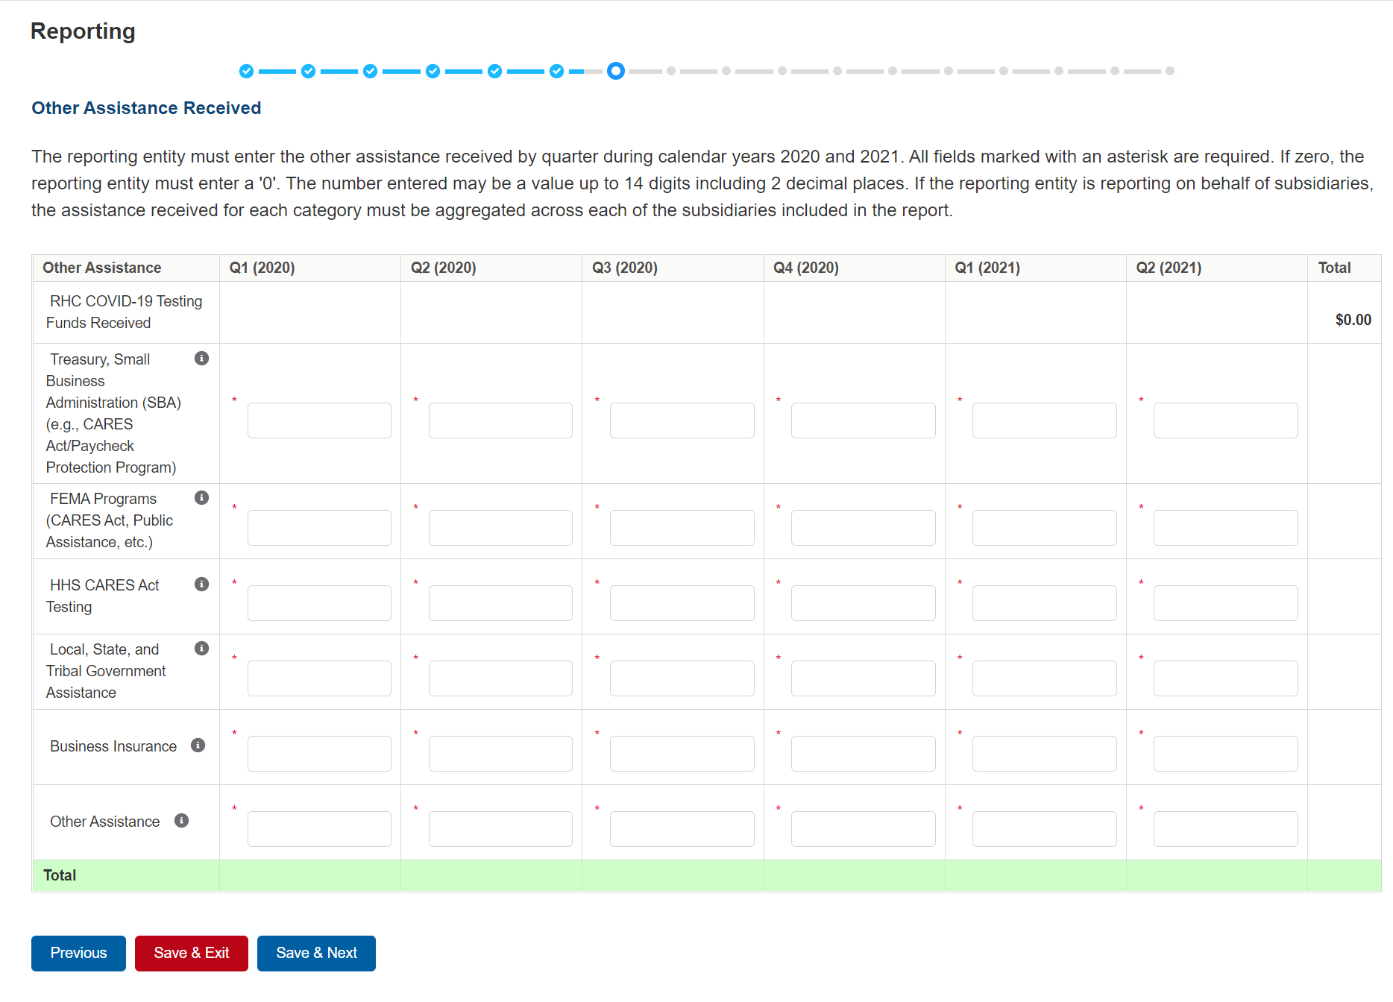

Figure 25 Other Assistance Received

The Reporting Entity must enter other assistance received by calendar year quarters in the period of availability of funds for the payments received in the Payment Received Period that corresponds to the current reporting period. Calendar year quarters are defined as follows:

* Quarter 1 (Q1): January 1 – March 31
* Quarter 2 (Q2): April 1 – June 30
* Quarter 3 (Q3): July 1 – September 30
* Quarter 4 (Q4): October 1 – December 31

Other Assistance Received will be reported for the period of availability by calendar year quarter for the Reporting Entity (and its subsidiaries included in reporting) as follows:

* **Department of the Treasury (Treasury) and/or Small Business Administration (SBA) Assistance:** Total amount of coronavirus-related relief received from Treasury and/or SBA, including the Paycheck Protection Program, by the Reporting Entity during the period of availability.
* **Federal Emergency Management Agency (FEMA) Programs**: Total amount of coronavirus related relief received from FEMA by the Reporting Entity during the period of availability.
* **HHS CARES Act Testing:** Total amount of relief received from HHS by the Reporting Entity for coronavirus testing-related activities during the period of availability.
* **Local, State, and Tribal Government Assistance:** Total amount of coronavirus-related relief received by the Reporting Entity from other Local, State, or Tribal government sources during the period of availability.
* **Business Insurance:** Paid claims against insurance policies intended to cover losses related to various types of health care business interruption during the period of availability.
* **Other Assistance:**  Total amount of other federal and/or coronavirus-related assistance received by the Reporting Entity during the period of availability.

*Note: If the Reporting Entity received funds from the Rural Health Clinic (RHC)* *COVID-19 Testing Program or the RHC COVID-19 Testing and Mitigation Program, the total dollar amount received will be pre-populated in the table of Other Assistance Received in the first row. RHC COVID-19 Testing Program and RHC COVID-19 Testing and Mitigation Program* payments are not PRF payments. *If you received Rural Health Clinic (RHC) COVID-19 Testing funds, you are required to report separately on the use of those funds at* [*https://www.rhccovidreporting.com*](https://www.rhccovidreporting.com)*.*

An error message in red will appear if the required fields are missing information or are not formatted properly as shown in *Figure 26 Other Assistance Received – Error Message*. Automated calculations will appear by row and column.

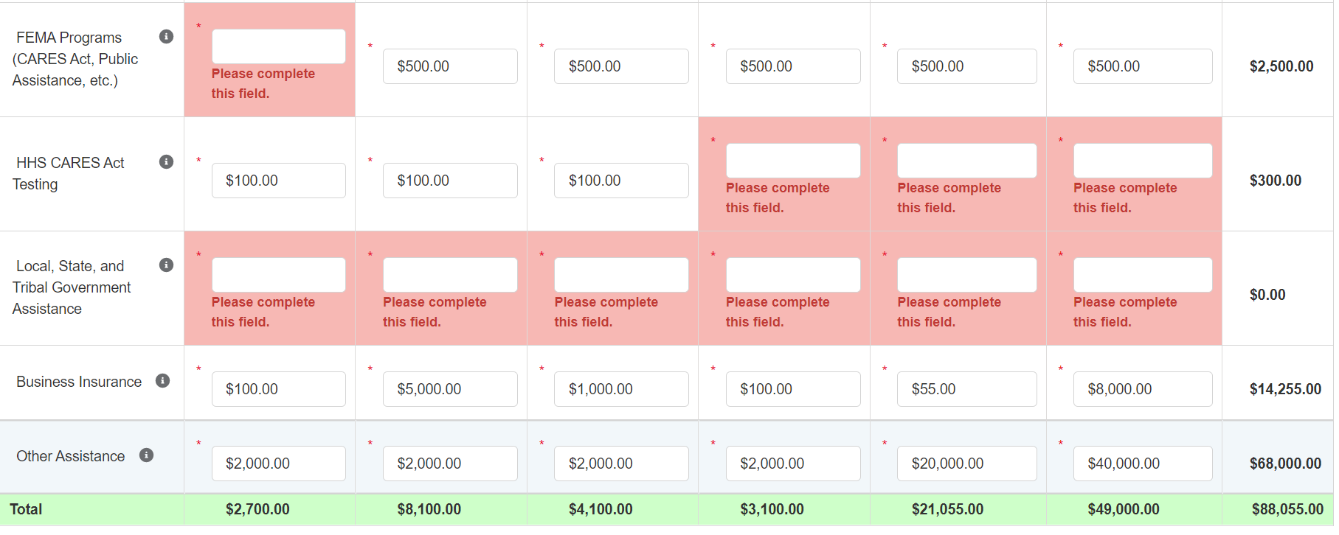

Figure 26 Other Assistance Received – Error Message

There is a Conditional Question for Reporting Entities (and their subsidiaries included in reporting) that received an RHC payment. The question requires that a ‘Yes’ or ‘No’ response be selected from a dropdown menu to answer, ‘Did you report on the use of your RHC COVID-19 Testing funds in the RHC portal?’

Users must click the blue ‘Save & Next’ button to proceed to Step 8 – Nursing Home Infection Control Expenses for Payments Received During Reporting Period. To return to a previous page, users should click the blue ‘Previous’ button. Portal users should exit the PRF Reporting Portal when they are not actively entering data and should do this by clicking the red ‘Save & Exit’ button. **Portal users should not exit the portal by closing the browser window or navigate away from the current page using the browser window as data entered on the current page will not be saved.**

## 4.10 Step 9 – Nursing Home Infection Control Expenses for Payments Received during Payment Period

After Step 7 – Other Assistance Received is complete, the Reporting Entity is directed to report on the use of Nursing Home Infection Control Distribution payments[11] received during the Payment Received Period that corresponds to the current Reporting Time Period. If the Reporting Entity did not receive Nursing Home Infection Control Payments during the applicable Payment Received Period, this page will be skipped and the user will be taken directly to Step 9 – Other PRF Expenses for Payments Received During Payment Period.

The Total Reportable Nursing Home Infection Control Distribution payment amount is shown in **bold** above the table and corresponds to the same value displayed in Step 6 – Payments Summary. The total dollar value of expenses reported on this page may not exceed the dollar value of the Total Reportable Nursing Home Infection Control Payments.

The Reporting Entity will report on the use of all Nursing Home Infection Control Distribution (including QIP) payments by entering the calendar year quarterly expenses unreimbursed by other sources and that other sources were not obligated to reimburse that were applied to these payments. The 'tab' key may be used to navigate between cells during data entry. All data entry fields must be completed, each cell is limited to 14 digits, including up to 2 decimal places, and all values must be positive. If expenses are zero, the Reporting Entity must enter a ‘0.’ Totals will automatically calculate by corresponding column and row as information is entered. Expenses must be reported by calendar year quarter.

Calendar year quarters are defined as follows:

* Quarter 1 (Q1): January 1 – March 31
* Quarter 2 (Q2): April 1– June 30
* Quarter 3 (Q3): July 1– September 30
* Quarter 4 (Q4): October 1 – December 31

As outlined in the most recently published Post-Payment Notice of Reporting Requirements, Nursing Home Infection Control Distribution payments may be used for infection control expenses limited to those outlined in the Terms and Conditions as follows:

* costs associated with administering COVID-19 testing;
* reporting COVID-19 test results to local, state, or federal governments;
* hiring staff to provide patient care or administrative support;
* providing additional services to residents; or
* other expenses incurred to improve infection control.

Reporting Entities that received between **$10,001 and $499,999 in aggregated PRF payments during the Payment Received Period** (shown in the table on Step 6 – Payments Summary) are required to report by calendar quarter on the use of Nursing Home Infection Control Distribution payments in two categories: (1) General and Administrative (G&A) Expenses and (2) Healthcare Related Expenses as shown in *Figure 27 Nursing Home Infection Control Expenses- Between $10,001 and $499,999.*

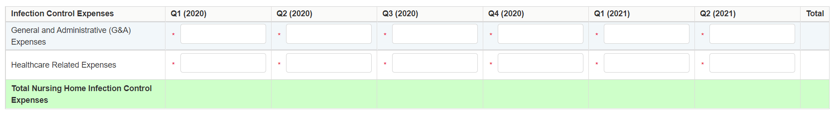

Figure 27 Nursing Home Infection Control Expenses- Between $10,001 and $499,999

Reporting Entities that received **$500,000 or more in aggregated PRF payments during the Payment Received Period** (shown in the table on Step 6 – Payments Summary) are required to report by calendar year quarter on the use of Nursing Home Infection Control Distribution payments in greater detail than the two categories of General and Administrative (G&A) Expenses and Healthcare Related Expenses as shown in *Figure 28 Nursing Home Infection Control Expenses- $500,000 or More Table* according to the following sub-categories of expenses:

**General and Administrative (G&A) Expenses for Nursing Home Infection Control Distribution Payments (includes QIP payments)** **Received During Payment Period**

* **Mortgage/Rent:** Payments related to mortgage or rent for a facility specifically for infection control.
* **Insurance:** Premiums paid for property, malpractice, business insurance, or other insurance relevant to operations for infection control.
* **Personnel:** [12] Workforce-related expenses as outlined in the Terms and Conditions such as personnel costs associated with administering COVID-19 testing; reporting COVID-19 test results to local, state, or federal governments; hiring staff to provide patient care or administrative support; providing additional services to residents; workforce training; and mentorship programs to improve infection control; or other personnel costs incurred for infection control. Staffing, including temporary employee or contractor payroll and overhead employees, is included.
* **Fringe Benefits**: Extra benefits supplementing an employee’s salary, which may include hazard pay, travel reimbursement, and employee health insurance. May only be charged in proportion to salary costs for infection control.
* **Lease Payments:** New equipment or software leases, fleet cars, and medical equipment that is not purchased and will be returned to its owner, so long as it is used for infection control.
* **Utilities/Operations:** Lighting, cooling/ventilation, cleaning, or additional third-party vendor services not included in the “Personnel” sub-category and whose purpose is for infection control.
* **Other General and Administrative Expenses:** Expenses not captured above that are for infection control and generally considered part of general and administrative expenses.

**Health Care-Related Expenses for Nursing Home Infection Control Distribution Payments** **(includes QIP payments)** **Received During Payment Period**

* **Supplies:** Expenses paid for purchase of supplies (*e.g.,* single use or reusable patient care devices, cleaning supplies, office supplies, etc.) used for the purpose of infection control during the period of performance. Such items may include personal protective equipment (PPE), hand sanitizer, and supplies for patient or staff COVID-19 testing, or expenses associated with distribution of a COVID-19 vaccine licensed or authorized by the Food and Drug Administration.
* **Equipment:** Expenses paid for purchase of equipment used for infection control, such as updates to HVAC systems or sanitizing equipment.
* **Information Technology (IT):** Expenses paid for IT or interoperability systems to expand or preserve infection control during the reporting period, such as telehealth infrastructure, increased bandwidth, technology that permits residents to connect with their families, and teleworking to support remote workforce.
* **Facilities:** Expenses such as lease or purchase of permanent or temporary structures, or to retrofit facilities to accommodate revised patient treatment practices to support infection control during the period of performance.
* **Other Health Care-Related Expenses:** Expenses not captured above that are for infection control and are health care-related expenses.

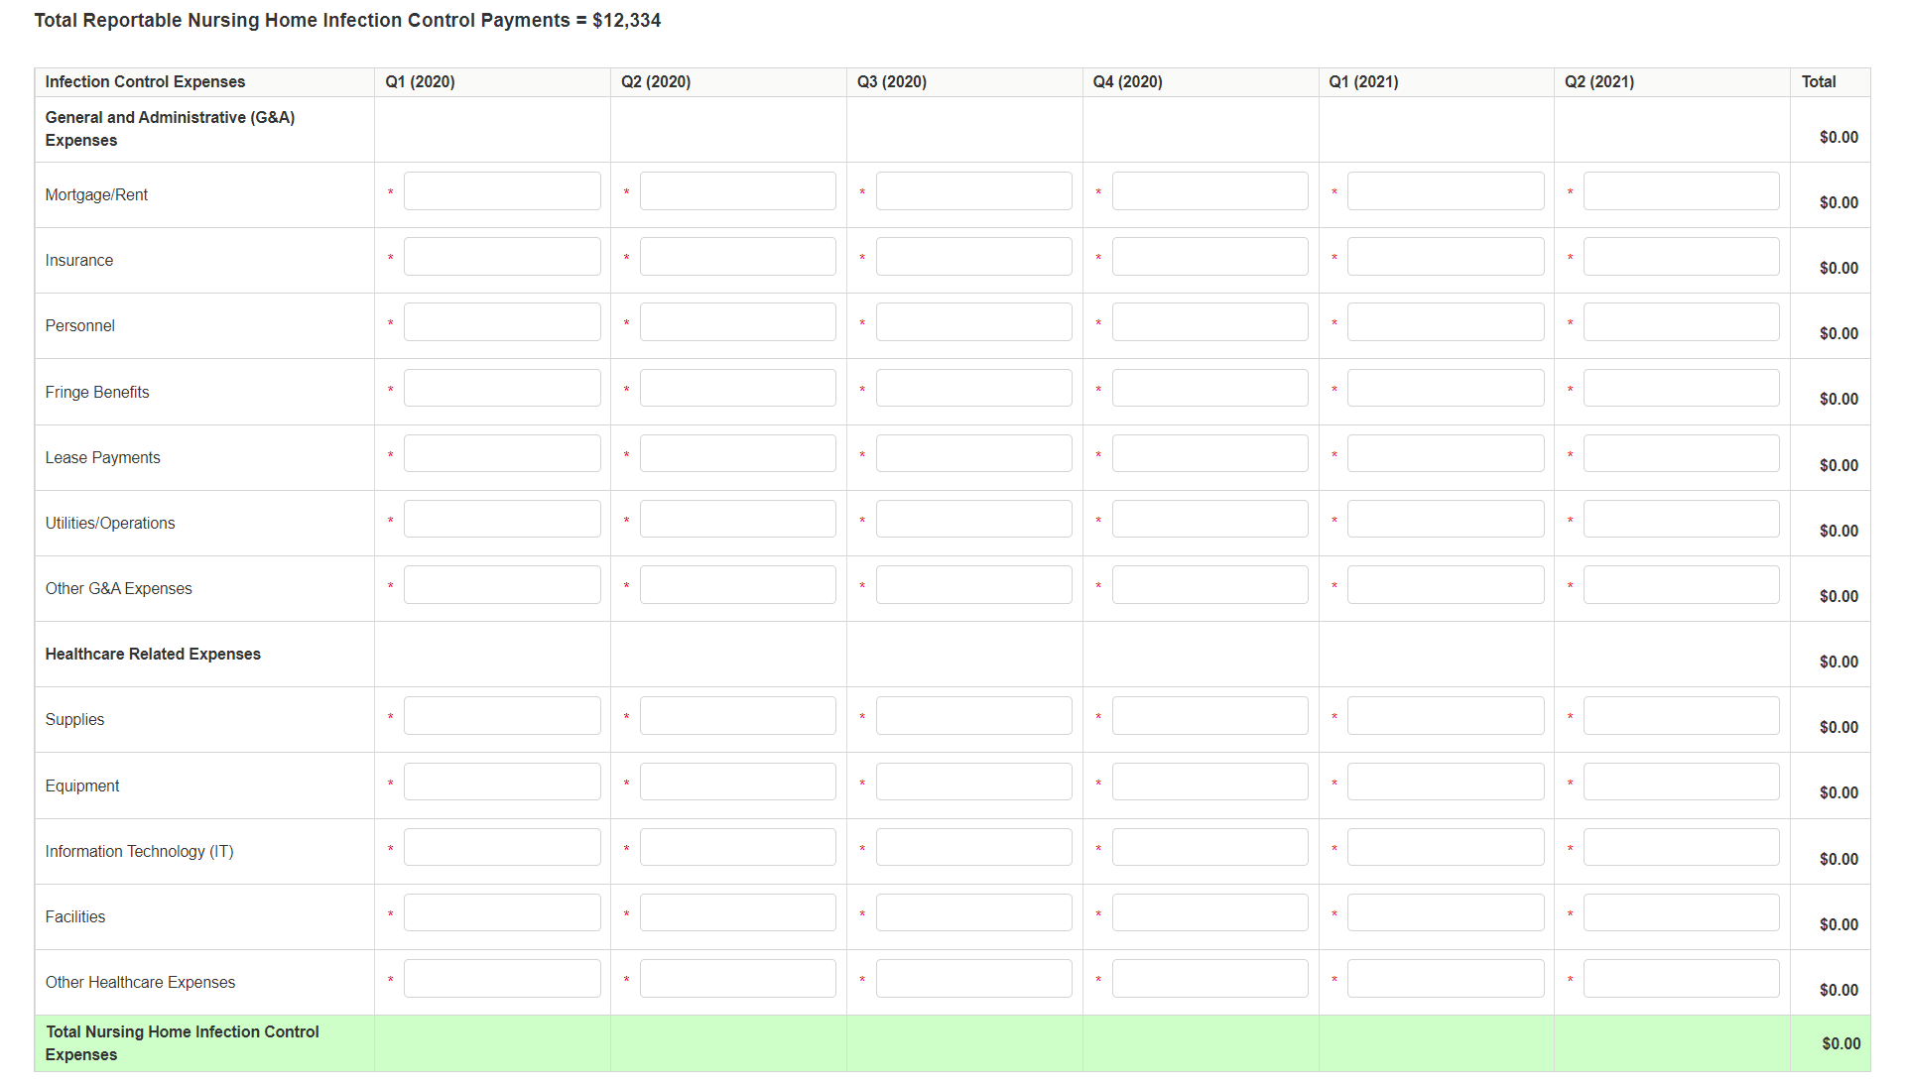

Figure 28 Nursing Home Infection Control Expenses- $500,000 or More Table

Users must click the blue ‘Save & Next’ button to proceed to Step 9 – Other PRF Expenses for Payments Received During Payment Period. To return to a previous page, users should click the blue ‘Previous’ button. Portal users should exit the PRF Reporting Portal when they are not actively entering data and should do this by clicking the red ‘Save & Exit’ button. **Portal users should not exit the portal by closing the browser window or navigate away from the current page using the browser window as data entered on the current page will not be saved.**

## 4.11 Step 10 – Other Provider Relief Fund Expenses for Payments Received during Payment Period

After Step 8 – Nursing Home Infection Control Expenses for Payments Received During Reporting Period is complete, the Reporting Entity is directed to report Step 9 - Other Provider Relief Fund Expenses for Payments Received During the Payment Period. On this page, the Reporting Entity is required to report on the use of all “Other PRF Payments” by indicating the quarterly expenses reimbursed with these payments. Provider Relief Fund payments must be used for expenses unreimbursed by other sources and that other sources are not obligated to reimburse. “Other PRF payments” includes all General Distribution payments and Targeted Distribution payments, except for those payments categorized as Nursing Home Infection Control[13] payments. The Reporting Entity must report the use of these payments by indicating the quarterly expenses reimbursed with these payments.

The Total Reportable Other PRF Payment amount is shown in **bold** above the table and corresponds to the same value displayed in Step 6 – Payments Summary. The total dollar value of expenses reported on this page may not exceed the Total Reportable Other PRF Payments.

The Reporting Entity will report on the use of all Other PRF payments by indicating the calendar year quarterly expenses (unreimbursed by other sources and that other sources were not obligated to reimburse) that the Other PRF payments were used for. The 'tab' key may be used to navigate between cells during data entry. All data entry fields must be completed, are limited to 14 digits, include up to 2 decimal places, and all values must be positive. If expenses are zero, the Reporting Entity must enter a ‘0.’ Totals will automatically calculate by corresponding column and row as information is entered. Expenses are reported by calendar year quarter.

Calendar year quarters are defined as follows:

* Quarter 1 (Q1): January 1 – March 31
* Quarter 2 (Q2): April 1 – June 30
* Quarter 3 (Q3): July 1– September 30
* Quarter 4 (Q4): October 1– December 31

Reporting Entities that received **between $10,001 and $499,999 in aggregated PRF payments during the Payment Received Period** (shown in the table on Step 6 – Payments Summary) are required to report on the use of Other PRF payments in two categories: (1) General and Administrative (G&A) Expenses and (2) Healthcare Related Expenses as shown in *Figure 29 Other PRF Expenses- Between $10,001 and $499,999*.

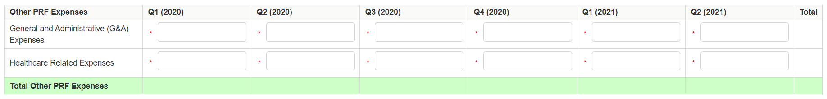

Figure 29 Other PRF Expenses- Between $10,001 and $499,999

Reporting Entities that received **$500,000 or more in aggregated PRF payments during the Payment Received Period** (shown in the table on Step 6 – Payments Summary) are required to report on the use of Other PRF payments in greater detail than the two categories of General and Administrative (G&A) Expenses and Healthcare Related Expenses as shown in *Figure 30 Other PRF Expenses- $500,000 or More Table* according to the following sub-categories of expenses:

**General and Administrative (G&A) Expenses for Other Provider Relief Fund Payments Received During Payment Period**

* **Mortgage/Rent:** Payments related to mortgage or rent for a facility.
* **Insurance:** Premiums paid for property, malpractice, business insurance, or other insurance relevant to operations.
* **Personnel:[14]** Workforce-related actual expenses paid to prevent, prepare for, or respond to coronavirus during the reporting period, such as workforce training, staffing, temporary employee or contractor payroll, overhead employees, or security personnel.
* **Fringe Benefits:** Extra benefits supplementing an employee’s salary, which may include hazard pay, travel reimbursement, and employee health insurance.
* **Lease Payments:** New equipment or software leases, such as fleet cars and medical equipment that is not purchased and will be returned to the owner.
* **Utilities/Operations:** Lighting, cooling/ventilation, cleaning, or additional third-party vendor services not included in the “Personnel” sub-category.
* **Other General and Administrative Expenses:** Expenses not captured above that are generally considered part of general and administrative expenses.

**Healthcare Related Expenses Attributable to Coronavirus**

* **Supplies:** Expenses paid for purchase of supplies (*e.g.,* single use or reusable patient care devices, cleaning supplies, office supplies, etc.) used to prevent, prepare for, and/or respond to coronavirus during the reporting period. Such items may include PPE, hand sanitizer, supplies for patient screening, or vaccination administration materials.
* **Equipment:** Expenses paid for purchase of equipment, such as ventilators, refrigeration systems for COVID-19 vaccines, or updates to HVAC systems.
* **Information Technology (IT):** Expenses paid for IT or interoperability systems to expand or preserve coronavirus care delivery during the reporting period, such as electronic health record licensing fees, telehealth infrastructure, increased bandwidth, and teleworking to support remote workforce.
* **Facilities:** Expenses such as lease or purchase of permanent or temporary structures, or to retrofit facilities to accommodate revised patient treatment practices, used to prevent, prepare for, and/or respond to coronavirus during the reporting period.
* **Other Healthcare Expenses:** Expenses, not previously captured above, that were paid to prevent, prepare for, and/or respond to coronavirus.

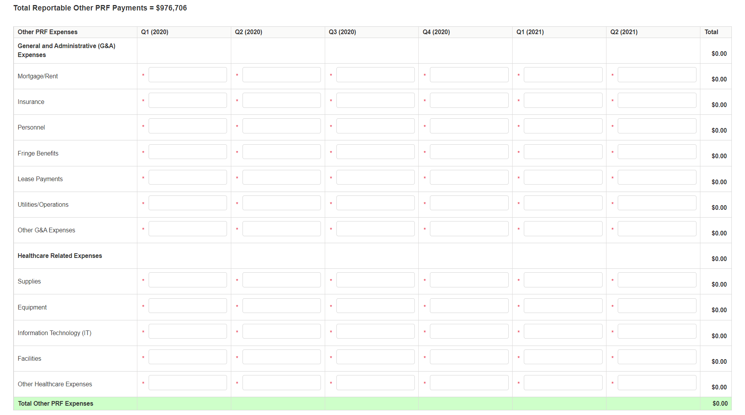

Figure 30 Other PRF Expenses- $500,000 or More Table

Users must click the blue ‘Save & Next’ button to proceed to Step 10 – Unreimbursed Expenses Attributable to Coronavirus. To return to a previous page, users should click the blue ‘Previous’ button. Portal users should exit the PRF Reporting Portal when they are not actively entering data and should do this by clicking the red ‘Save & Exit’ button. **Portal users should not exit the portal by closing the browser window or navigate away from the current page by using the browser window as data entered on the current page will not be saved.**

## 4.12 Step 11 – Unreimbursed Expenses Attributable to Coronavirus

After Step 9 – Other PRF Expenses for Payments Received During Reporting Period is complete, Reporting Entities will complete Step 10 – Unreimbursed Expenses Attributable to Coronavirus. On this worksheet, the Reporting Entity is required to report on the net unreimbursed expenses attributable to coronavirus that have not been reimbursed by other sources and that other sources are not obligated to reimburse. Reporting Entities must consider other financial assistance received, including other PRF payments, when determining net unreimbursed expenses attributable to coronavirus reported on this worksheet. The net unreimbursed expenses attributable to coronavirus reported to HRSA will not be used in the calculation of expenses or lost revenues. Reporting Entities are expected to determine whether there are net unreimbursed expenses attributable to coronavirus after taking into consideration the application of Other Assistance Received and all PRF payments. HRSA expects that Provider Relief Fund payments would be applied to unreimbursed expenses attributable to coronavirus that are not obligated to be reimbursed by other sources before Provider Relief Fund payments are used for lost revenues.

On this worksheet, the Reporting Entity is required to report on the net unreimbursed expenses attributable to coronavirus (net after other assistance received and PRF payments are applied) by indicating the calendar year quarterly expenses during the period of availability of the Payments Received that correspond to the current reporting period.

Calendar year quarters are defined as follows:

* Quarter 1 (Q1): January 1 – March 31
* Quarter 2 (Q2): April 1 – June 30
* Quarter 3 (Q3): July 1 – September 30
* Quarter 4 (Q4): October 1 – December 31

The 'tab' key may be used to navigate between cells during data entry. All data entry fields must be completed. Each cell is limited to 14 digits, including up to 2 decimal places, and all values must be positive numbers. If expenses are zero, the Reporting Entity must enter a ‘0.’ Totals will automatically calculate by corresponding column and row as information is entered.

Expenses are reported in two categories: (1) General and Administrative (G&A) Expenses and (2) Healthcare Related Expenses as shown in *Figure 31 Unreimbursed Expenses Table*.

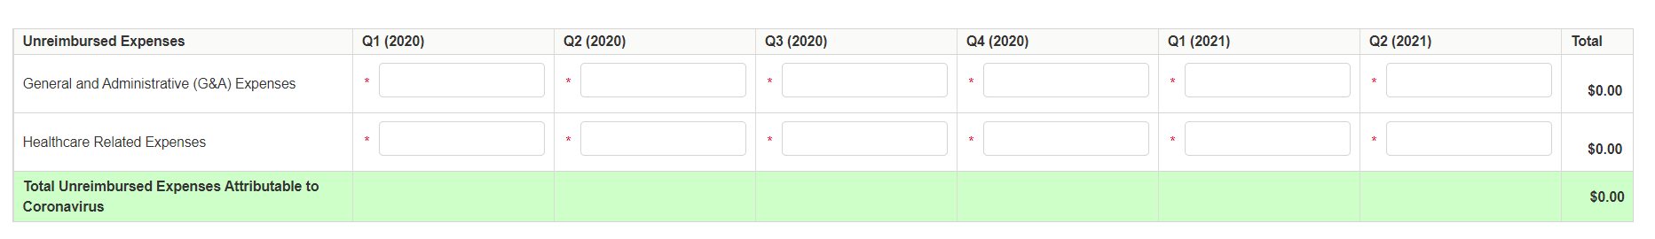

Figure 31 Unreimbursed Expenses Table

Users must click the blue ‘Save & Next’ button to proceed to Step 11 – Actual Patient Care Revenue or Lost Revenues. To return to a previous page, users should click the blue ‘Previous’ button. Portal users should exit the PRF Reporting Portal when they are not actively entering data and should do this by clicking the red ‘Save & Exit’ button. **Portal users should not exit the portal by closing the browser window or navigate away from the current page using the browser window as data entered on the current page will not be saved.**

## 4.13 Step 12 – Actual Patient Care Revenue or Lost Revenues

Depending on data from previous pages, one of two pages will be automatically displayed.

### Actual Patient Care Revenue

If Total Reportable Other PRF Payments (from Step 6 – Payments Summary) is equal to Total Other PRF Expenses (from Step 9 – Other PRF Expenses for Payments Received During Payment Period), the Actual Patient Care Revenue page displays as shown in *Figure 32 Actual Patient Care Revenue*. Otherwise, the Lost Revenues Questionnaire is displayed*Section 13.2.2*.

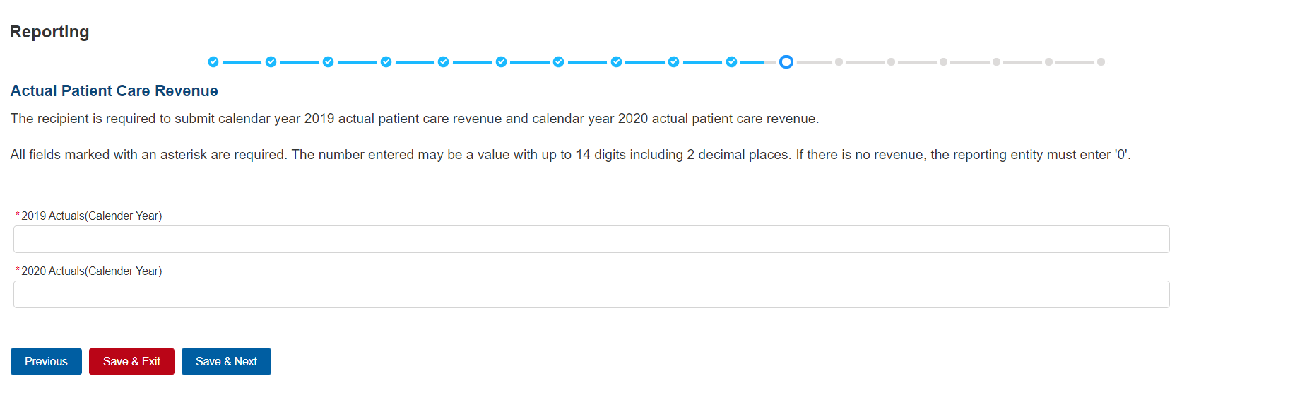

Figure 32 Actual Patient Care Revenue

The Actual Patient Care Revenue page is only shown if all Other PRF Payments were expensed and Reporting Entities do not need to select a method for reporting lost revenues. (As a reminder, Nursing Home Infection Control payments may not be used to reimburse lost revenues.) On the Actual Patient Care Revenue page, the Reporting Entity must provide total actual patient care revenue for the completed calendar years within the period of availability for the payments received that correspond to the current reporting period. Both fields are required, limited to 14 digits including 2 decimal places, and actual revenue must be positive values. If the revenues are zero, the Reporting Entity must enter a ‘0.’

After the user clicks the blue ‘Save & Next’ button, they skip Step 12 – Lost Revenues and are taken directly to Step 13 – PRF Financial Summary. To return to a previous page, users should click the blue ‘Previous’ button. Portal users should exit the PRF Reporting Portal when they are not actively entering data and should do this by clicking the red ‘Save & Exit’ button. **Portal users should not exit the portal by closing the browser window or navigate away from the current page by using the browser window as data entered on the current page will not be saved.**

### Lost Revenues Questionnaire

If the Total Reportable Other PRF Payments (from Step 6 – Payments Summary) is greater than the Total Other PRF Expenses reported (from Step 9 – Other PRF Expenses for Payments Received During Reporting Period ), then the Reporting Entity has PRF payments remaining to apply to lost revenues and the Lost Revenues Questionnaire page is shown. The Lost Revenues Questionnaire is shown in *Figure 33 Lost Revenues Questionnaire*.

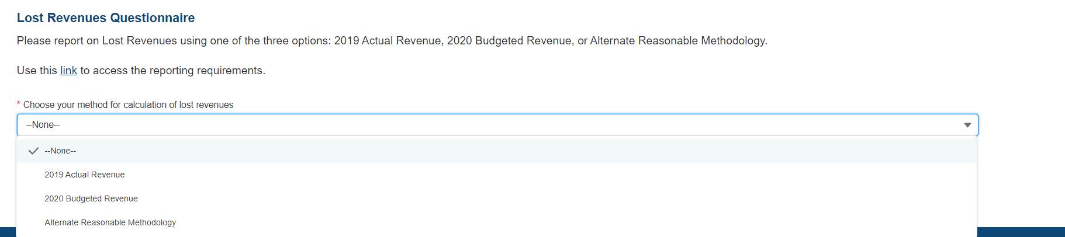

Figure 33 Lost Revenues Questionnaire

The Lost Revenues Questionnaire requires the Reporting Entity to select the method they will use to calculate lost revenues. This Reporting Portal page also contains a link to the most recently published [Post-Payment Notice of Reporting Requirements](https://www.hhs.gov/sites/default/files/provider-post-payment-notice-of-reporting-requirements-june-2021.pdf), which will open in a new browser tab so as to not affect data entered. The Reporting Entity must select one of three methods as described in the most recently published Post-Payment Notice of Reporting Requirements:

1. **2019 Actual Revenue:** The difference between **actual patient care revenues** (uses 2019 calendar year quarters as the baseline); or
2. **2020 Budgeted Revenue:** The difference between **budgeted** (prior to March 27, 2020) and actual patient care revenues (uses the approved budget as the baseline); or
3. **Alternate Reasonable Methodology:** Calculated by **any reasonable method** of estimating revenues.

Depending on which method is selected, one of the three pages below will be shown.

## 4.14 Step 13 – Lost Revenues

If the Reporting Entity was shown the Step 11- Actual Patient Care Revenue page, they will be directed to Step 13 – PRF Financial Summary Page instead of the following page options. Depending on the Reporting Entity’s selection on the Step 11- Lost Revenues Questionnaire, one of the three pages below will be shown. Each of the three pages will determine the calculation of lost revenues and the calculation will be applied to the balance of the Other PRF payments (after reported expenses are deducted) to determine the total dollar amount of PRF payments expended for the Payment Received Period. As a reminder, Nursing Home Infection Control payments may not be used for lost revenues and will not figure into the calculation of PRF payments applied to the lost revenues.

### 4.13.1 2019 Actual Revenue (Calculation of Lost Revenues Attributable to Coronavirus)

If in the Lost Revenues Questionnaire, the Reporting Entity selects the 2019 Actual Revenue method, the page will appear as shown in *Figure 34 Total Revenue/Net Charges from Patient Care (2019 Actuals)*.

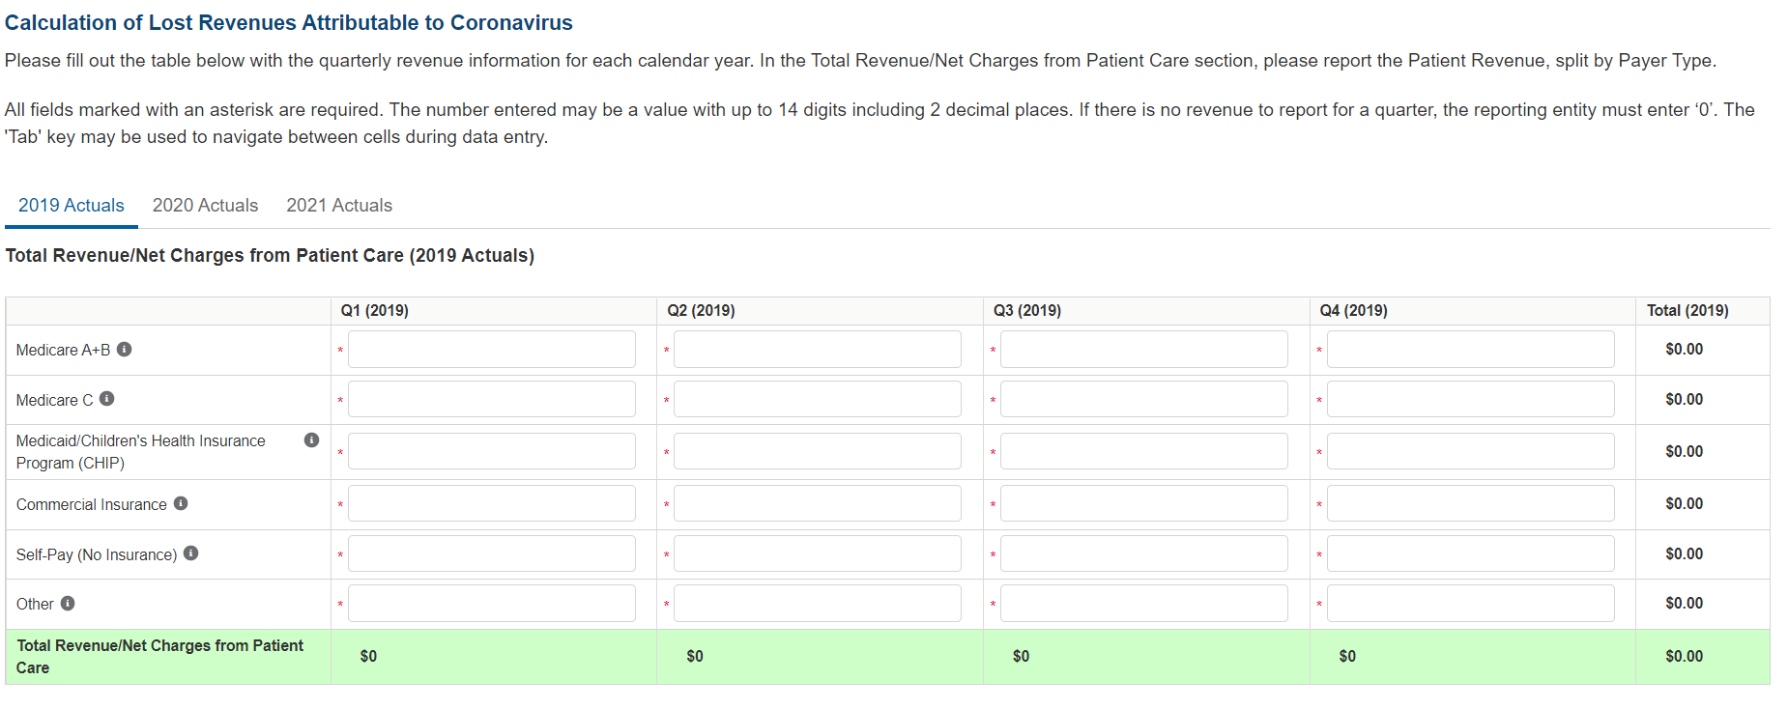

Figure 34 Total Revenue/Net Charges from Patient Care (2019 Actuals)

The Reporting Entity must complete three (3) tables with actual quarterly revenue information for calendar years 2019 to the end of the period of availability. Reporting Entities will submit revenues[15]/net charges from patient care[16] (prior to netting with expenses) split by payer mix (including out of pocket charges), and by calendar year quarter for each quarter during the period of availability.

Calendar year quarters are defined as follows:

* Quarter 1 (Q1): January 1 – March 31
* Quarter 2 (Q2): April 1 – June 30
* Quarter 3 (Q3): July 1 – September 30
* Quarter 4 (Q4): October 1 – December 31

The Reporting Entity will report on total revenue/net charges from patient care split by payer type for each of the relevant calendar year quarters as follows:

* **Medicare Part A + B:** actual revenues/net charges received from Medicare Part A + B for patient care.
* **Medicare Part C (Medicare Advantage):** actual revenues/net charges received from Medicare Part C for patient care.
* **Medicaid/Children’s Health Insurance Program (CHIP):** actual revenues/net charges received from Medicaid/CHIP for patient care.
* **Commercial Insurance:** actual revenues/net charges from commercial insurance payers for patient care.
* **Self-Pay (No Insurance):** actual revenues/net charges received from self-pay patients, including the uninsured or individuals without insurance who bear the burden of paying for health care themselves.
* **Other:** actual revenues/net charges from other sources received for patient care services and not included in the list above.

The 'tab' key may be used to navigate between cells during data entry. All data entry fields are required, each cell is limited to 14 digits including 2 decimal places, and all values must be positive numbers. If there is no revenue to report for a quarter, the Reporting Entity must enter ‘0.’ Patient care revenue totals will automatically calculate within a table by corresponding column and row as information is entered. The user will be able to move between the three tables by clicking the ‘2019 Actuals,’ ‘2020 Actuals,’ and ‘2021 Actuals’ tabs, without losing data. However, the data on this page will not be saved until the blue ‘Save & Next’ button is selected. Note: clicking ‘Previous” will take the user to the previous page, not move between the tables in this page.

The total lost revenues calculated by the system will not appear on this page. Reporting entities should be aware however, that if they choose this method, lost revenues will be calculated for each quarter during the period of availability, as a standalone calculation, with 2019 quarters serving as a baseline. For each calendar year of reporting, the applicable quarters where lost revenues were demonstrated are totaled to determine an annual lost revenues amount. The annual lost revenues are then added together to determine a total that can be applied to PRF payments.

If a table or data entry field has not been completed or has an invalid value, a red error message will appear both above and below the table directing the user to correct the error. Once complete, the user must click the blue ‘Save & Next’ button to go to Step 13 – PRF Financial Summary. To return to a previous page, users should click the blue ‘Previous’ button. Portal users should exit the PRF Reporting Portal when they are not actively entering data and should do this by clicking the red ‘Save & Exit’ button. **Portal users should not exit the portal by closing the browser window or navigate away from the current page using the browser window as data entered on the current page will not be saved.**

### 2020 Budgeted Revenue (Calculation of Lost Revenues Attributable to Coronavirus)

If in the Lost Revenues Questionnaire, the Reporting Entity selects the 2020 Budgeted Revenue method, the page will appear as shown in *Figure 35 Total Revenue/Net Charges from Patient Care (2020 Budgeted)*.

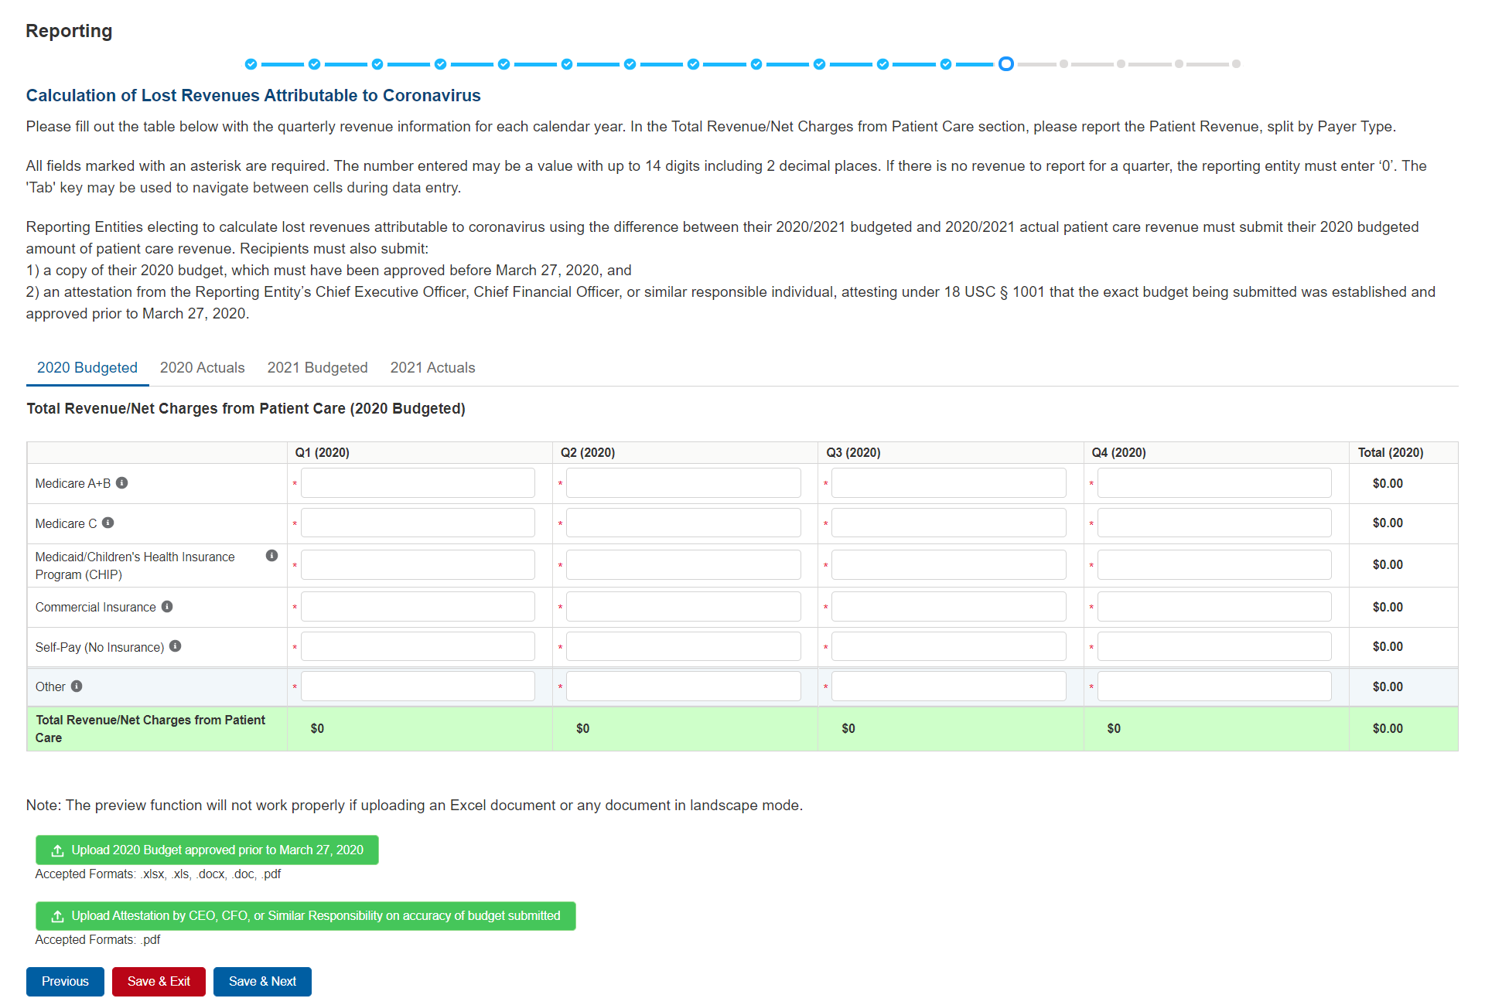

Figure 35 Total Revenue/Net Charges from Patient Care (2020 Budgeted)

The Reporting Entity must complete four (4) tables with quarterly revenue information for calendar years 2020 through the end of the period of availability. Reporting Entities will submit both (1) budgeted and (2) actuals for their revenues[17]/net charges from patient care[18] (prior to netting with expenses) split by payer mix (including out of pocket charges), and by calendar year quarter for each quarter during the period of availability.

Calendar year quarters are defined as follows:

* Quarter 1 (Q1): January 1 – March 31
* Quarter 2 (Q2): April 1 – June 30
* Quarter 3 (Q3): July 1 – September 30
* Quarter 4 (Q4): October1 – December 31

The Reporting Entity will report on (1) budgeted and (2) actual total revenue/net charges from patient care by payer type for each of the relevant quarters as follows:

* **Medicare Part A + B:** actual revenues/net charges received from Medicare Part A + B for patient care.
* **Medicare Part C (Medicare Advantage):** actual revenues/net charges received from Medicare Part C/ Medicare Advantage for patient care.
* **Medicaid/Children’s Health Insurance Program (CHIP):** actual revenues/net charges received from Medicaid/CHIP for patient care.
* **Commercial Insurance:** actual revenues/net charges from commercial insurance payers for patient care.
* **Self-Pay (No Insurance):** actual revenues/net charges received from self-pay patients, including the uninsured or individuals without insurance who bear the burden of paying for health care themselves.
* **Other:** actual revenues/net charges from other sources received for patient care services and not included in the list above.

The 'tab' key may be used to navigate between cells during data entry. All data entry fields are required, each cell is limited to 14 digits including 2 decimal places, and all values must be positive numbers. If there is no revenue to report for a quarter, the Reporting Entity must enter ‘0.’ Patient care revenue totals will automatically calculate within a table by corresponding column and row as information is entered. The user will be able to move between the four tables without losing data by clicking ‘2020 Budgeted,’ ‘2020 Actuals,’ ‘2021 Budgeted,’ and ‘2021 Actuals’ tabs. However, the data on this page will not be saved until the blue ‘Save & Next’ button is selected. Note: clicking ‘Previous” will take the user to the previous page, not move between the tables in this page.

The total lost revenues for the reporting period that is calculated by the system will not appear on this page. Reporting entities should be aware however, that if they choose this method, lost revenues that can be applied to PRF payments will be calculated by calendar year quarter for each quarter during the period of availability, as a standalone calculation, with 2020 or 2021 quarters serving as a baseline. For each calendar year of reporting, the applicable quarters where lost revenues are demonstrated are totaled to determine an annual lost revenues amount. The annual lost revenues are then added together to determine a total that can be applied to PRF payments.

In addition to completing four tables with budgeted and actuals for total revenue/net charges from patient care, Reporting Entities that select this method of calculating lost revenues must submit the following documentation:

1. A copy of the budget approved prior to March 27, 2020 that covers the entire period of availability. The budget must be submitted in one of the following accepted file formats: .xlsx, .xls, .docx, .doc, or .pdf.
2. Attestation by a Chief Executive Officer (CEO), Chief Financial Officer (CFO), or other similarly responsible individual representing the Reporting Entity on the accuracy of the budget submitted. The attestation must be submitted in a .pdf file format. The attestation should state that the budget was established and approved prior to March 27, 2020, be submitted on organizational letterhead, and include a signature and complete contact information.

Documentation must be uploaded by clicking the green ‘Upload’ buttons as shown in *Figure 36 Upload Budget and Attestation*. Once uploaded, the name of the attachment will be displayed to the right of the ‘Upload’ button and the documentation may be previewed to ensure it has been submitted correctly. Portal users may also download or remove previously uploaded documentation. In order to preview documents in .pdf format, the latest version of Adobe Acrobat Reader must be installed. If needed, instructions to download Adobe Acrobat Reader are located [here](https://get.adobe.com/reader/). The preview function is not available for documents in .xlsx or .xls formats or any document in landscape mode. The maximum upload file size is 2GB.

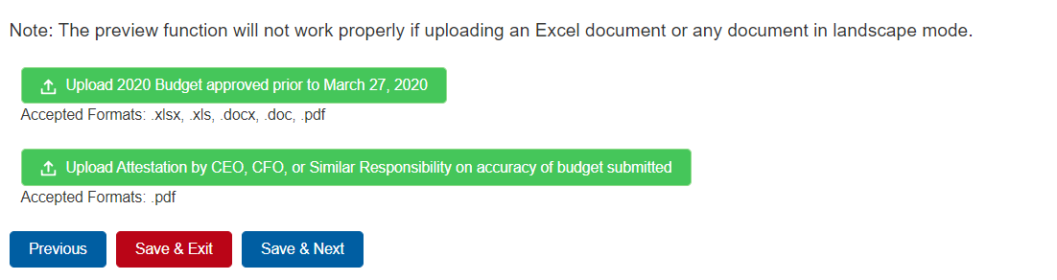

Figure 36 Upload Budget and Attestation

If a data entry field has not been completed, has an invalid value, or if a required document is not uploaded, a red error message will appear directing the user to correct the error. Once complete, the user must click the blue ‘Save & Next’ button to go to Step 13 – PRF Financial Summary. To return to a previous page, users should click the blue ‘Previous’ button. Portal users should exit the PRF Reporting Portal when they are not actively entering data and should do this by clicking the red ‘Save & Exit’ button. **Portal users should not exit the portal by closing the browser window or navigate away from the current page using the browser window as data entered on the current page will not be saved.**

### 4.13.3 Alternate Method of Calculating Lost Revenues Attributable to Coronavirus

If the Reporting Entity selects the Alternate Reasonable Methodology method in the Lost Revenues Questionnaire, the Alternate Method of Calculating Lost Revenues Attributable to Coronavirus page will appear as shown in *Figure 37 Lost Revenues Alternate Reasonable Methodology.* All recipients seeking to use an alternate methodology face an increased likelihood of an audit by HRSA.

HRSA will notify a Reporting Entity if their proposed methodology is not reasonable, including if it does not demonstrate with a reasonable certainty that claimed lost revenues were caused by coronavirus. If HRSA determines that a Reporting Entity’s proposed alternate methodology is not reasonable, HRSA will require the Reporting Entity to resubmit its report within 30 days of notification using one of the other options to calculate lost revenues attributable to coronavirus (*i.e.,* Actuals or Budgeted).

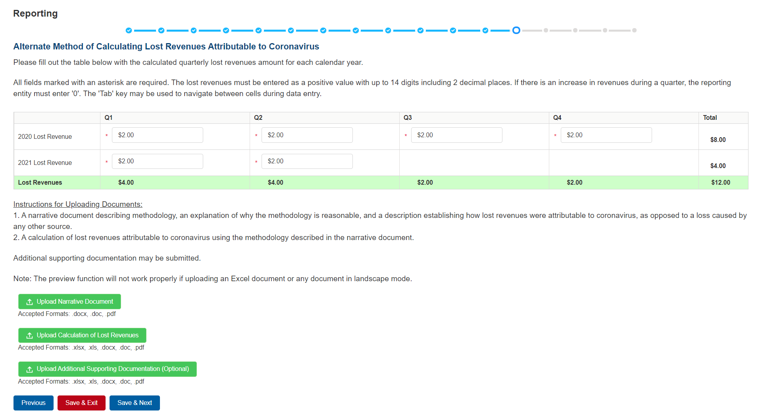

Figure 37 Lost Revenues Alternate Reasonable Methodology

The Reporting Entity is required to complete one (1) table with the calculated quarterly lost revenues values (using the alternate reasonable method calculation) for calendar years 2020 through the end of the period of availability.

Calendar year quarters are defined as follows:

* Quarter 1 (Q1): January 1 – March 31
* Quarter 2 (Q2): April 1 – June 30
* Quarter 3 (Q3): July 1 – September 30
* Quarter 4 (Q4): October 1 – December 31

The 'tab' key may be used to navigate between cells during data entry. All data entry fields in the table are required and each cell is limited to 14 digits including 2 decimal places. **If there is an increase in revenues during any quarter during the period of availability, the Reporting Entity must enter ‘0’ to indicate that there were no lost revenues.** Totals will automatically calculate within the table by corresponding column and row as information is entered.

Reporting Entities selecting the alternate reasonable methodology are required to submit additional documentation, with maximum file size of 2GB, as follows:

1. **Narrative Document:** The narrative document must describe the methodology, an explanation of why the methodology is reasonable, and a description establishing how lost revenues were attributable to coronavirus (as opposed to a loss caused by any other source). Acceptable file formats for the narrative document are .docx, .doc, or .pdf.
2. **Calculation of Lost Revenues:** The calculation of lost revenues attributable to coronavirus must use the methodology described in the Narrative Document described above. Acceptable file formats for the calculation of lost revenues documentation are .xlsx, .xls, .docx, .doc, or .pdf.
3. *Optional:* Additional Supporting Documentation: One file of additional documentation may be submitted. Acceptable file formats for the supporting documentation are: .xlsx, .xls, .docx, .doc, or .pdf.

Documentation must be uploaded by clicking the corresponding green ‘Upload’ buttons as shown in *Figure 38 Upload Narrative and Calculation of Lost Revenues.*

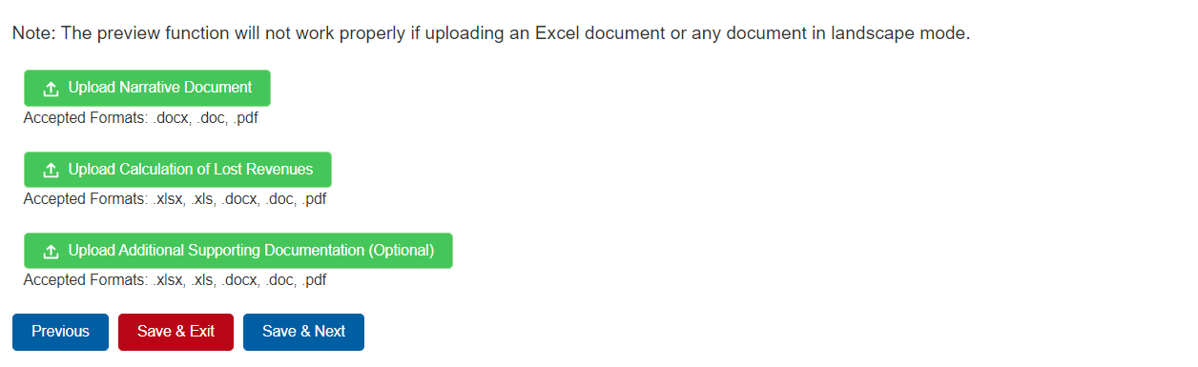

Figure 38 Upload Narrative and Calculation of Lost Revenues

Once uploaded, the name of the attachment will be displayed to the right of the ‘Upload’ button and the documentation may be previewed to ensure it has been attached correctly. Reporting Entities may also download or remove previously uploaded documentation. In order to preview documents in .pdf format, the latest version of Adobe Acrobat Reader must be installed. If needed, instructions to download Adobe Acrobat Reader are located [here](https://get.adobe.com/reader/). The preview function is not available for documents in .xlsx or .xls formats or any document in landscape mode.

If a data entry field has not been completed or has an invalid value or if a required document is not uploaded, a red error message will appear directing the user to correct the error as shown in *Figure 39 Table Error Messages*.

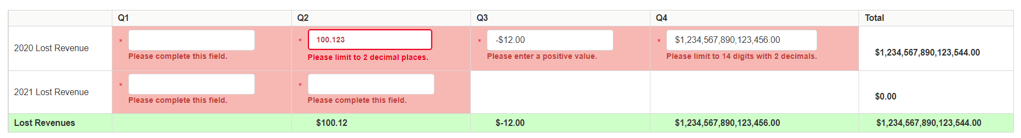

Figure 39 Table Error Messages

Once complete, the user must click the blue ‘Save & Next’ button to go to Step 13 – PRF Financial Summary.

To return to a previous page, users should click the blue ‘Previous’ button. Portal users should exit the PRF Reporting Portal when they are not actively entering data and should do this by clicking the red ‘Save & Exit’ button. **Portal users should not exit the portal by closing the browser window or navigate away from the current page using the browser window as data entered on the current page will not be saved.**

## Step 14 – PRF Financial Summary

The Step 14 - PRF Financial Summary page displays pre-populated values based on calculations from data entered during the reporting process as shown in *Figure 40 PRF Financial Summary- 2019 or 2020 Lost Revenue Path* and *Figure 41 PRF Financial Summary- Alternate Methodology Lost Revenue Path*. Depending on whether Actual Patient Care Revenue or Lost Revenues were reported, the look of the PRF Financial Summary page will vary. There is no validation or data entry required on this page. The PRF Financial Summary may be printed using the web browser.

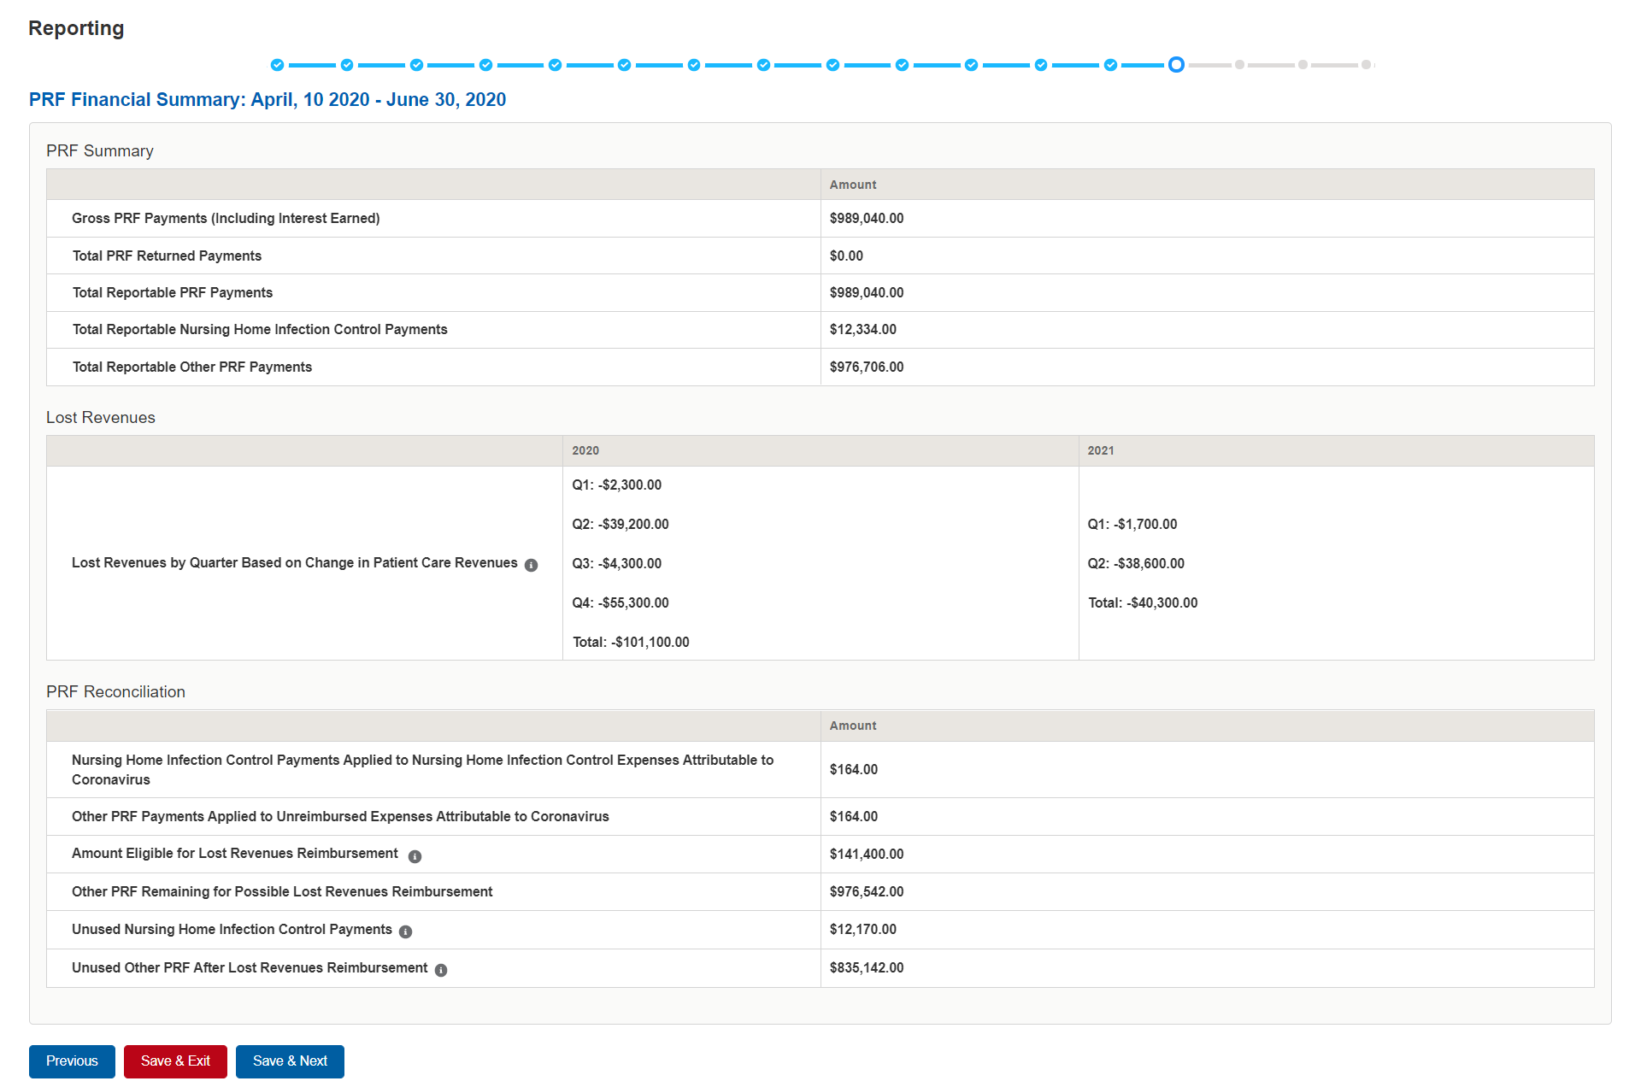

Figure 40 PRF Financial Summary- 2019 or 2020 Lost Revenue Path

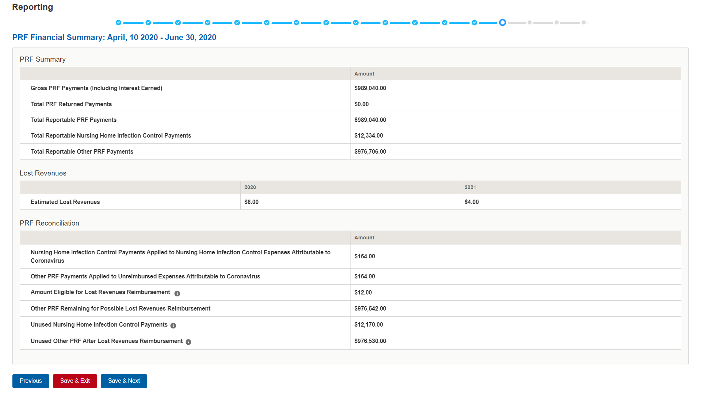

Figure 41 PRF Financial Summary- Alternate Methodology Lost Revenue Path

Reporting Entities should verify the accuracy of the financial summary information on this page. If all information appears to be accurate, the user should click the “Save & Next” button at the bottom of the page. If any information appears to be inaccurate, the user should navigate back to the previous pages of the portal indicated in the “Page for Error Correction” column listed in *Table 2 PRF Financial Summary*. The user can access previous pages by clicking the blue ‘Previous’ button at the bottom of the page.

| **Field** | **Field Calculation** | **Page for Error Correction** |
| --- | --- | --- |
| Gross PRF Payments (Including Interest Earned) | Sum of Total Nursing Home Infection Control Payments, Total Other PRF Payments, Total Interest Earned on Nursing Home Infection Control Payments, and Total Interest Earned on Other PRF Payments from the Step 6 – Payments Summary page. | Total Nursing Home Infection Control Payments and Total Other PRF Payments are populated by the system and cannot be corrected by the user without contacting the Provider Support Line.  Total Interest Earned on Nursing Home Infection Control Payments and Total Interest Earned on Other PRF Payments on Step 5 – Interest Earned on PRF Payments, Tax Information, and Single Audit Information. |
| Total PRF Returned Payments (This refers to PRF payments returned by the recipient to the PRF). | Total PRF Returned Payments from Step 4 – Payments to Recipient or Step 6 – Payments Summary page. | Total PRF Returned Payments is populated by the system and cannot be corrected by the user without contacting the Provider Support Line. |
| Total Reportable PRF Payments | Gross PRF Payments (Including Interest Earned) - Total PRF Returned Payments (Returns) | Total Nursing Home Infection Control Payments and Total Other PRF Payments and Total PRF Returned Payments are populated by the system and cannot be corrected by the user without contacting the Provider Support Line.  The only values that are editable are the Interest Earned values found on Step 5 – Interest Earned on PRF Payments, Tax Information, and Single Audit Information which are included in Total Reportable Nursing Home Infection Control Payments and Total Reportable Other PRF Payments |
| Total Reportable Nursing Home Infection Control Payments | Sum of Total Nursing Home Infection Control Payments and Total Interest Earned on Nursing Home Infection Control Payments minus subtotal of Amount Returned from Nursing Home Infection Control Payments table from Step 6 – Payments Summary page. | Total Nursing Home Infection Control Payments and Amount Returned from Nursing Home Infection Control Payments are populated by the system and cannot be corrected by the user without contacting the Provider Support Line.  Total Interest Earned on Nursing Home Infection Control Payments can be found on Step 5 – Interest Earned on PRF Payments, Tax Information, and Single Audit Information. |
| Total Reportable Other PRF Payments | Sum of Total Other PRF Payments and Total Interest Earned on Other PRF Payments minus the sub total of Amount Returned from Other PRF Payments table from Step 6 – Payments Summary page. | Total Other PRF Payments and Amount Returned from Other PRF Payments are populated by the system and cannot be corrected by the user without contacting the Provider Support Line.  The Other PRF interest value included in Total Interest Earned on Other PRF Payments can be modified on Step 5 – Interest Earned on PRF Payments, Tax Information, and Single Audit Information. |
| **Lost Revenues by Quarter Based on Change in Patient Care Revenue** | | |
| **Lost Revenues by Quarter Based on Change in Patient Care Revenue** A zero will be displayed if there is a positive change in revenue in any quarter.  *This is a system calculated field that is only shown if the Reporting Entity chooses the 2019 Actuals (option i) or 2020 Budgeted (option ii) method of calculating lost revenues, Total Reportable Other PRF payments are greater than 0, or Total Reportable Other PRF Payments are greater than Total Other PRF Expenses* | *If the 2019 Actual Revenue method was selected (option i):*  **2020**  **Q1: Q1 2020 Actual Revenue - Q1 2019 Actual Revenue**  **Q2: Q2 2020 Actual Revenue - Q2 2019 Actual Revenue**  **Q3: Q3 2020 Actual Revenue - Q3 2019 Actual Revenue**  **Q4: Q4 2020 Actual Revenue - Q4 2019 Actual Revenue**  2020 Total: Q1 + Q2 + Q3 + Q4  **2021**  **Q1: Q1 2021 Actual Revenue - Q1 2019 Actual Revenue**  **Q2: Q2 2021Actual Revenue - Q2 2019 Actual Revenue**  2021 Total: Q1 + Q2  OR  ***If the 2020 Budgeted method was selected (option ii):***  **2020**  **Q1: Q1 2020Actual Revenue - Q1 2020 Budgeted Revenue**  **Q2: Q2 2020 Actual Revenue - Q2 2020 Budgeted Revenue**  **Q3: Q3 2020 Actual Revenue – Q3 2020 Budgeted Revenue**  **Q4: Q4 2020 Actual Revenue – Q4 2020 Budgeted Revenue**  2020 Total: Q1 + Q2 + Q3 + Q4  **2021**  **Q1: Q1 2021 Actual Revenue - Q1 2021 Budgeted Revenue**  **Q2: Q2 2021=Actual Revenue - Q2 2021 Budgeted Revenue**  2021 Total: Q1 + Q2  ***If the value is positive, a zero (0) will be displayed.*** | 2019 Actual Revenues or 2020 Budgeted Revenues |
| **Lost Revenues** | | |
| Estimated Lost Revenues  *This is a system calculated field only shown if the Reporting Entity selected the Alternate Reasonable Methodology Calculation, Total Reportable Other PRF Payments are greater than 0, or Total Reportable Other PRF Payments are greater than Total Other PRF Expenses.* | **Pre-populated from the** Step 12 - Alternate Reasonable Methodology **calculation**  **2020**  Total = Q1 + Q2 + Q3 + Q4  **2021**  Total = Q1 + Q2 | Alternate Reasonable Methodology |
| **PRF Reconciliation** | | |
| Nursing Home Infection Control Payments Applied to Nursing Home Infection Control Expenses Attributable to Coronavirus  *This row is not present if Reportable Nursing Home Infection Control Payments* *is equal to 0.* | Total from Nursing Home Infection Control Expenses table in Step 8 – Nursing Home Infection Control Expenses for Payments Received During Reporting Period | Nursing Home Infection Control Expenses |
| Other PRF Payments Applied to Other PRF Expenses | Total from Other PRF Expenses table in Step 9 – Other PRF Expenses for Payments Received During Reporting Period | Step 9 – Other PRF Expenses for Payments Received During Reporting Period |
| Amount Eligible for Lost Revenues Reimbursement  *Not present if Total Reportable PRF Payments is equal to 0, Total Reportable Other PRF Payments equals Total Reportable Other PRF Expenses, or change in patient revenue for 2020 and 2021 is greater than 0* | Sum of 2020 and 2021 Calculated Lost Revenues  *If either 2020 or 2021 sum value is positive, the value is considered 0 and then added to the other. If the 2020 or 2021 sum values are negative take the absolute value and add together*  OR  Sum of 2020 and 2021 Estimated Lost Revenues | 2019 Actuals Revenues, 2020 Budgeted Revenues, or Alternate Reasonable Methodology |
| Other PRF Remaining for Possible Lost Revenue Reimbursement | **Total Reportable Other PRF Payments** minus Total Other PRF Payments Applied to Other PRF Expenses | **Total Reportable Other PRF Payments:**  The Total Other PRF Payments and Amount Returned from Other PRF Payments are populated by the system and cannot be corrected by the user without contacting the Provider Support Line.  The Other PRF interest value included in Total Interest Earned on Other PRF Payments can be modified on Step 5 – Interest Earned on PRF Payments, Tax Information, and Single Audit Information.  **Other PRF Payments Applied to Other PRF Expenses:** Step 9 - Other PRF Expenses |
| Unused Nursing Home Infection Control Payments | **Total Reportable Nursing Home Infection Control Payments**minus **Nursing Home Infection Control Payments Applied to Nursing Home Infection Control Expenses** | **Total Reportable Nursing Home Infection Control Payments:**  Total Nursing Home Infection Control Payments and Amount Returned from Nursing Home Infection Control Payments are populated by the system and cannot be corrected by the user without contacting the Provider Support Line.  Total Interest Earned on Nursing Home Infection Control Payments can be found on Step 5 – Interest Earned on PRF Payments, Tax Information, and Single Audit Information.  **Nursing Home Infection Control Payments Applied to Nursing Home Infection Control Expenses:**  Nursing Home Infection Control Expenses |
| Unused Other PRF Payments After Lost Revenues Reimbursement | Other PRF Payments Remaining for Possible Lost Revenues Reimbursement minus Amount Eligible for Lost Revenues Reimbursement  *If value is negative, $0.00 is shown* | **Other PRF Remaining for Possible Lost Revenues Reimbursement:** See above  **Amount Eligible for Lost Revenue Reimbursement:** 2019 Actuals Revenue, 2020 Budgeted Revenue, or Alternate Reasonable Methodology |

Table 2 PRF Financial Summary

## 4.16 Step 15 – Personnel, Patient, and Facility Metrics

The purpose of Step 15- Personnel, Patient, and Facility Metrics is to quantify the impact of COVID-19 on the Reporting Entity’s personnel, patient, and facility metrics. The Personnel, Patient, and Facility Metrics page is comprised of three tabs, each with its own table(s). These tables will capture different metrics, but all cells are required, restricted to eight digits with no decimals, and must be positive values. If the value for a cell is zero, the user must enter “0.” The 'tab' key may be used to navigate between cells during data entry. A horizontal scroll bar may appear at the bottom of each table, depending upon the portal user’s monitor size. As the user enters values in each field, the last column and row will calculate totals. The user will be able to move between the tabs and tables without losing data, however, the data on this page will not be saved until the data entry is complete and the blue ‘Save & Next’ button is selected.

Calendar year quarters are defined as follows:

* Quarter 1 (Q1): January 1– March 31
* Quarter 2 (Q2): April 1 – June 30
* Quarter 3 (Q3): July 1 – September 30
* Quarter 4 (Q4): October 1 – December 31

An error message will appear if the user tries to proceed to the next page with an empty data entry field or if the value does not meet validation checks. The portal user must correct errors before proceeding to the next page as shown in *Figure 42 Personnel Metrics- Error Messages*.

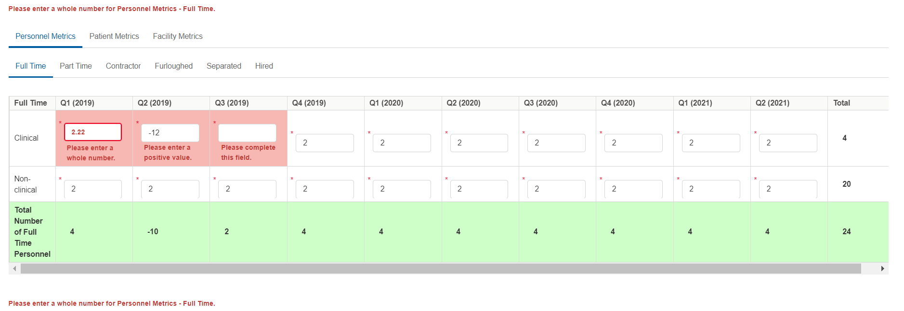

Figure 42 Personnel Metrics- Error Messages

*Personnel Metrics*

The Personnel Metrics data tables will require Reporting Entities to calculate a total number of people employed (across all TINs included in the reporting) by labor category for all clinical and non-clinical staff as defined below, by quarter. Values should be considered as of the quarter end date. Reporting Entities will include metrics for personnel for calendar year 2019 through the end of the period of availability of the funds on which the provider is reporting. The number of personnel reported are not intended to be indicative of how PRF payments were used. In other words, personnel numbers should be reported here whether or not their salaries and/or benefits were paid using the PRF payments included in the reporting.

The Personnel Metrics tab is comprised of six tables as shown in *Figure 43 Personnel Metrics*. All six tables must be completed. A horizontal scroll bar may appear at the bottom of each table, depending upon the portal user’s monitor size. The 'tab' key may be used to navigate between cells during data entry. The user will be able to move between the tabs and tables by clicking the relevant header, without losing data. However, the data on this page will not be saved until the blue ‘Save & Next’ button is selected. Note: clicking ‘Previous” will take the user to the previous page, not move between the tables or tabs in this page.

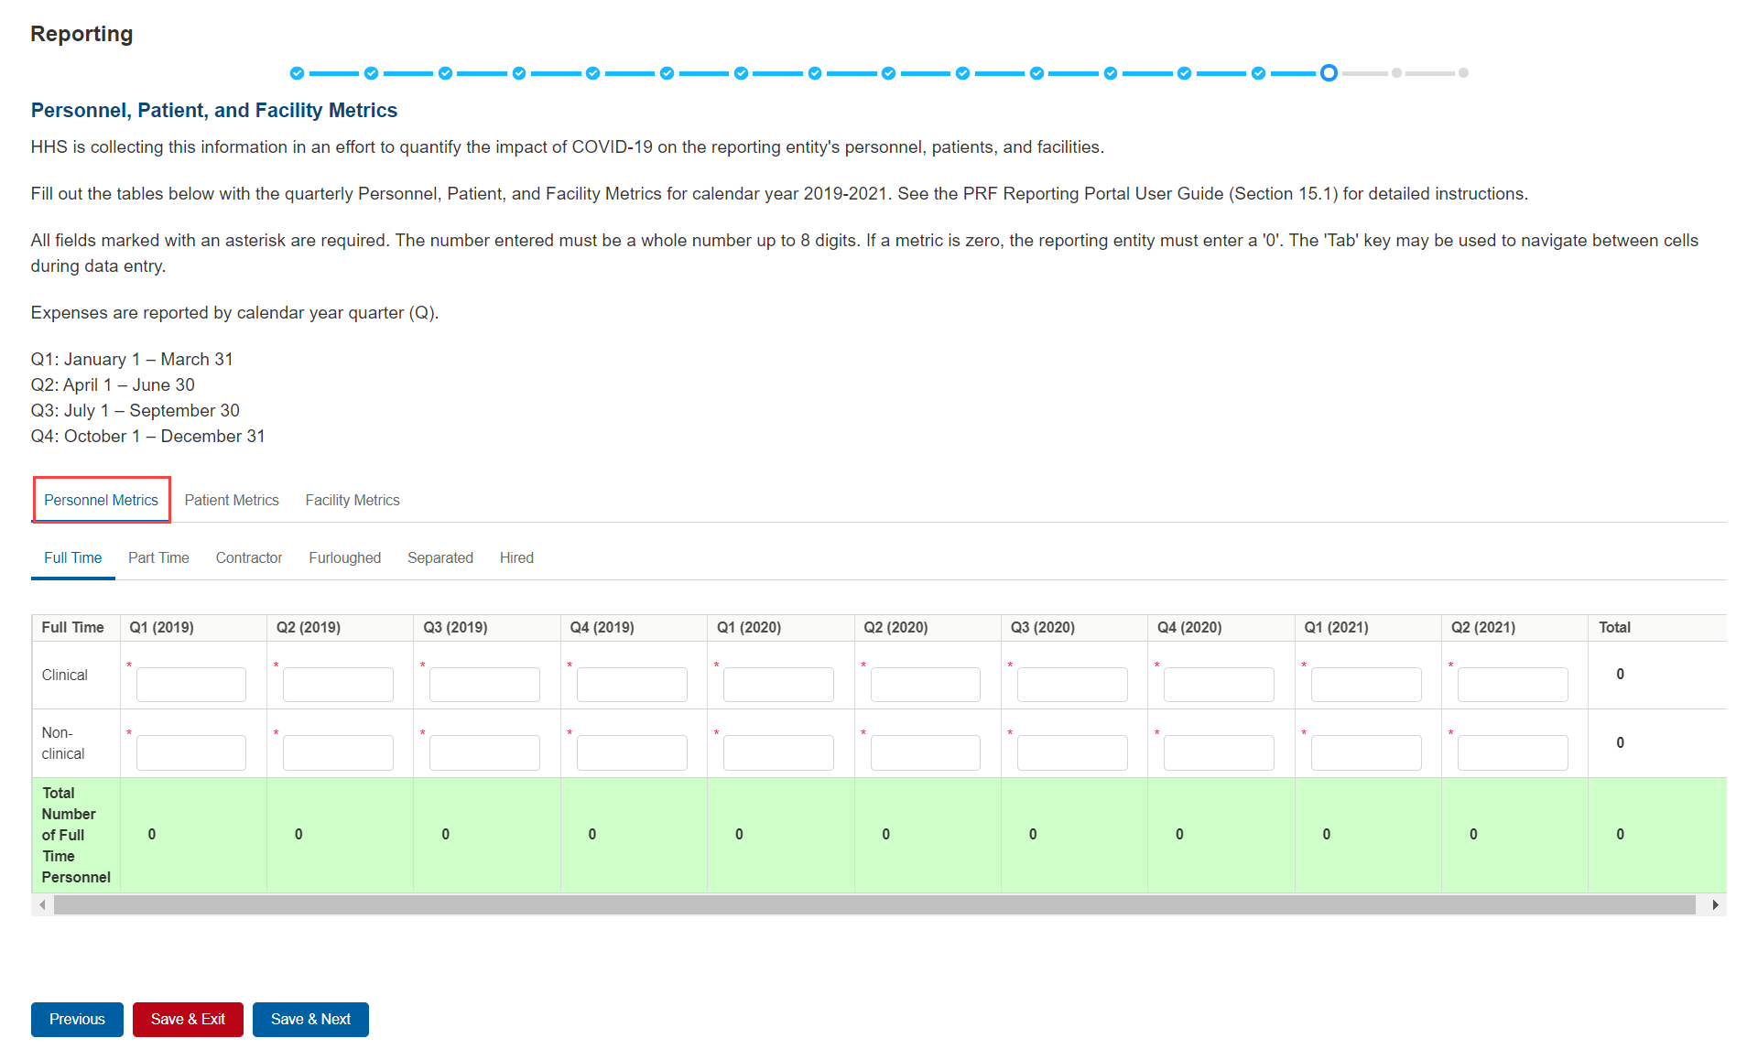

Figure 43 Personnel Metrics

Definitions of personnel metrics are as follows:

* Clinical: Total number of clinical personnel providing direct patient care by labor category (full time, part time, contract, furloughed, separated, hired). Clinical staff provides direct patient care and may provide direct diagnosis, treatment, or care for the patient. Clinical roles often require certifications or licensure. Clinical personnel may include: physicians, hospitalists, physician assistants, nurse practitioners, registered nurses, nursing assistants, patient care technicians, social workers, and therapists. Personnel must be categorized as clinical if 50% or more of their time is spent delivering direct patient care.
* Non-Clinical: Total number of non-clinical personnel by labor category (full time, part time, contract, furloughed, separated, hired). Personnel must be categorized as non-clinical if less than 50% of their time is spent delivering direct patient care. Non-clinical personnel may support patient care. Non-clinical personnel may include medical billers and coders, transcriptionists, hospital executives, and receptionists.
* All clinical and non-clinical personnel employed at any point and in any capacity during a calendar year quarter by the Reporting Entity (or its subsidiaries included in the report) must be categorized into one of the following labor categories. The labor categories are mutually exclusive, and each employee should only be included in one labor category per quarter. If a hiring action (*e.g.,* furloughed, separated, hired) occurred during the quarter personnel should be considered non-clinical if less than 50% of their time does not involve direct patient care. The employee should be identified in the category that occurred closest to the end of the quarter. All full-time, part-time, or contractor personnel should be those that experienced no hiring action during the respective quarter.
* Full-time: Number of personnel employed on average 30 hours of service per week, or 130 hours for a calendar month. However, health care practices may have exceptions to this, such as nursing shifts.
* Part-time: Number of personnel employed any time between 1 and 34 hours per week, whom may or may not qualify for benefits.
* Contractor: Number of personnel employed as an individual or under organizational contracts and do not receive direct benefits or compensation from the employer/provider.
* Furloughed: Number of personnel on temporary involuntary and unpaid leave of absence.
* Separated: Number of personnel who 1) voluntarily submit a written or verbal notice of resignation or 2) the employer/provider decided to terminate its relationship with the employee(s) (includes lay-offs and expired contracts).
* Hired: Number of personnel 1) not previously employed by the employer or 2) that left an employer due to voluntary or involuntary separation and are brought back to work by employer.

The Patient Metrics tab is comprised of one table that gathers patient visit metrics as shown in *Figure 44 Patient Metrics*.

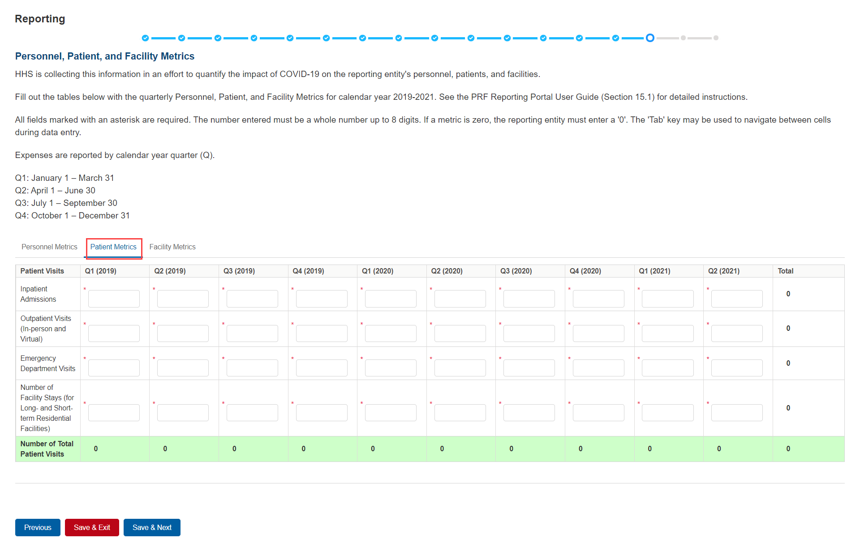

Figure 44 Patient Metrics

Definitions of patient metrics are as follows:

* Inpatient Admissions: Number of hospital admissions on a clinician’s order (*i.e.,* direct admit) or formally admitted from the emergency department to the hospital (*i.e.,* emergency admission).
* Outpatient Visits (in-person and virtual): Number of in-person or virtual patient encounters with a clinician in an office-based, clinic, or hospital outpatient department setting that do not require an inpatient admission.
* Emergency Visits: Number of emergency department encounters for care or treatment. This may include patients on observation status who are cared for no longer than 72 hours and not formally admitted to a hospital.
* Facility Stays (for Long- and Short-term Residential Facilities): Number of stays (defined as unique admissions) for patients residing in a long-term or short-term care or treatment facility.

The Facility Metrics tab is comprised of a required question ‘Does the Reporting Entity or its subsidiaries operate or support staffed beds?’ A staffed bed is defined as a licensed and physically available bed with staff on hand to attend to patients; includes both occupied and available beds. If the answer to the question is ‘No,’ and the Personnel and Patient Metrics tables are complete, the user may click the blue ‘Save & Next’ button to proceed to the next page. If the answer to the question is ‘Yes,’ an additional table will need to be completed as shown in *Figure 45 Facility Metrics*.

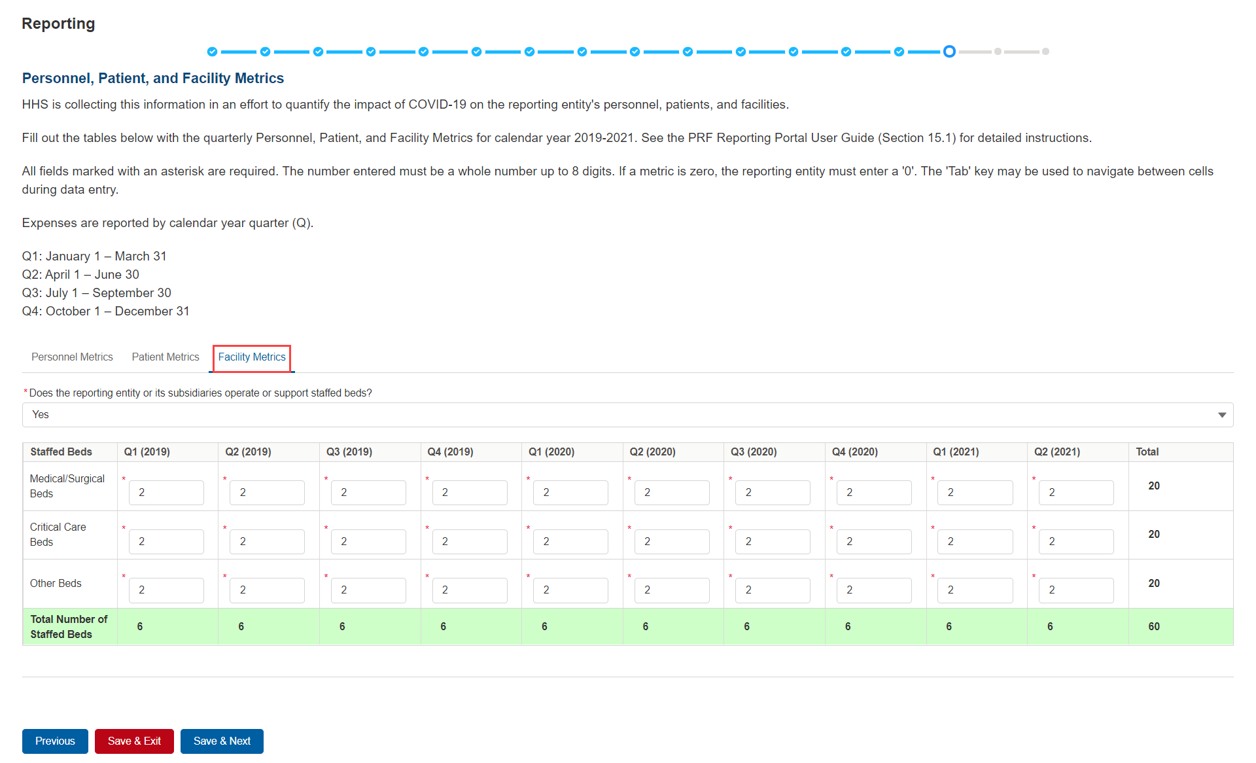

Figure 45 Facility Metrics

Definitions of facility metrics are as follows:

* Medical/Surgical Beds: Number of general medical/surgical beds, which are the beds used for routine care or “ward” beds.
* Critical Care Beds:Number of beds inintensive care units (ICUs), critical care units (CCUs) or intensive therapy units (ITUs).
* Other Beds: Number of any other type of staffed bed that the facility has physically available and licensed to operate.

Users must click the blue ‘Save & Next’ button to proceed to Step 15 – Survey. To return to a previous page, users should click the blue ‘Previous’ button. Portal users should exit the PRF Reporting Portal when they are not actively entering data and should do this by clicking the red ‘Save & Exit’ button. **Portal users should not exit the portal by closing the browser window or navigate away from the current page using the browser window as data entered on the current page will not be saved.**

## 4.17 Step 16 – Survey

Step 16 – Survey is the last data entry page in the report and is included to evaluate the impact of PRF payment(s) on the Reporting Entity’s financial and clinical care situation during the period of availability of funding that corresponds to the current reporting period. The Reporting Entity should consider the impact of the PRF payments received during the Payment Received Period that corresponds to the current Reporting Period as shown in Table 1 Reporting Periods. The survey consists of two sections: 1) Financial effects of PRF payment(s) and 2) Clinical care effects of PRF payment(s).

Responses to the following statements and questions are required as part of the Section: Financial Effects of PRF Payment(s) as shown in *Figure 46 Survey Financial Effects of PRF Payment(s)*:

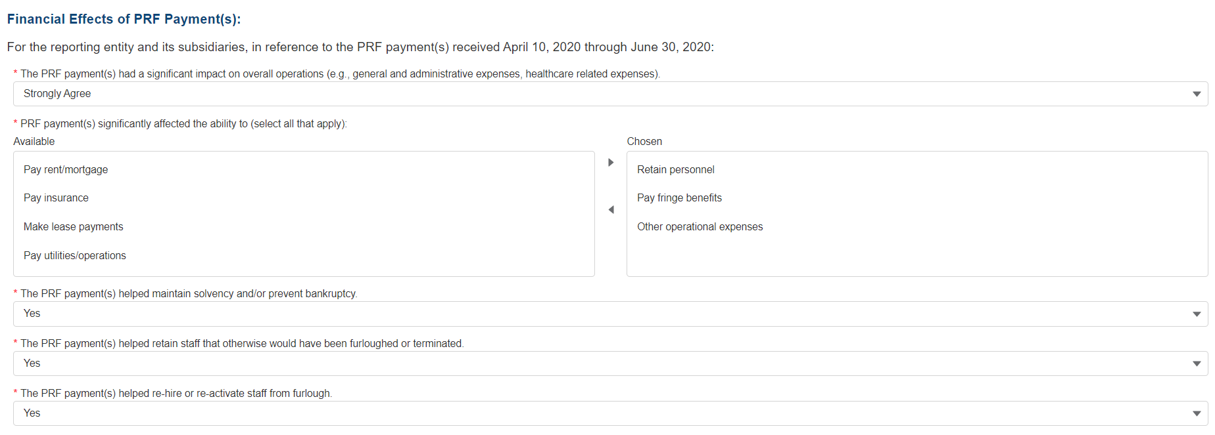

Figure 46 Survey Financial Effects of PRF Payment(s)

Financial Effects of PRF Payments:

For the Reporting Entity (and its subsidiaries as applicable), in reference to PRF payments received during the Payment Received Period that corresponds to the current reporting period:

1. The PRF payment(s) had a significant impact on overall operations (*e.g.,* general and administrative expenses, healthcare related expenses).

A response must be selected from the dropdown list as follows: ‘Strongly Agree,’ ‘Agree,’ ‘Neutral,’ ‘Disagree,’ or ‘Strongly Disagree.’ If the respondent selects ‘Strongly Agree’ or ‘Agree’ to this question an additional question will be required, as shown in *Figure 47 Conditional Question Financial Effects of PRF Payment(s).*

1. (Conditional) PRF payment(s) significantly affected the ability to (select all that apply):

Responses should be selected from the following options: retain personnel, pay fringe benefits, pay insurance, pay other operational expenses, make lease payments, pay utilities/operations. Multiple selections may be made. The user should click on each response applicable under the ‘Options’ table and after each selection, use the right-facing arrow to move the response to the ‘Selected’ table. To remove a selected value, the user should click on the response in the ‘Selected’ table and use the left-facing arrow to move it back to the ‘Options’ table.

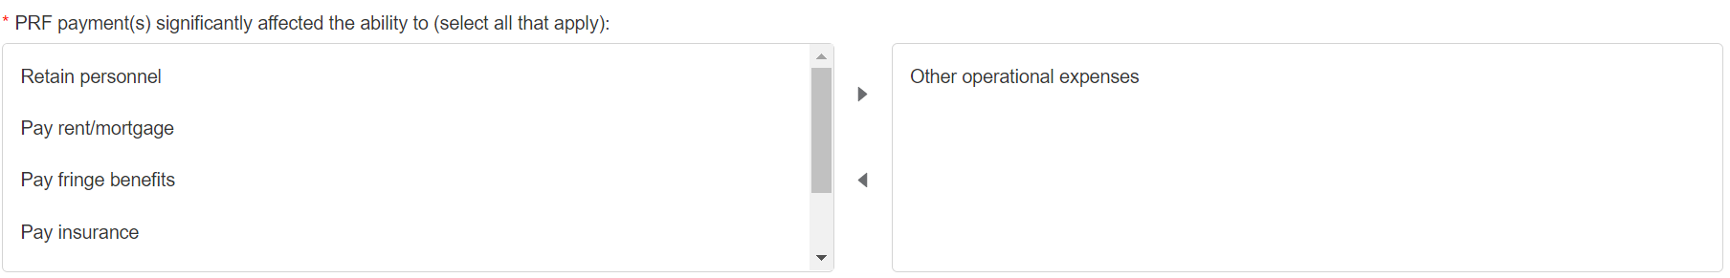

Figure 47 Conditional Question Financial Effects of PRF Payment(s)

1. The PRF payment(s) helped maintain solvency and/or prevent bankruptcy.

A response must be selected from the dropdown list as follows: ‘Yes,’ ‘No,’ or ‘Not Applicable.’

1. The PRF payment(s) helped retain staff that otherwise would have been furloughed or terminated.

A response must be selected from the dropdown list as follows: ‘Yes,’ ‘No,’ or ‘Not Applicable.’

1. The PRF payment(s) helped re-hire or re-activate staff from furlough.

A response must be selected from the drop-down list as follows: ‘Yes,’ ‘No,’ or ‘Not Applicable.’

Clinical Care Effects of PRF Payment(s):

Responses to the following statements and questions are required as part of the Section: Financial Effects of PRF Payment(s) as shown in *Figure 48 Survey Clinical Care Effects of PRF Payment(s).*

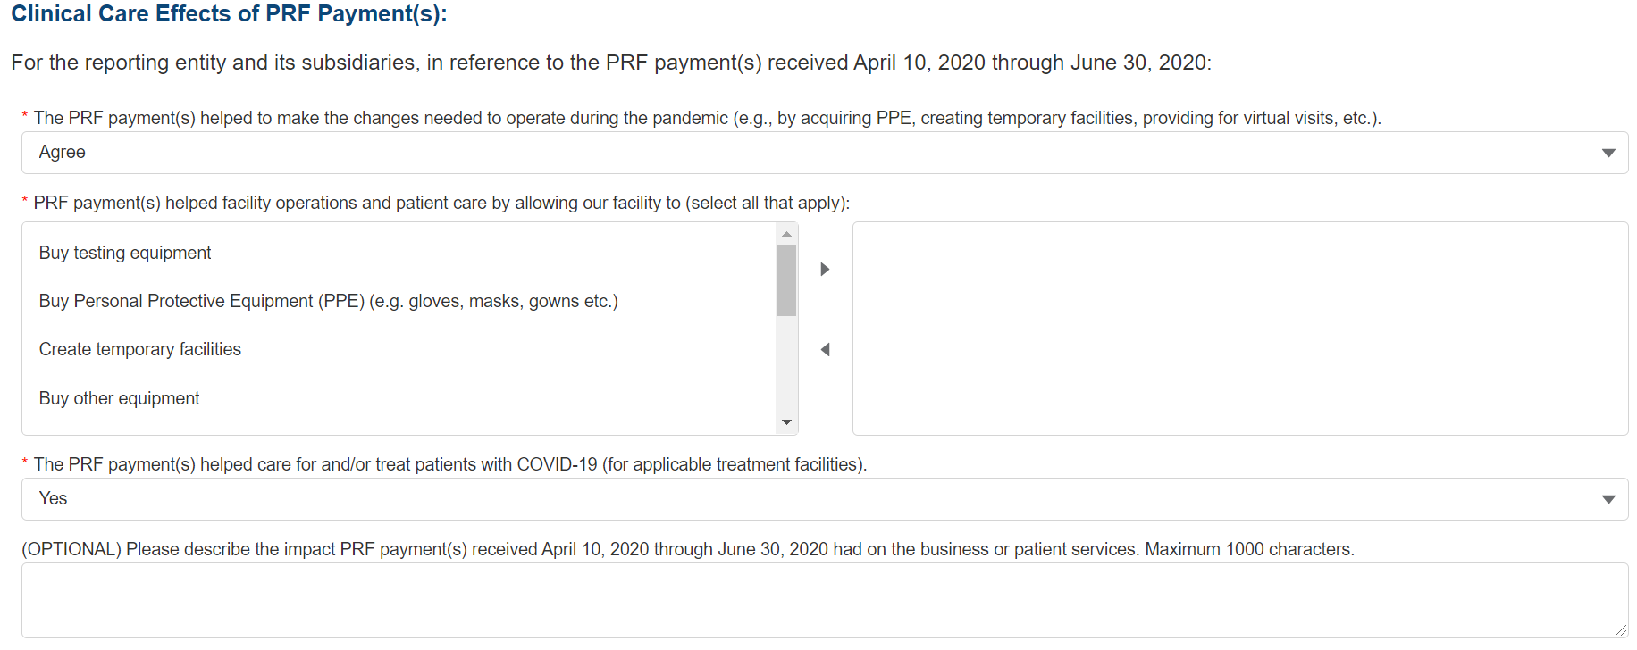

Figure 48 Survey Clinical Care Effects of PRF Payment(s)

For the Reporting Entity (and its subsidiaries as applicable), in reference to PRF payments received during the Payment Received Period that corresponds to the current reporting period:

1. The PRF payment(s) helped to make the changes needed to operate during the pandemic (*e.g.,* by acquiring personal protective equipment (PPE), creating temporary facilities, providing for virtual visits, *etc.*).

A response must be selected from the dropdown list as follows: ‘Strongly Agree,’ ‘Agree,’ ‘Neutral,’ ‘Disagree,’ or ‘Strongly Disagree.’ If the respondent selects ‘Strongly Agree’ or ‘Agree’ to this question an additional question will be required, as shown in Figure 49 Conditional Question Survey Clinical Care Effects of PRF Payment(s).

1. (Conditional) PRF payment(s) helped facility operations and patient care by allowing our facility to (select all that apply):

Responses should be selected from the following options: buy testing equipment, buy personal protective equipment (PPE), buy other equipment, buy supplies, enhance information technology, enhance or implement telemedicine services, improve facilities, increase testing capacity, other healthcare related expenses. Multiple selections may be made. The user should click on each response applicable under the ‘Options’ table and after each selection, use the right-facing arrow to move the response to the ‘Selected’ table. To remove a selected value, the user should click on the response in the ‘Selected’ table and use the left-facing arrow to move it back to the ‘Options’ table.

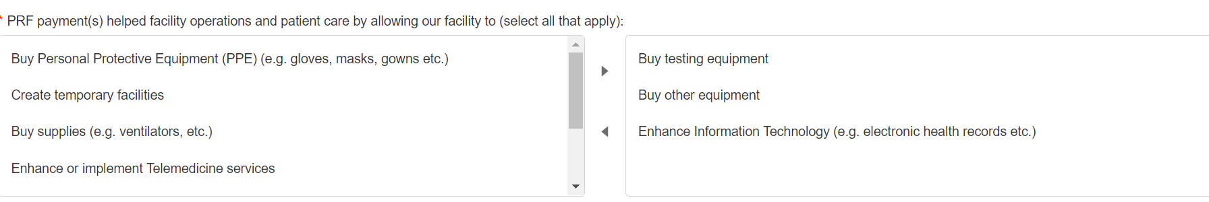

Figure 49 Conditional Question Survey Clinical Care Effects of PRF Payment(s)

1. The PRF payment(s) helped care for and/or treat patients with COVID-19 (for applicable treatment facilities).

A response must be selected from the menu: ‘Strongly Agree,’ ‘Agree,’ ‘Neutral,’ ‘Disagree,’ or ‘Strongly Disagree.’ The Reporting Entity should use the dropdown menus to select the best response.

The final data field of the survey is optional. HRSA strongly encourages Reporting Entities to provide narrative feedback on the impact of the PRF payment(s) received during the Payment Received Period that corresponds to the current reporting period. HRSA is interested in receiving feedback regarding both positive impact of the payments, limitations of the payments, and other comments or concerns that relate to the applicable PRF payments. The narrative response is limited to 1000 characters.

1. Please describe the impact PRF payment(s) received [during the Payment Received Period corresponding with the current Reporting Period as shown in Table 1 Reporting Periods had on business or patient services.

Users must click the blue ‘Save & Next’ button to proceed to Step 16 - Review and Submit. To return to a previous page, users should click the blue ‘Previous’ button. Portal users should exit the PRF Reporting Portal when they are not actively entering data and should do this by clicking the red ‘Save & Exit’ button. **Portal users should not exit the portal by closing the browser window or navigate away from the current page using the browser window as data entered on the current page will not be saved.**

## 4.18 Step 17 – Review and Submit

Step 17 - Review and Submit **is a summary of all data entered in the report. Portal users will only be able to reach this portal page if the data entry on all prior pages is complete.** The user representing the Reporting Entity in its submission of a final report to HRSA must carefully review this summary for accuracy before submitting the report to HRSA.

Headers in this section are collapsible. To collapse or expand a header, click the arrowhead (Dropdown icon) before each section header. Data on this page cannot be edited, but if the portal user sees an error, they should navigate back to the appropriate page using the blue ‘Previous’ button. Portal users may choose to print the page as a record by using the print option on their web browser. Once the report is submitted, the Reporting Entity will no longer be able to edit the report.

If the report on the use of funds indicates that the Reporting Entity (or its subsidiaries as applicable) has unused PRF payments for the Payment Received Period that corresponds with the Reporting Time Period, the user will be directed in red text to follow the instructions located on the PRF website to return unused PRF payments. *(This statement only appears if the provider has unused PRF payments.)*

The Reporting Entity is presented with the following questions for response as shown in *Figure 50 Review and Submit Page*:

* Did you report on the use of your Rural Health Clinic COVID-19 Testing funds in the RHC portal? Select “Yes’ or “No’ from the dropdown list. *(This question only appears if the Reporting Entity (or its subsidiaries as applicable) received RHC COVID-19 Testing Program or RHC COVID-19 Testing and Mitigation Program payments.)*
* Do you certify that the above information is accurate to the best of your knowledge?
  + If ‘No’ is selected, the Reporting Entity will see the following message: ‘Please click on the ‘Previous’ button at the bottom of the page to go back to correct the inaccurate data.’
  + If ‘Yes’ is selected, the Reporting Entity may click the blue ‘Submit’ button.

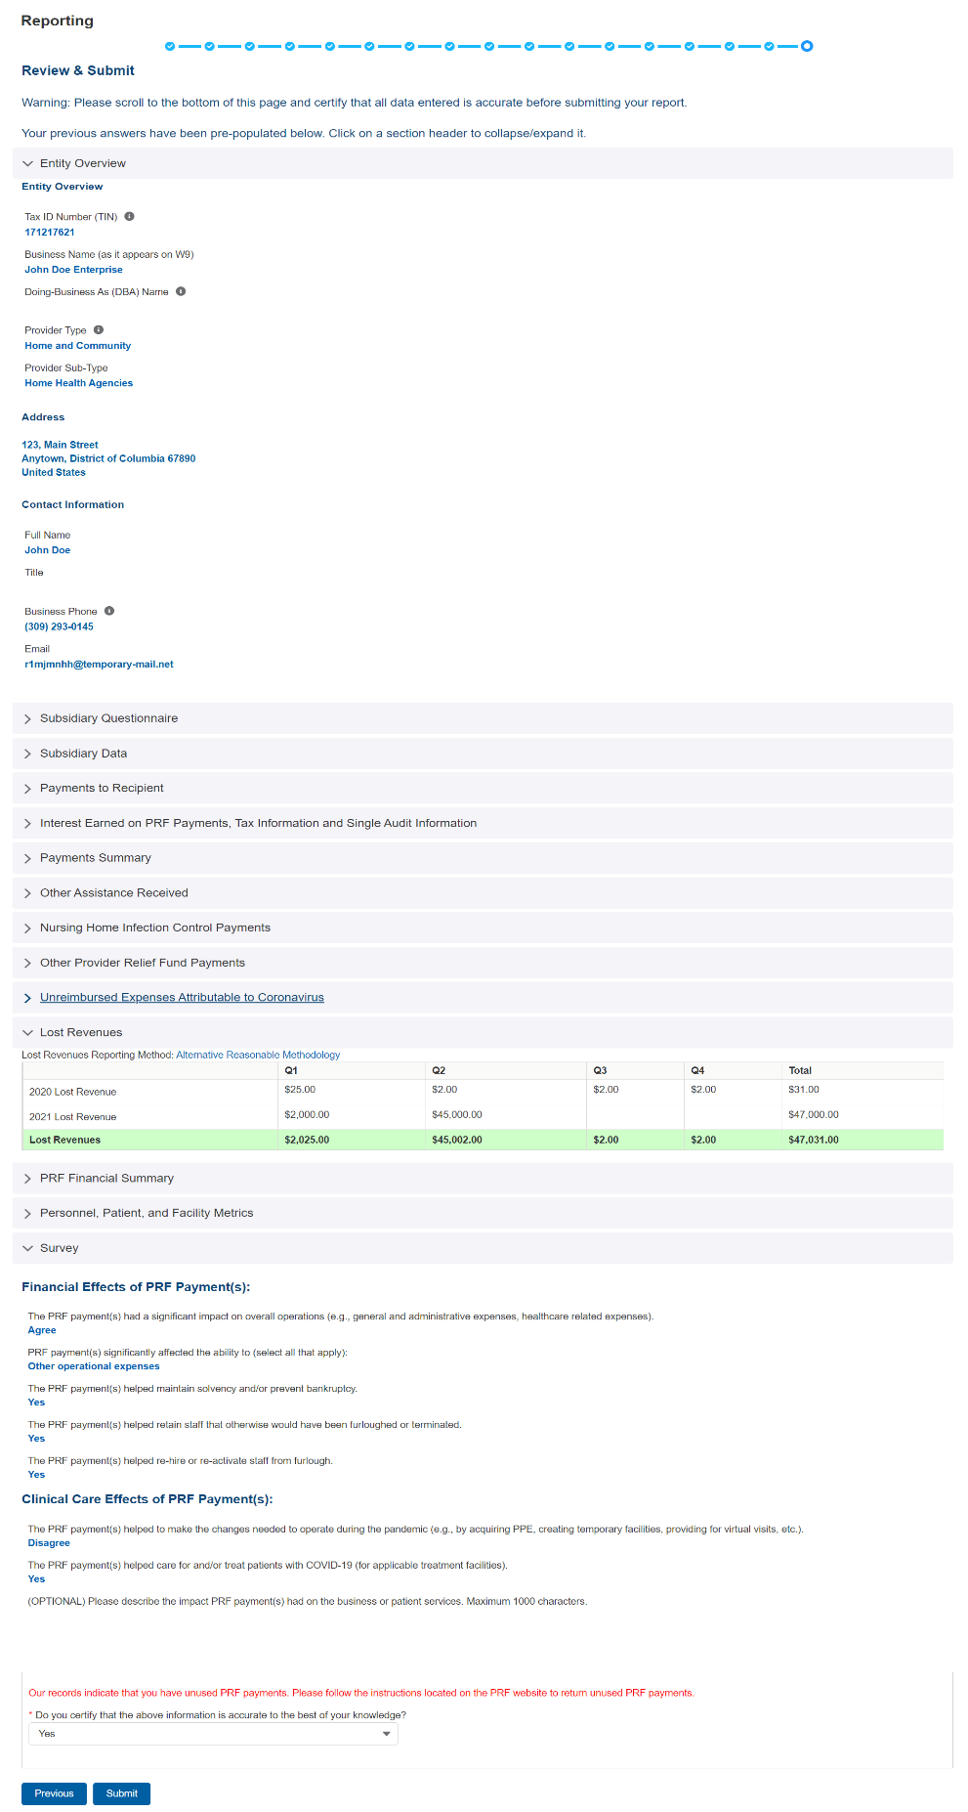

Figure 50 Review and Submit Page

If the data is correct, and the user clicks the blue ‘Submit’ button, a pop-up message will appear as shown in *Figure 51 Submit Pop-Up* confirming the intent to submit. If the user would like to submit the report at this time, they must select ‘I Agree – Submit.’ If the user does not want to submit at this time, they can select ‘Save & Resume Later.’ All data will be saved, and the user will be taken back to Step 17 – Review and Submit.

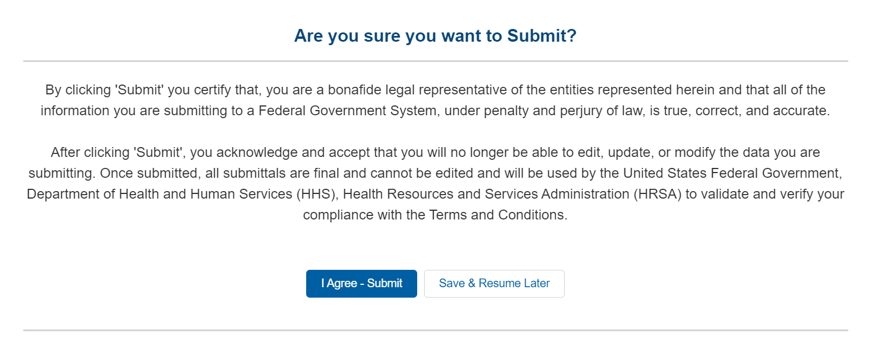

Figure 51 Submit Pop-Up

**Once the ‘Submit’ button is clicked, a pop-up will appear confirming the submission was made as shown in** *Figure 52 Reporting Successful Pop-Up****.*** If the Reporting Entity received additional PRF payments in other Payment Received Periods, has indicated that they have not reported on the use of RHC COVID-19 Testing Program funds, or has unused PRF payments from the Payment Received Period corresponding to the current reporting period, additional information will be provided in the pop-up message. Reporting Entities with unused funds from the current reporting period will see a ‘Return Funds’ button next to the ‘Log Out’ button and may click on the link to begin the return of unused funds.

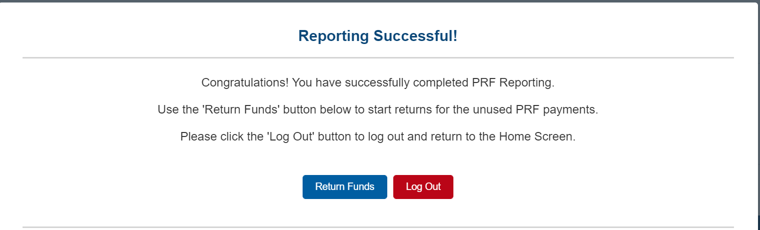

Figure 52 Reporting Successful Pop-Up

Upon submission of the report, the Reporting Entity will receive a confirmation email from ‘[PRFReporting-NoReply@hrsa.gov](mailto:PRFReporting-NoReply@hrsa.gov).’ If the Reporting Entity has received additional PRF payments in other Payment Received Periods, has indicated that they have not reported on the use of RHC COVID-19 Testing Program or RHC COVID-19 Testing and Mitigation Program funds, or has unused PRF payments from the Payment Received Period corresponding to the current reporting period, additional information will be provided in the email as shown in *Figure 53 Reporting Successful Email*.

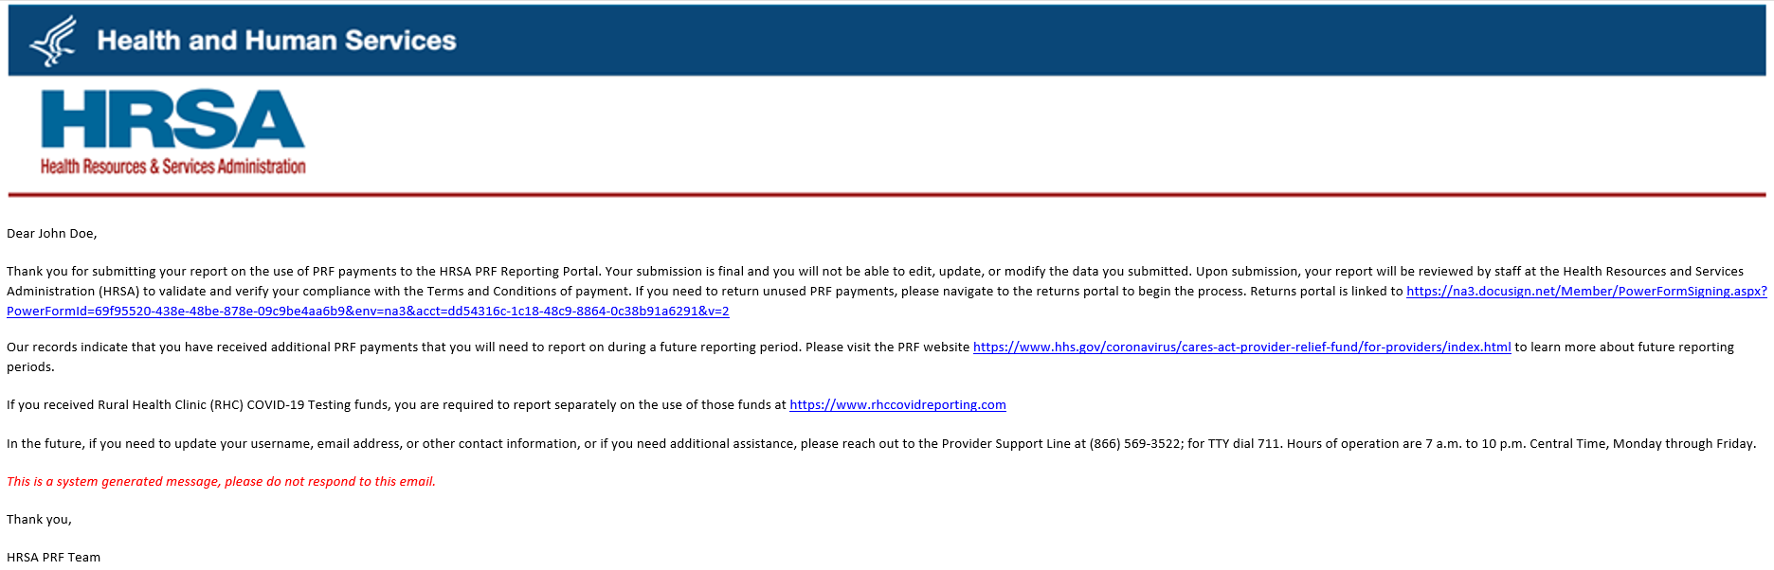

Figure 53 Reporting Successful Email

## 4.19 Locked Page

If a user logs into the Reporting Portal after they have successfully submitted their report, they will see a page as shown in *Figure 54 Locked Page*. This page cannot be edited.

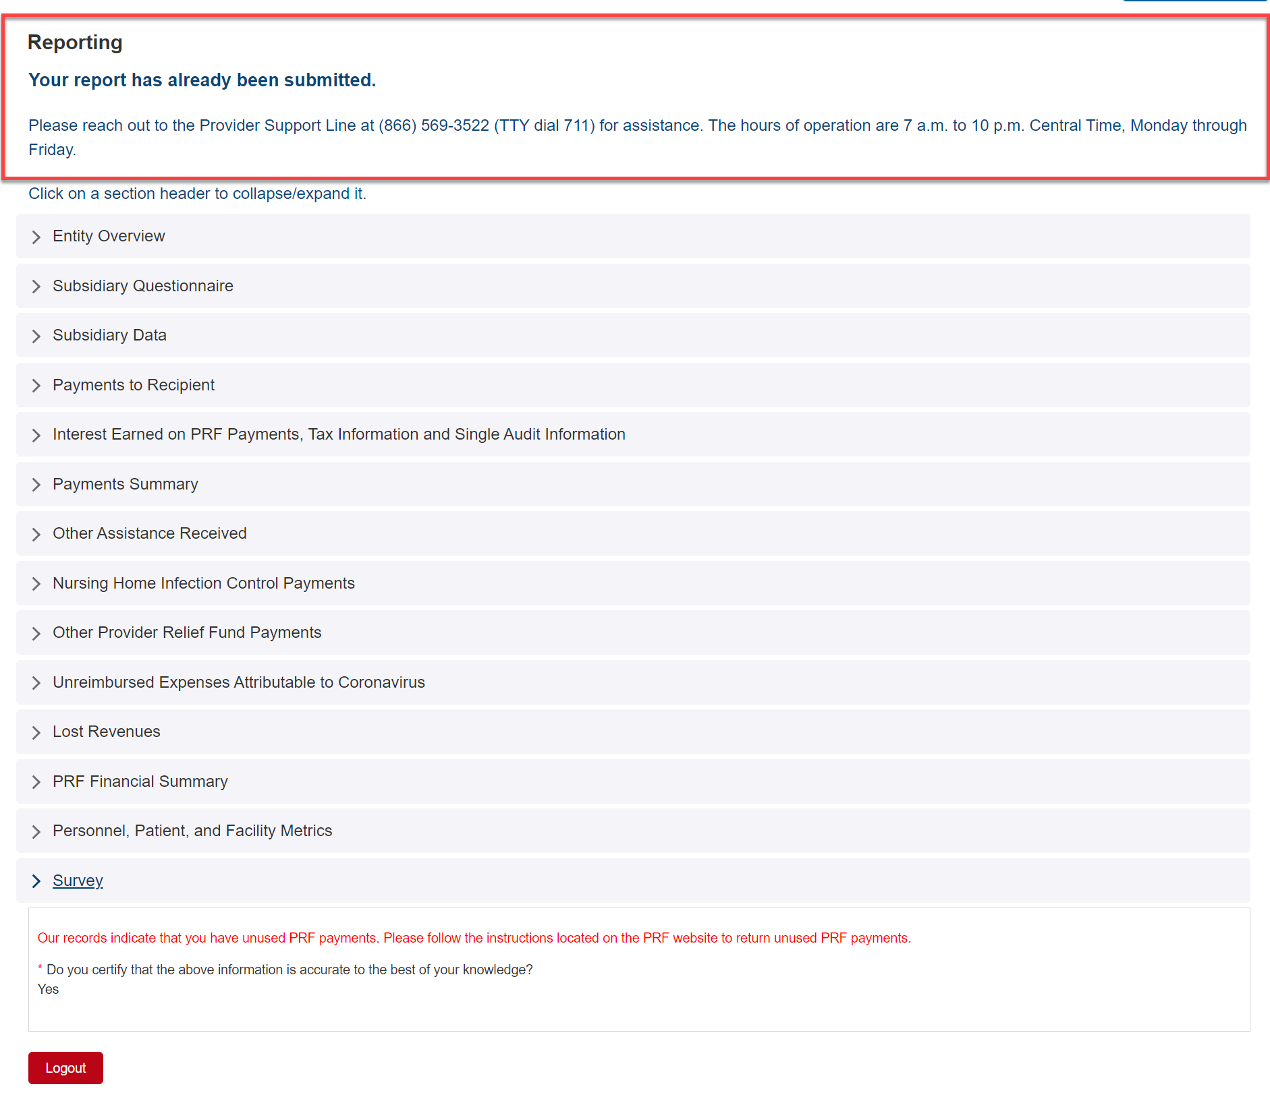

Figure 54 Locked Page

If a user logs into the Reporting Portal to complete reporting, but it is outside their designated reporting period, they will see their submitted report and prompted to contact the Provider Support Line at (866) 569-3522; for TTY dial 711. Hours of operation are 8 a.m. to 10 p.m. Central Time, Monday through Friday, when the portal is open for reporting.

1. For the purposes of reporting, “Eligible health care providers” means public entities, Medicare or Medicaid enrolled suppliers and providers, and such for-profit entities and not-for profit entities as the Secretary may specify, within the United States (including territories), that provide diagnoses, testing, or care for individuals with possible or actual cases of COVID-19.
2. For the purposes of reporting, “Eligible health care providers” are defined as public entities, Medicare or Medicaid enrolled suppliers and providers, and such for-profit entities and not-for-profit entities as the Secretary may specify, within the United States (including territories), that provide diagnoses, testing, or care for individuals with possible or actual cases of COVID–19.
3. The period of availability of funds is cited in the most recently published Post-Payment Notice of Reporting Requirements.
4. Transferred Targeted Distribution payments face an increased likelihood of an audit by HRSA.
5. 5 The period of availability of funds is cited in the most recently published Post-Payment Notice of Reporting Requirements.
6. Only select providers were eligible for, and received, these payments. While this is the formal title of the Distribution, it is known informally as Nursing Home Infection Control.
7. Reporting Entities do not need to report on the Rejected Payments. This table is shown to assist PRF recipients in ensuring that rejected payments are returned to HRSA as required.
8. Nursing Home Infection Control payments are a type of Targeted Distribution payment, but in order to distinguish from other Targeted Distribution payments for the purposes of reporting, they are labeled Infection Control payments on this portal page.
9. If interest is earned on funds that are only partially expended, the interest earned on remaining unused funds must be calculated, reported, and returned.
10. Abbreviated from formal name “Skilled Nursing Facility and Nursing Home Infection Control Distribution Payments”
11. Nursing Home Infection Control Payments are Targeted Distributions with associated Terms and Conditions and include QIP payments.
12. The Terms and Conditions associated with each PRF payment do not permit recipients to use PRF payments to pay any salary at a rate in excess of Executive Level II which is set at $197,300 (2020), $199,300 (2021). For the purposes of the salary limitation, the direct salary is exclusive of fringe benefits and indirect costs. The limitation only applies to the rate of pay charged to PRF payments and other HHS awards. An organization receiving PRF payments may pay an individual’s salary amount in excess of the salary cap with non-federal funds.
13. As a reminder, Nursing Home Infection Control payments include QIP payments.
14. The Terms and Conditions associated with each PRF payment do not permit recipients to use PRF money to pay any salary at a rate in excess of Executive Level II which is set at $197,300 (2020), $199,300 (2021). For the purposes of the salary limitation, the direct salary is exclusive of fringe benefits and indirect costs. The limitation only applies to the rate of pay charged to PRF payments and other HHS awards. An organization receiving PRF may pay an individual’s salary amount in excess of the salary cap with non-federal funds.
15. Net of uncollectible patient service revenues recognized as bad debts.
16. “Patient care” means health care, services and supports, as provided in a medical setting, at home/telehealth, or in the community. It should not include non-patient care revenue such as insurance, retail, or real estate revenues (exception for nursing and assisted living facilities’ real estate revenues where resident fees are allowable); prescription sales revenues (exception when derived through the 340B program); grants or tuition; contractual adjustments from all third party payers; charity care adjustments; bad debt; and any gains and/or losses on investments.
17. Net of uncollectible patient service revenues recognized as bad debts.
18. “Patient care” means health care, services and supports, as provided in a medical setting, at home/telehealth, or in the community. It should not include non-patient care revenue such as insurance, retail, or real estate revenues (exception for nursing and assisted living facilities’ real estate revenues where resident fees are allowable); prescription sales revenues (exception when derived through the 340B program); grants or tuition; contractual adjustments from all third party payers; charity care adjustments; bad debt; and any gains and/or losses on investments.