* We are all affected by this incident
* We are trained (hidden curriculum) to ignore our own emotions, thoughts, and needs
* We are trained to focus on the patient and their needs, and that if we focus on our needs we will provide worse care, and might even harm the patient
* This can lead to compassion fatigue and burn out
* Long term stress can be harmful to your body, which includes your brain

**What does stress look like?**

* **Emotional** — Irritability, feeling numb or detached; feeling overwhelmed or maybe even hopeless. Lack of feeling or empathy or impersonal response toward one’s clients or patients.
* **Self Esteem -** Feeling a lack of personal achievement, general worsening self-confidence.
* **Physical** — Muscle tension, headaches, stomach pain, racing heart and sweating. You may also experience low energy or fatigue. On the other hand, you may feel restless, on edge or agitated.
* **Behavioral** — Changing your routine or engaging in self-destructive coping mechanisms, eating poorly and poor sleep (too much or not enough), using alcohol or other substances.
* **Professional** — Experiencing low performance of job tasks and responsibilities; feeling low job morale. Cynicism and negative attitude one might develop toward one’s clients (patient satisfaction can be affected).
* **Cognitive** — Experiencing confusion, diminished concentration, and difficulty with decision making/easily distracted; experiencing trauma imagery, which is seeing events over and over again..
* **Spiritual** — questioning the meaning of life or lacking self-satisfaction.
* **Interpersonal** — Physically withdrawing or becoming emotionally unavailable to your co-workers or your family. Strained personal relationships or marriages.

**What CAN You Do?**

• **Follow a healthy lifestyle:** Stress can affect your health – protect your health.Eat healthy foods and exercise regularly. Avoid substance use. Practice good sleep hygiene and make time for rest and relaxation on a regular basis

• **Make wellness part of everyday life:** Prioritize emotional health to improve resilience and manage stress. This may include things such as exercise, spending time by yourself, or mindfulness exercises. If possible, take a walk for 30 minutes each day to help with mood and physical symptoms. Deep breathing exercises can alleviate the feelings of stress and regulate your body. Meditation and yoga are both effective for stress reduction.

• **Schedule annual checkups:** Take care of your body so you can face

adversity and to help manage stress.

• **Connect with friends and family:** Supportive relationships are important to everyone’s well-being. Connect with a supportive colleague or workplace mentor to think through helpful strategies for managing stress at work. Stay in touch with family through telephone calls, Face Time, Zoom or other platforms.

• **Seek support from a support group or mental health professional:** These are unprecedented times. The responses listed above are normal and can be expected. They may be temporary, or they may last for a period of time. Stress can result in anxiety, depression or trauma if the responses interfere with functioning and last for a long time. Seek mental health treatment to increase current and develop new coping strategies.

**Mental health treatment is effective.**

**If you have suicidal thoughts, please call the National Suicide Prevention Lifeline at 1-800-273-TALK (8255) which is available 24 hours a day 7 days a week. A lifeline chat is available at** [**https://suicidepreventionlifeline.org**](https://suicidepreventionlifeline.org)**.**

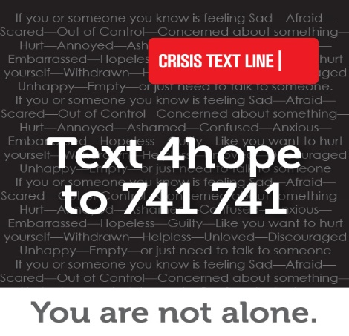

Text the keyword “**4hope**” to [**741 741**](sms:741741) to be connected to a trained Crisis Counselor within 5 minutes.

Any person may need help in coping with a stressful situation. Reach out by text to communicate with someone trained to listen and respond in a method that is private, secure and confidential.

The Crisis Text Line is a free, confidential service available 24/7 via text on mobile devices.

Throughout Ohio, you can text the keyword “**4hope**” to [**741 741**](sms:741741) to be connected to a trained Crisis Counselor. Data usage while texting Crisis Text Line is free and the number will not appear on a phone bill with the mobile service carrier. People of all ages can use Crisis Text Line.

**Visit** [**coronavirus.ohio.gov**](http://coronavirus.ohio.gov/) **or call 1-833-4-ASK-ODH for answers**