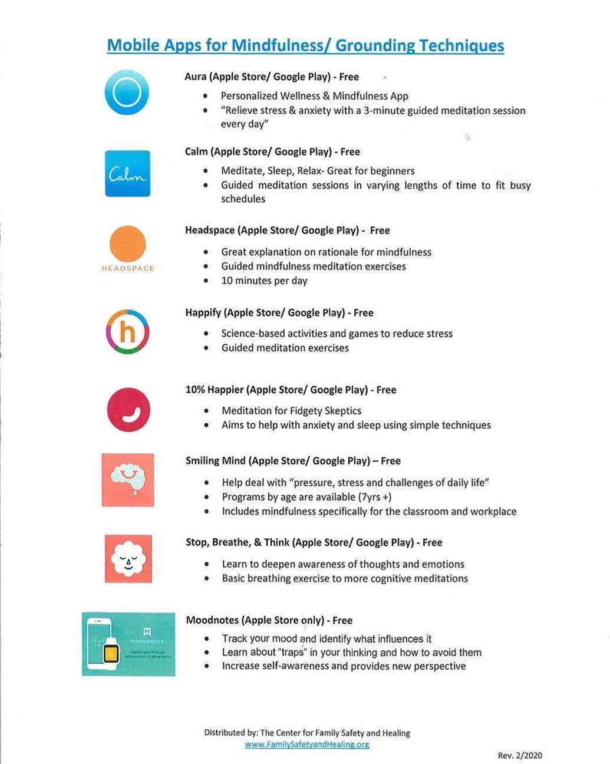

**Mindfulness Coach – Free (iPhone; iPad)**

* Guided, self-guided program
* Understand and adopt a simpe mindfulness practice

**Smiling Minds – Free (web app available)**

* Meditation for all ages
* Practice daily meditation and mindfulness exercises from any device