**CARE PROVIDERS AND RESIDENTS**

Taking care of yourself, your friends, and your family can help you cope with stress.

Helping others cope with their stress can also make your community stronger

**Things you can do to support yourself**

* Take breaks from watching, reading, or listening to news stories, including social media. Hearing about the pandemic repeatedly can be upsetting.
* Take care of your body. Take deep breaths, stretch, or meditate. Try to eat healthy, well-balanced meals, exercise regularly, get plenty of sleep, and avoid alcohol and drugs.
* Make time to unwind. Try to do some other activities you enjoy.
* Connect with others. Talk with people you trust about your concerns and how you are feeling

**Stress during an infectious disease outbreak can include**

* Fear and worry about your own health and the health of your loved ones
* Changes in sleep or eating patterns
* Difficulty sleeping or concentrating
* Worsening of chronic health problems
* Increased use of alcohol, tobacco, or other drugs
* Physical reactions, such as headaches, body pains, stomach problems, and skin rashes.
* Anger or short-temper

**Visit** [**coronavirus.ohio.gov**](http://coronavirus.ohio.gov/) **or call 1-833-4-ASK-ODH for answers**

**For Care Providers**: Monitor Residents for Depression and Anxiety

**As a Care Provider**, if you are experiencing feelings of hopelessness and suicidal thoughts, please contact 911 or the crisis text line:

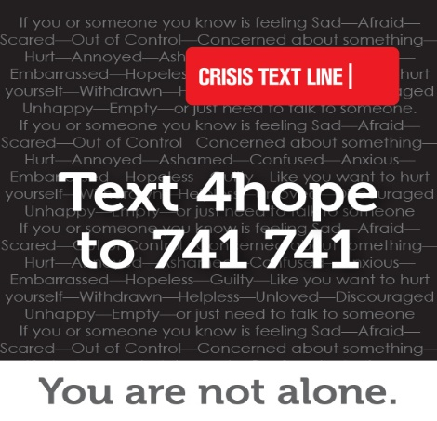

Text the keyword “**4hope**” to [**741 741**](sms:741741) to be connected to a trained Crisis Counselor within 5 minutes.

Any person may need help in coping with a stressful situation. Reach out by text to communicate with someone trained to listen and respond in a method that is private, secure and confidential.

The Crisis Text Line is a free, confidential service available 24/7 via text on mobile devices.

Throughout Ohio, you can text the keyword “**4hope**” to [**741 741**](sms:741741) to be connected to a trained Crisis Counselor. Data usage while texting Crisis Text Line is free and the number will not appear on a phone bill with the mobile service carrier. People of all ages can use Crisis Text Line.

**OhioMHAS Help Line**  
[1-877-275-6364](tel:18772756364)

**Disaster Distress Helpline**  
[1-800-985-5990](tel:18009855990)  
1-800-846-8517 TTY  
Text "TalkWithUs" to [66746](sms:66746)  
Spanish-speakers: Text "Hablanos" to [66746](sms:66746)  
Available 24 hours a day, 7 days a week, year-round

**OMHAS Director Lori Criss – Managing Coronavirus Related Stress**

<https://www.youtube.com/watch?v=wTmJac_eTf8&feature=youtu.be>

**Additional Resources**

Guided Meditation

<http://www.ilivethelifeilove.com/10-best-guided-meditations/>

Meditation Relax Music

<https://www.youtube.com/user/YourRelaxMusic1>

**Please contact the Ombudsman with concerns**: 800-282-1206